“Our laboratory, where everyone is respected, has less research stress” GIST holds the 1st Human Rights-Friendly Laboratory Contest

- Selected as the first human rights-friendly laboratory that practices mutual respect, cooperation and consideration, and ethical compliance... The grand prize winner is Professor Hyunseob Lim's laboratory in the Department of Chemistry, and the first prize winner is Professor Changwoo Kim's laboratory in the School of Earth Sciences and Environmental Engineering
- The award-winning laboratory’s efforts stand out, such as operating the ‘Voice of the Heart’, sharing research fund usage details, calling members by nicknames, and free vacations... “We will actively support the establishment of a healthy laboratory culture.”

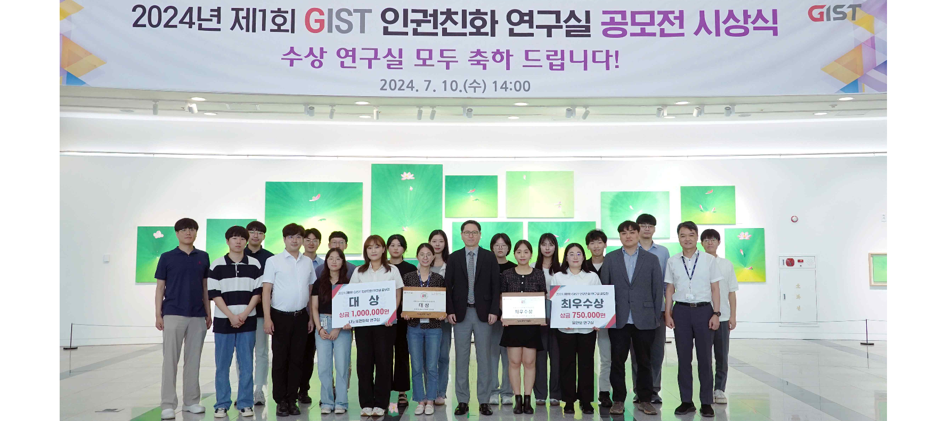▲ The ‘1st GIST Human Rights-Friendly Lab’ contest award ceremony was held and attendees of the labs that won the grand prize and first prize are taking commemorative photos.

The Gwangju Institute of Science and Technology (GIST, President Kichul Lim) announced that it would hold the ‘2024 1st GIST Human Rights-Friendly Laboratory Contest’ and held an awards ceremony at Oryong Hall on the 10th (Wednesday).

Nine graduate school labs on campus applied for this contest, which GIST conducted for the first time this year to promote student human rights and spread a healthy lab culture, for about a month starting April 4.

The Office of Human Rights and Legal Affairs promotes: ▴ a culture of mutual respect within the laboratory without abuse of power, verbal abuse, or forcing people to have company dinners against their will ▴ a culture of communication that supports free opinion suggestions and equal distribution of work ▴ a culture of cooperation that is considerate of foreign students and new students and compliments each other ▴ and the final two labs were selected as 'human rights-friendly labs' after comprehensively evaluating their efforts to create a human rights-friendly lab culture, including transparent lab operation and an ethics compliance culture aimed at improving member treatment, and the presence of specific systems.

The grand prize went to the Department of Chemistry’s ‘Nanoscale Surface Chemistry Laboratory’ (advisor Professor Hyunseob Lim/representative student, doctoral student Jee Hyeon Kim), and the first prize went to the School of Earth Sciences and Environmental Engineering’s ‘Water Security Laboratory’ (advisor Professor Changwoo Kim/representative student, doctoral student Jiwon Son).

The 'Nanoscale Surface Chemistry Laboratory', led by Professor Hyunseob Lim of the Department of Chemistry, operates a 'Voice of the Heart' where members can freely suggest opinions, shares research fund usage details with all members, and operates an incentive system linked to weekly research reports.

It was highly praised for its culture of caring for new students by providing indirect experience to familiarize them with the work in the first 1-2 semesters after entering the school and operating a supervisor/assistant supervisor system, as well as for its efforts to create a flat lab culture with a free commuting policy.

Professor Changwoo Kim of the School of Earth Sciences and Environmental Engineering's 'Water Security Laboratory' is creating a culture that values mutual communication among members by calling each other by nicknames, deciding on common hobbies such as running a garden, and carrying out lab activities.

In addition, it encourages free expression through frequent communication between supervisors and lab members, and has formed an people-centered, human rights-friendly culture with a policy of setting work tasks in consideration of individual inclinations and strengths and freely adjusting working hours and vacations.

President Kichul Lim said, "We expect that the discovery of laboratories that practice mutual respect and communication will have a positive impact on other laboratories. We will hold a contest every year and actively support the establishment of a healthy laboratory culture free from abuse of power toward students."

Meanwhile, GIST presented a ‘Human Rights-Friendly Lab’ signboard as a reward to the winning lab and awarded a prize of 1 million won to the grand prize lab and 750,000 won to the first prize lab.



