GIST, Damyang-gun sign MOU to revitalize local culture and tourism - cutting-edge science and technology and regional specialized industries such as artificial intelligence, metaverse, robots, etc.

- Decided to cooperate in five areas, including fostering local industries, utilizing cutting-edge science and technology, discovering linked projects, educational cooperation, and talent development
- “Expectation to lay the foundation for fostering future new industries (regional culture and tourism revitalization, etc.) in the region using artificial intelligence technology”

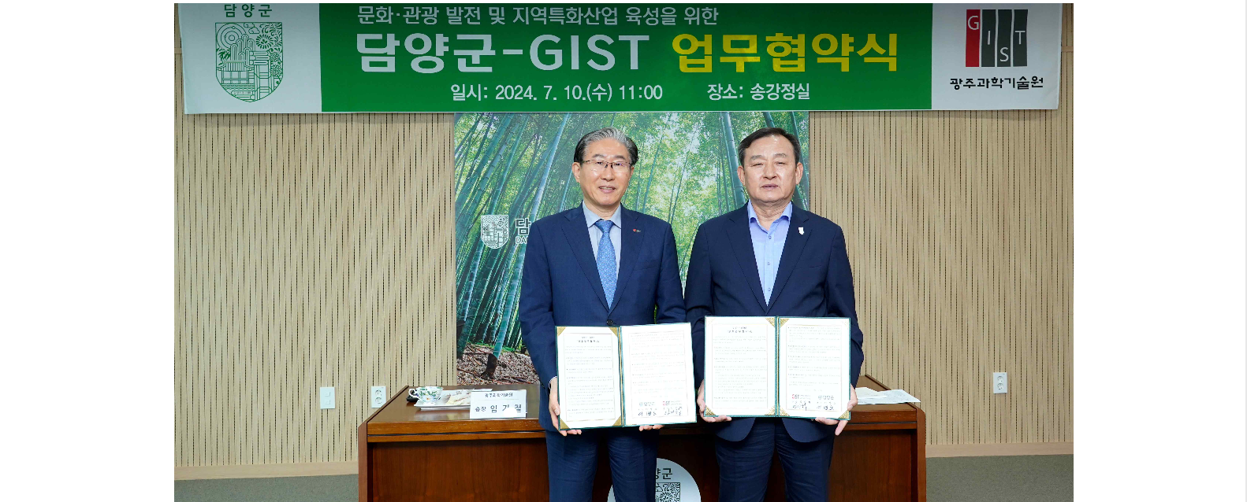▲ GIST and Damyang-gun signed a business agreement (MoU) to develop local culture and tourism using cutting-edge science and technology, and (from the left) GIST President Kichuk Lim and Damyang-gun Governor Byeong-no Lee are taking a commemorative photo.

The Gwangju Institute of Science and Technology (GIST, President Kichuk Lim) announced that it signed a business agreement (MoU) with Damyang-gun, Jeollanam-do (Governor Byeong-no Lee) for the development of local culture and tourism using cutting-edge science and technology.

The agreement ceremony was held on Wednesday, July 10th, at the Damyang County Office with about 10 people in attendance, including GIST President Kichul Lim, Vice President for Public Affairs Yonghwa Chung, Korea Culture Technology Institute Director Kyung-Joong Kim (professor in the School of Integrated Technology), Damyang County Governor Byeong-no Lee, Administrative Director Kyeong-won Kang, and Director of Planning and Budget Yeon-deok Han.

The main contents of the agreement include: ▴ Fostering local industries: joint cooperation to develop and operate programs for the development of local culture and revitalization of tourism, etc. ▴ Utilization of cutting-edge science and technology: education and technical cooperation and joint research, including artificial intelligence (AI), metaverse, and robots, and joint use of research facilities and equipment ▴ Discovery of linked projects: Joint cooperation to discover linked projects related to government 4th industry and select public offering projects ▴ Education cooperation: Joint cooperation for Damyang-gun educational development and nurturing local talent ▴ Talent training: This included cooperation in establishing the GIST Techno Management Business Academy (GTMBA) curriculum and selection of scholarship students.

Damyang-gun plans to build an artificial intelligence (AI)-based digital theme park in 2027 (planned), and through collaboration with GIST, it plans to create a digital theme park at major tourist spots such as Bamboo Green Park to provide new attractions for tourists and promote stay-type tourism.

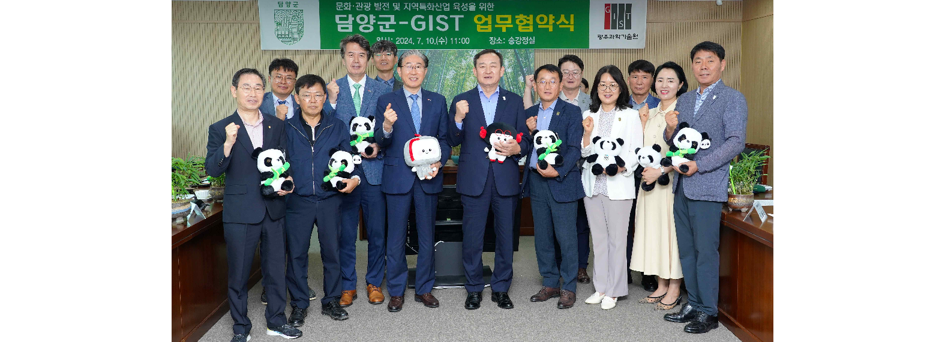▲ GIST and Damyang-gun signed a business agreement (MoU) for the development of local culture and tourism using cutting-edge science and technology, and attendees are taking a commemorative photo.

GIST President Kichul Lim said, "In the digital economy era, we are always thinking about ways to utilize GIST's technology, knowledge, and industry experience for regional and national economic development. Applying GIST's AI and digital technology to Damyang-gun's cultural and tourism contents will attract tourists and greatly revitalize the local economy."

Damyang-gun Governor Byeong-no Lee said, "Damyang-gun, like other rural areas, is making efforts to revitalize the local economy by expanding the residential population. We will do our best to create Damyang, a city with a variety of experiential and stay-oriented tourism infrastructure, by incorporating cutting-edge science and technology, such as GIST's artificial intelligence, into Damyang-gun's cultural tourism industry."



