GIST Techno Management Business Academy (GTMBA) Alumni Association and Alumni Golf Club donate 10 million won in development funds to GIST

- GTMBA Alumni Association President Yun-seop Kim and GTMBA Alumni Golf Club President Jeong-soon Park donated 5 million won each to the university development fund in commemoration of the sports competition.
- “As a GIST alumni, I will participate in the development of GIST” (Chairman Yun-seop Kim), “I will repay GIST for providing me with various knowledge and valuable relationships and experiences” (Chairman Jeong-soon Park)

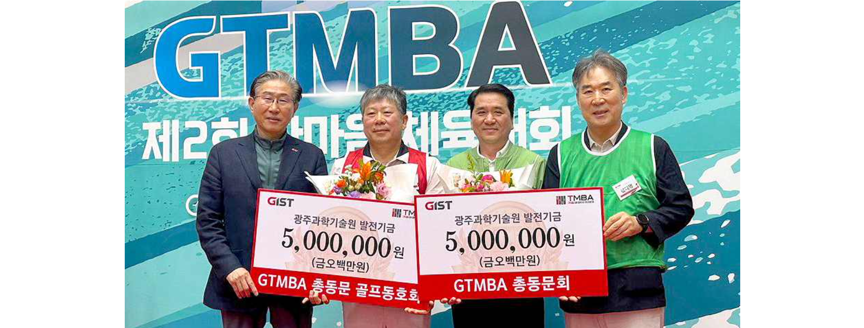▲ On Saturday, June 1, the GTMBA Alumni Association (Chairman Yun-seop Kim of Hanyoung P&S Co., Ltd.) and the GTMBA Alumni Golf Club (Chairman Jeong-soon Park of Dongyang Metal Co., Ltd.) each donated 5 million won in development funds and took a commemorative photo. I'm doing it.

(From left) President Kichul Lim, Chairman Jeong-soon Park, Chairman Yun-seop Kim, and GIST Development Foundation Chairman Hae-myeong Kim

The Gwangju Institute of Science and Technology (GIST, President Kichul Lim) announced that the GTMBA Alumni Association (Chairman Yun-seop Kim of Hanyoung P&S Co., Ltd.) and the GTMBA Alumni Golf Club (President Jeong-soon Park of Dongyang Metal Co., Ltd.) each donated 5 million won in power generation funds.

The donation ceremony was held on Saturday, June 1st at the GIST gymnasium with President Kichul Lim, Vice President for External Affairs Yonghwa Chung, and Yun-seop Kim. It was held with Chairman Jeong-soon Park, GTMBA executives, and Wooga Won in attendance.

The GTMBA Alumni Association and the GTMBA Alumni Golf Club held the 'Alumni One-Mind Athletic Competition' (June 1) and the 'Alumni President's Boat Athletic Competition' (May 19), respectively, and donated funds for the development of GIST, according to GIST officials.

GTMBA 7th Alumni President Yun-seop Kim said, "We hope that this fund will contribute to students' academic and research activities, and as alumni of GIST, GTMBA alumni will continue to show interest and provide unsparing support for the school's future development. We hope that GIST will continue to grow into a world-class institution through innovative research and education, and GTMBA alumni will join us on that journey."

Jeong-soon Park, president of the GTMBA alumni golf club, said, "The GTMBA course provided our graduates with not only diverse knowledge but also valuable connections and experiences. We hope that this donation, prepared to repay GIST in some small way for providing us with learning opportunities, will go beyond simple financial support and serve as a foundation for stronger ties and development between our school and its alumni."

President Kichul Lim said, "We are grateful for the warm hearts and deep affection of the GTMBA Alumni Association and the GTMBA Alumni Golf Club, and this served as an opportunity to once again confirm GIST's bright vision for the future. GIST will continue to strive to become a world-class university thanks to the strong support of GTMBA alumni."



