GIST Academy invites Cheon-ho Cho, former director of the Korea Institute of Meteorological Science, to the breakfast forum ‘From climate crisis to bold transition’

- On Tuesday, May 28th, the first Director of the National Institute of Meteorological Research, Cheon-ho Cho, was invited to hold the May Breakfast Forum... Recognizing the current crisis caused by ‘climate change’ and emphasizing transition for future generations

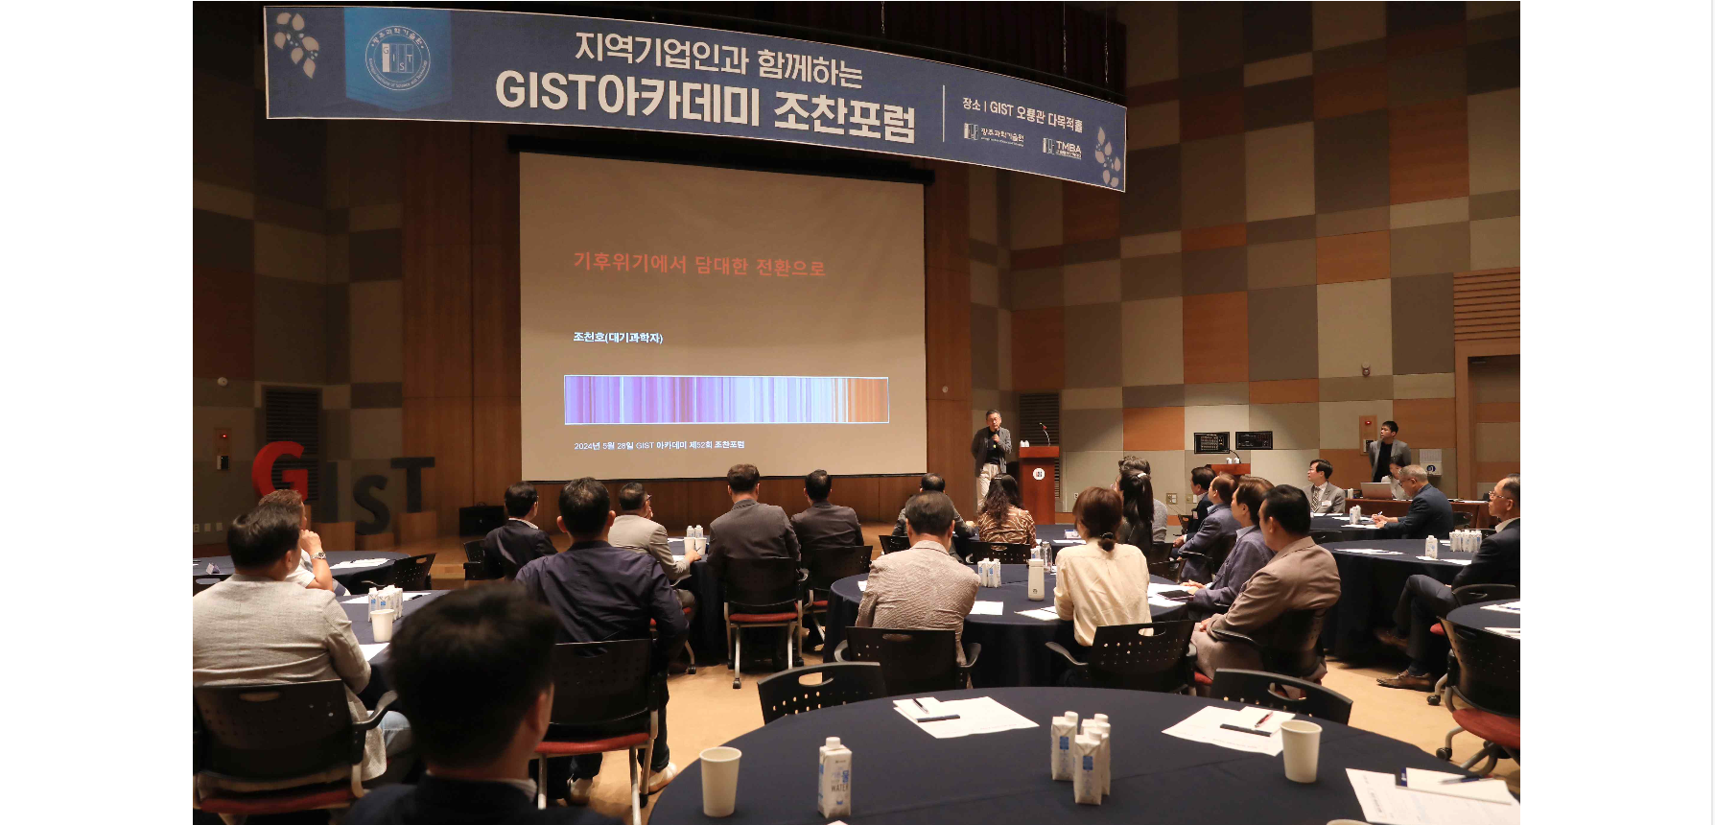▲ On the 28th (Tuesday), the GIST Academy May Breakfast Forum is being held by inviting former Director Cheon-ho Cho of the National Institute of Meteorological Science.

The Gwangju Institute of Science and Technology (GIST, President Lim Ki-cheol) announced that it held its May Breakfast Forum on Oryong Hall on Tuesday, May 28, with about 50 representative business leaders from the Gwangju and Jeonnam regions in attendance, and Cheon-ho Cho, former director of the National Institute of Meteorological Research, who has been researching climate change and the global environmental crisis.

Former Director Cheon-ho Cho, who served as the first director of the National Institute of Meteorological Science after serving as the director of the climate research office and the forecast research office at the National Institute of Meteorological Research, is a climate expert and atmospheric scientist who has worked in the field of meteorology for 30 years. He is also a national and international authority on carbon tracing systems, which were first introduced to the Korean National Meteorological Institute by major countries such as the United States and Japan.

In his talk, “From Climate Crisis to Bold Transition,” former Director Cho said that the climate crisis is no longer a story for future generations but for us now and that we have a golden opportunity to tackle it, and he suggested ways to do so wisely.

Former Director Cho began his lecture by saying, “The Earth has the right to destroy itself,” and emphasized the importance of fossil fuels in the development of human civilization, explained the dangers of fossil fuels, which have changed global temperatures by 1°C in just over a hundred years, and addressed the side effects and risks of continuing to use fossil fuels at a time of climate change transition.

He said, "If we don't act on the climate crisis, the economic crisis will precede the climate crisis. Sustainability should be pursued through technologically feasible and more efficient energy transitions"

Meanwhile, GIST Academy operates the GIST Techno Management Business Academy (GTMBA, opened in 2010) as a non-degree program, and holds 'GIST Academy Breakfast Forum' on the last Tuesday of March, May, June, September, and October for academy alumni and executives of local companies, inviting experts from various fields as lecturers.

In particular, for the balanced development of local industries, an additional GTMBA program will be opened in the eastern region (Yeosu, Suncheon, and Gwangyang) in September, and classes will be held in Suncheon City on topics such as the latest science and technology and global management issues.



