GIST-Gwangju Metropolitan City holds an open seminar in response to the Special Act on Distributed Energy Activation

- Invitation of experts in the field of power and new energy industries... the future brought by distributed energy, exploration of future response methods, etc.

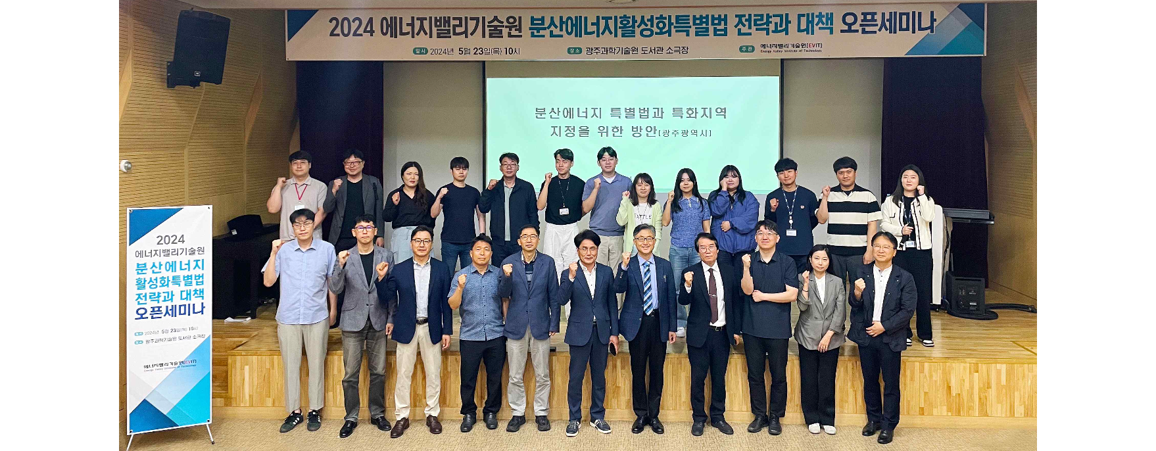▲ GIST Energy Valley Technology Institute, together with Gwangju Metropolitan City, held an energy expert seminar in response to the ‘Special Act on Distributed Energy Activation’ at the GIST Central Library Mini Theater, and attendees are taking commemorative photos.

The Gwangju Institute of Science and Technology (GIST, President Kichul Lim) announced that it successfully held an energy expert seminar to respond to the ‘Special Act on Distributed Energy’ with Gwangju Metropolitan City.

The Energy Valley Technology Institute (Director Kwanghee Lee, Vice President for R&DB) invites experts in the new energy industry to hear technological trends and holds energy expert seminars frequently every year to exchange opinions between local research institutes and energy companies.

About 50 people from Gwangju Metropolitan City, Gwangju Techno Park, Gwangju Research Institute, and related companies attended this seminar held on the 23rd (Thursday) at the mini theater of GIST Central Library. A presentation and Q&A were held on the topic of major issues and countermeasures in the Distributed Energy Special Act (Korea Energy Agency Director Hyeong-joong Kim).

First, Professor Soon-Hyung Lee of Dongshin University explained the main contentious provisions of the Special Act on Distributed Energy and the strategies that Gwangju City should take in the future. Next, Hyeong-Joong Kim, Director of the Korea Energy Agency, explained the background of the policies of the Special Act on Distributed Energy, as well as the outline and main contents of the law. A response plan was presented in accordance with the implementation of the law.

After the seminar, a discussion session was held to explore various business models suitable for decentralizing power supply, which is the purpose of the Distributed Energy Act, and to explore future response methods, confirming the high interest of academia and industry in the field of distributed energy.

Director Kwanghee Lee said, "I hope that this seminar will be an opportunity for many people to think about the Special Act on Distributed Energy Activation, which has recently become a hot issue. In addition, together with Gwangju Metropolitan City, GIST will continue to actively seek ways to cooperate with the region."

Meanwhile, the Energy Valley Technology Institute announced that it plans to hold a seminar for energy experts on Thursday, May 30th under the themes of ‘Industrial Innovation Base Construction Project’ and ‘Battery Reuse Industry’.



