GIST-Finland's Aalto University holds a creative convergence education seminar with the theme of 'Cases of creative convergence talent training based on design thinking'

- On May 30th (Thursday), cases and directions of global talent training, creative problem-solving research and development, and corporate cooperation projects operated by Finland's Aalto University will be discussed at Oryong Hall... Interested citizens can also attend
- GIST Korea Culture Technology Institute plans to strengthen creative convergence education and engineering-centered R&D system... Prior to the seminar, an educational workshop will be held with Alto Design Factory for three days starting from Monday 27th

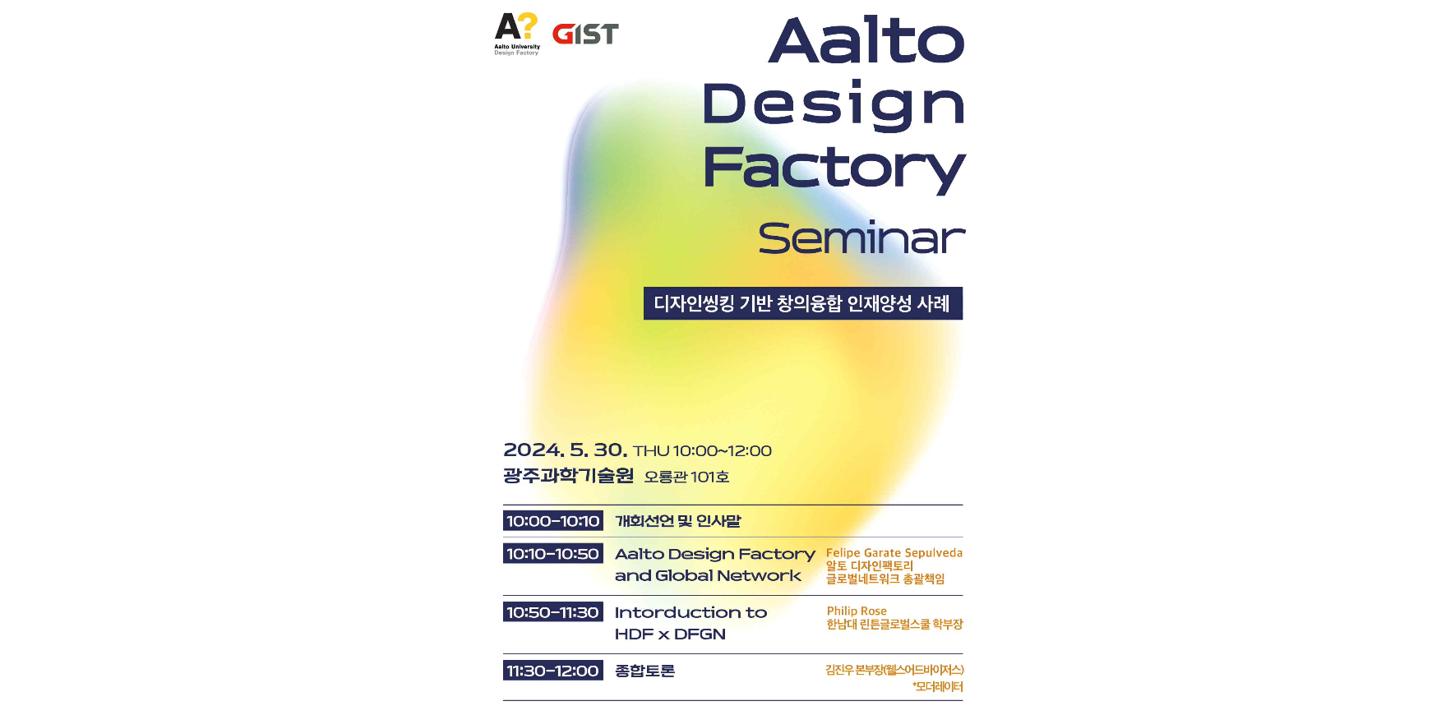▲ Alto Design Factory seminar poster

The Gwangju Institute of Science and Technology (GIST, President Kichul Lim) announced that it will hold the ‘Aalto Design Factory Seminar’ on Thursday, May 30, co-hosted with Aalto University of Finland.

In this seminar, GIST Korea Culture Technology Institute (Director Kyung-Joong Kim) checked the progress and status of the operation of Aalto Design Factory, a creative convergence talent training platform of Finland's Aalto University, and discussed the development direction of both institutions.

The theme of the seminar is ‘Cases of creative convergence talent training based on design thinking’ and will discuss examples and directions of global talent training, creative problem-solving research and development, and corporate cooperation projects operated by Aalto University.

The first speaker will be Felipe Garate, Alto Design Factory's global network general manager, who will present the concept and operation direction of Design Factory and the current status of the global network. Next, Philip Rose, Dean of Linton Global School, Hannam University, a member institution of the ‘Design Factory Global Network’, will present the progress and results of design factory operations in Korea.

The Design Factory Global Network is a collaboration between 39 universities and research institutes in 25 countries around the world that operates a number of product and service R&D projects in cooperation with global companies, and Aalto University provides curriculum mentoring and technology development cooperation to member institutions.

'Design Thinking' is a product service development method that focuses on solving customer problems and uses the sensitivity and creative work process of designers in all stages of product development, including demand research, planning, and marketing.

Alto Design Factory supports people to realize creative ideas and develop problem-solving skills through a design thinking-based product development process. In particular, it is characterized by practical education that goes beyond interdisciplinary barriers and an integrated curriculum of engineering, design, and business administration.

Prior to the seminar, the Korea Culture Technology Institute held an alto session on the topic of 'Design thinking-based product service development teaching method' for 3 days from May 27th to 29th for about 20 researchers and staff from partner organizations who will run related projects in the future.

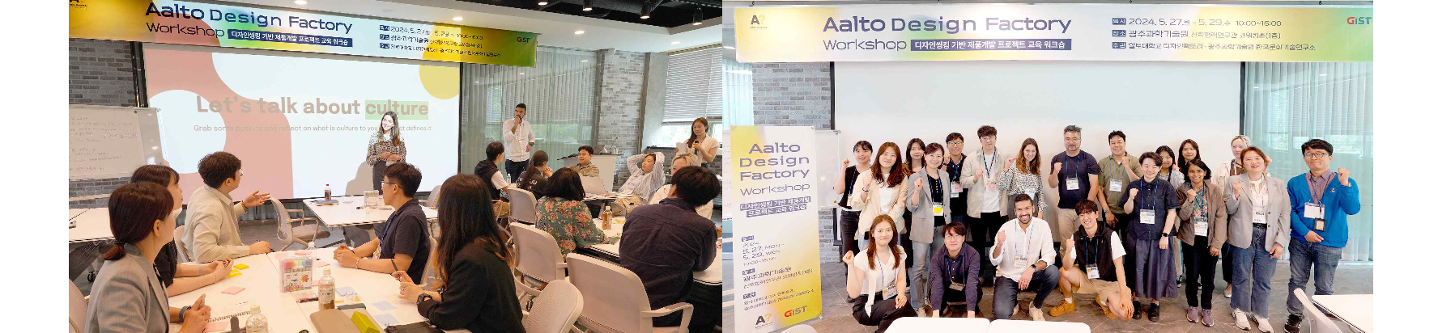▲ At the Alto Design Factory workshop held on Monday, May 27, participants are practicing the design thinking research and development process and taking a group photo.

Attendees learned practical research and development methods such as user research, problem-solving techniques, and user-centered development process through hands-on training with Alto Design Factory instructors.

After this educational workshop, the Korea Culture Technology Institute plans to pursue membership in the ‘Design Factory Global Network’ by making full use of GIST’s educational infrastructure and cultural technology R&D capabilities.

Director Kyung-Joong Kim said, "Recently, global collaborative talent training and research and development are expanding. Through this educational workshop and seminar with Aalto University, we will further strengthen the talent training system that combines the engineering-centered R&D system and creative convergence methodology."

Meanwhile, this seminar will be held in room 101 of GIST's Oryong Hall, and interested citizens can also attend.



