GIST Research Institute for Solar and Sustainable Energies participates in the '2024 Gwangju Science Invention Festival'... Promote the importance of eco-friendly solar energy

- ‘Making an eco-friendly solar car’ experience booth was operated... For two days starting from Saturday, May 18, about 300 citizens, including students and parents, visited the booth, which received a great response

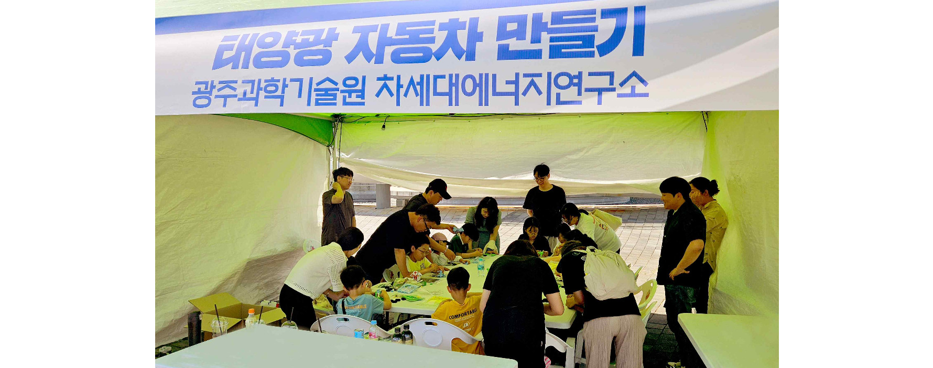▲ ‘Making a solar car’ experience booth operated by GIST Research Institute for Solar and Sustainable Energies at the ‘2024 Gwangju Science and Invention Festival’.

The Gwangju Institute of Science and Technology (GIST, President Kichul Lim) set up an eco-friendly energy experience booth at the '2024 Gwangju Science and Invention Festival' held at the Gwangju National Science Museum from Saturday, May 18 to Sunday, May 19 and concluded the event successfully.

The ‘2024 Gwangju Science and Invention Festival’, hosted by Gwangju Metropolitan City and the Gwangju Science and Culture Association, was designed to allow people to experience various scientific invention programs and, this year, was held under the theme of ‘Energy world through science and invention.’

▲ Citizens, including students and parents, are directly experiencing the process of manufacturing electric vehicles using solar energy.

At this festival, GIST received a great response when the Research Institute for Solar and Sustainable Energies (Director Sanghan Lee) operated an experience booth for ‘Making a solar car’ under the theme of ‘Eco-friendly energy field.’

Over the two days of the event, about 300 students, parents, and other citizens who visited the GIST Research Institute for Solar and Sustainable Energies booth thought about the importance of energy science and technology and its applicability to real life and had time to experience the process of manufacturing an electric vehicle using solar energy.

GIST Research Institute for Solar and Sustainable Energies opened as a Solar Energy Research Institute in 2009 to expand the distribution of solar energy and develop core technologies that will lead industrial growth. In addition to new and renewable energy such as solar power and energy storage technology, the scope of research and development has been expanded to include next-generation core energy technology and energy grid technology.

In particular, it has established and is conducting joint research with Professor Alan Jay Heeger (USA) and Professor Gerhard Ertl (Germany), who have won the Nobel Prize in Chemistry in the field of organic solar cells, fuel cells, and catalysts, by establishing the 'Heeger Center for New Materials Research' and 'Ertl Center for Catalysis Research', respectively. It has also established collaborative relationships with Imperial College London, a world-class university in the UK, and the University of California, Santa Barbara in the U.S., laying the foundation for joint research across borders.

Director Sanghan Lee said, "GIST develops and distributes a variety of science and technology content, including energy technology and eco-friendly technology related to real life, and it plans to continue activities to spread positive awareness of science and technology and form a proper scientific culture."

Meanwhile, GIST is working to expand the base of science and technology education and excellent research results by operating the ‘GIST Science School’ through continuous cooperation with the Gwangju National Science Museum to increase interest and understanding of science and technology among community members and help students grow into future science and technology talents.



