GIST, <THE University Evaluation> A remarkable leap forward 2023 → 2024 Large increase in Asian and emerging university evaluations

- The rankings for 2024 rose significantly compared to the previous year, including from 85th in the world to 40th (up 45th) in the Emerging University Rankings announced by British university evaluation agency THE, and from 94th to 62nd (up 32nd in Asian University Rankings).
- 9th President Kichul Lim's innovation management to strengthen university competitiveness is on track... spurring the implementation of the '30 innovation strategies', including improving the faculty personnel system to increase 'research quality' capabilities in major evaluation areas

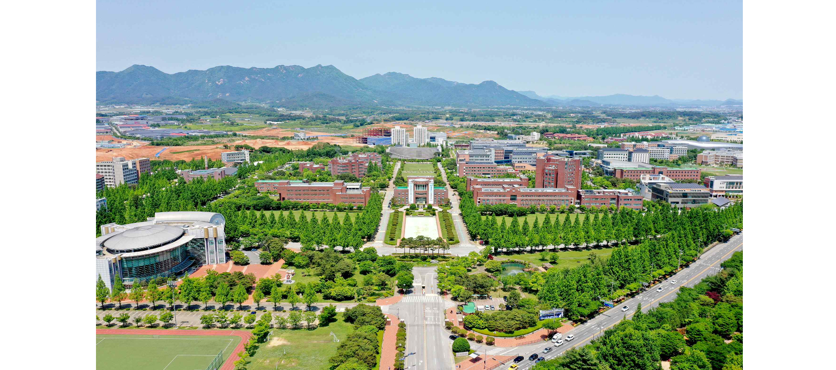▲ Panoramic view of GIST campus

The Gwangju Institute of Science and Technology (GIST, President Kichul Lim) announced on the 16th (Thursday) that it had made a notable leap forward in the 2024 major university evaluations announced this month by British university evaluation agency THE (Times Higher Education).

The 9th President Kichul Lim, who took office in July of last year, based on the spirit of ‘innovation, if there is no way, we create it’ ▴ Potential-Up ▴ Cultivating the spirit of community (Harmony-Up) ▴ This is also the time when GIST’s innovation management, which has been promoted for the past 300 days by presenting three major strategies (3-Ups), including GIST Value-Up, is on track.

GIST rose rapidly by 45 ranks from 85th in the world in 2023 to 40th in 2024 in ‘THE Young University Rankings’, an evaluation conducted on emerging universities within 50 years of opening. THE announced the 2024 emerging university rankings on the 14th (local time), and GIST's increase is the highest among domestic universities.

In addition, in ‘THE Asia University Rankings’ announced on April 30, local time, GIST ranked 62nd in 2024, jumping 32 places compared to the previous year’s ranking (94th).

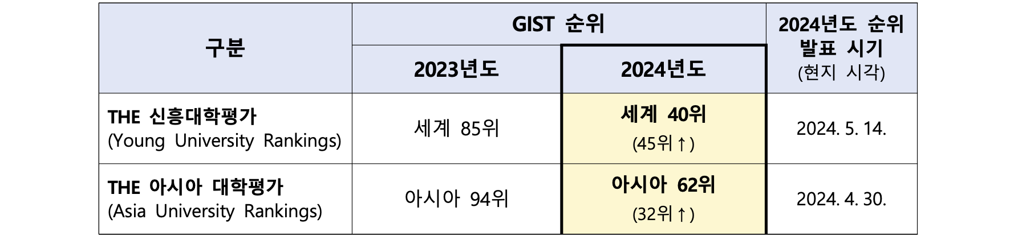▲ 2023, 2024 THE University Evaluation Rankings (GIST)

In order to strengthen the university's competitiveness, GIST formed the 'Administrative Innovation Committee (Chairman Sang-Don Kim, Vice President for Academic Affairs)' in the second half of last year to develop a total of 30 innovation strategies in three categories, including ▴ Proud GISTian TF ▴ Happy GISTian TF ▴ Hopeful GISTian TF.

In particular, in order to increase capabilities in the ‘Research Quality’ sector, which is evaluated as an important factor in world university evaluations, GIST is promoting the improvement of the faculty personnel system that focuses on evaluating the qualitative excellence of papers.

Planning Dean Hisam Kim said, "GIST, which has established itself as a ‘small but very strong’ research-oriented university through convergence and internationalization strategies, is taking a new leap forward starting last year when it celebrated its 30th anniversary. In the future, we will increase our external status, expand the development fund, and conduct personnel and evaluation activities. We will do our best to achieve world-class competitiveness as a science and technology specialized university by improving the welfare system and promoting harmony among internal members."



