Korea Alps Co., Ltd. sponsors the 1st GIST Science Imagination Children’s Art Contest

- Korea Alps Co., Ltd., a representative foreign investment company located in Gwangju Metropolitan City, jointly sponsors a children's art contest hosted by GIST along with the GIST Development Foundation and the Gwangju Metropolitan Office of Education... “I thought of it as an opportunity to repay the love of local residents.”
- Registration closed for 200 students on a first-come, first-served basis, including 50 kindergarten students... Received a positive response for a cultural event targeting science dreamers

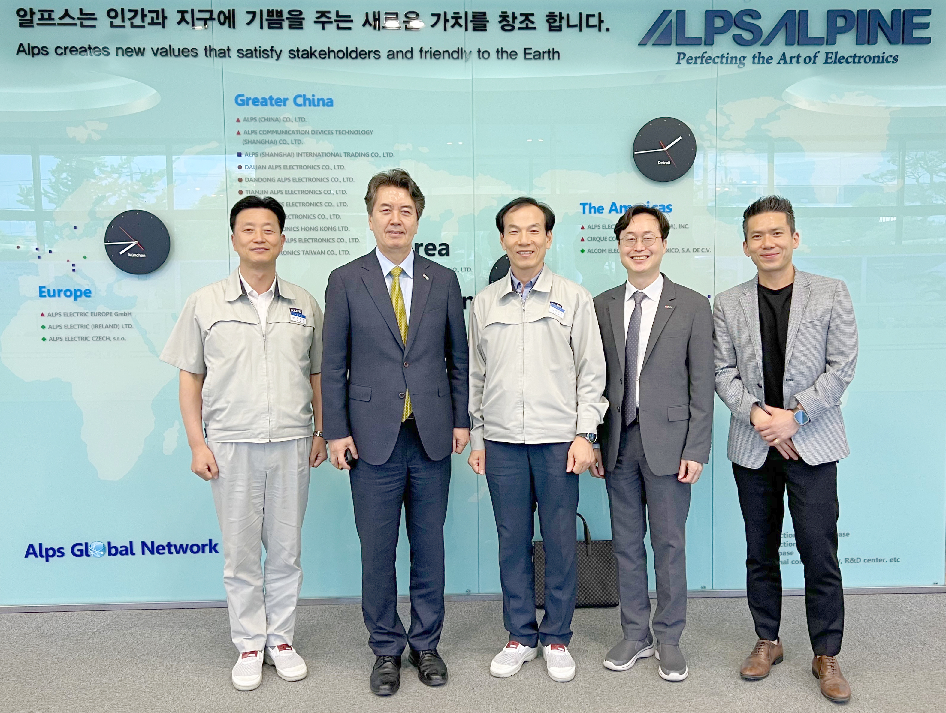▲ Korea Alps Co., Ltd. has decided to participate as a joint sponsor in the ‘1st GIST Science Imagination Children’s Art Contest’. (From left) Yong-hyeon Park, managing director of Korea Alps Co., Ltd., Vice President for External Affairs Yonghwa Chung, Korea Alps Co., Ltd. CEO Gyu-nam Kim, GIST International and Public Affairs Dean Jae Gwan Kim, and GIST Development Fund Team Leader Seung-jae Lee visited Korea Alps Co., Ltd. and took a commemorative photo.

The Gwangju Institute of Science and Technology (GIST, President Kichul Lim) announced on the 14th (Tuesday) that Korea Alps Co., Ltd. (CEO Gyu-nam Kim) has stepped forward as a joint sponsor of the ‘1st GIST Science Imagination Children’s Art Contest’.

The ‘1st GIST Science Imagination Children’s Art Contest’, which will be held on the 18th (Saturday) from 10 am to 1 pm at the GIST Oryong Hall and surrounding area, will be held in ‘Toward the future with the region’ by adding ‘sharing’ to science and technology. This is the first art contest for children held by GIST, which has established a new vision for external cooperation and is sponsored by the GIST Development Foundation and the Gwangju Metropolitan Office of Education along with Korea Alps Co., Ltd.

Founded in 1987, Korea Alps Co., Ltd. is a company 100% invested by the Japanese global company Alps Alpine Co., Ltd., which manufactures and produces electronic components such as automotive electronics and communication-related parts and components.

They have partnerships with major global customers such as Hyundai Motors, Kia, Samsung Electronics, LG Electronics, Volvo, and BMW and is a representative foreign-invested company in Gwangju Metropolitan City that has contributed to regional development and growth to the extent that it is called a domestic multinational company.

Gyu-nam Kim, CEO of Korea Alps Co., Ltd., said, "AlpsAlpine has grown under the philosophy of creating new values that bring joy to humanity and the earth. I decided to sponsor this GIST Science Imagination Children's Art Contest because I thought it was an opportunity to repay the love shown to me by local residents."

GIST decided to use the donation from Korea Alps to purchase prizes such as tablet PCs and smart watches to be awarded to art contest winners.

GIST Vice President for External Affairs Yonghwa Chung said, "We are happy to be able to practice sharing with Korea Alps Co., Ltd. by inviting future science dreamers to the GIST campus. We ask for the support and encouragement of local residents for GIST and Korea Alps Co., Ltd. so that they can focus more on regional development in the future."

Meanwhile, the 1st GIST Science Imagination Children’s Art Contest has been well received as a cultural event for children hosted by GIST, with the first 200 applications (50 for kindergarten, 100 for lower elementary school, and 50 for upper elementary school) closed on May 10 (Friday).



