“Being calm in the face of death is...” Artist Hee-won Han’s invitation exhibition ‘Birth, From Being’ held at GIST Oryong Art Hall

- GIST Oryong Art Hall, the 3rd invitation exhibition in 2024, will exhibit approximately 20 works by Hee-won Han, a leading artist in Gwangju... from May 1 (Wed) to June 28 (Fri)

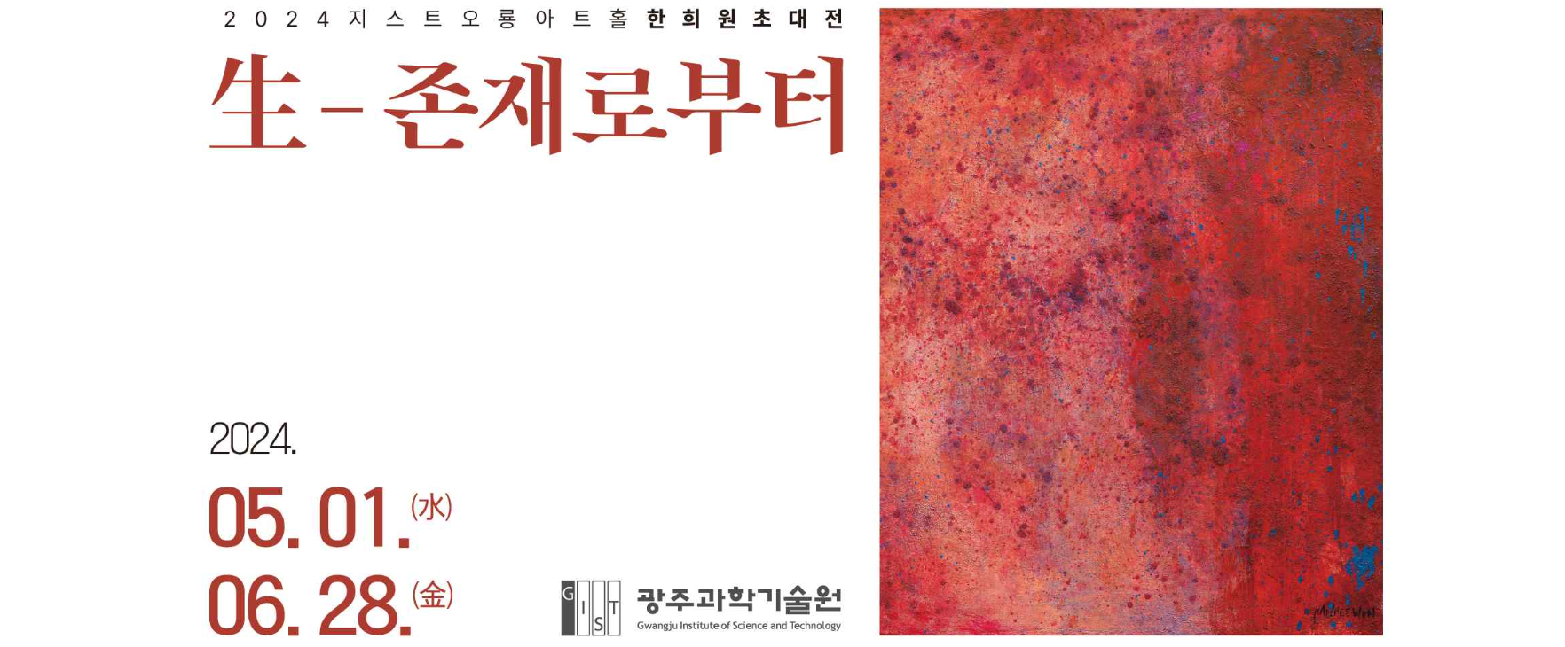▲ 2024 Oryong Art Hall 3rd exhibition ‘Birth, From Being’ poster

‘In order for philosophy and art, which discuss and express death and life, to not be trampled in real life and become mere ideas, it seems that we need to be desperate to look at and meet ourselves endlessly. (omitted) Staring at it without avoiding it, and being able to be calm in the face of death, may be the answer given by a time like this.’
- From the author's notes

The invitation exhibition ‘Birth, From Being’ by Han Hee-won, a leading painter representing the region who pursues a style of aesthetic thinking, will be held at the Oryong Art Hall of the Gwangju Institute of Science and Technology (GIST, President Kichul Lim) from May 1 to June 28.

This exhibition is the third invitational exhibition held at the Oryong Art Hall this year, and about 20 works that depict the topic of death and life presented by artist Hee-won Han with the artist's unique thick texture are displayed.

In particular, in works such as ‘From Being’, ‘Fragments of Life and Memory’, and ‘Abstraction of Being’, one can feel the fundamental existence of humans and the essence of life, which is also the theme of this exhibition.

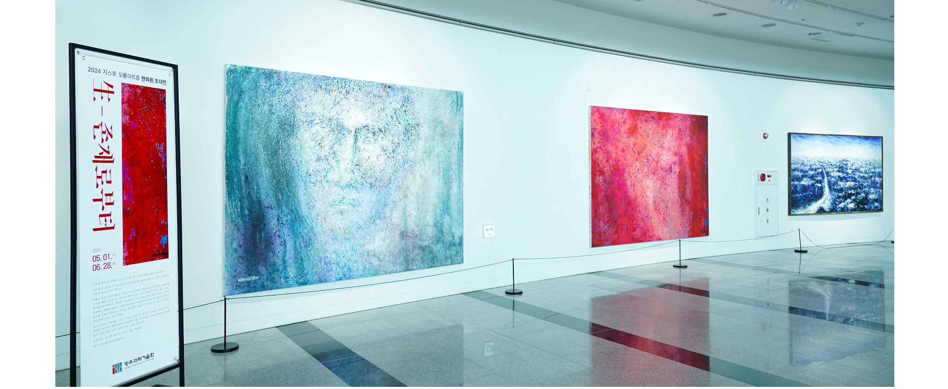▲ Panoramic view of Oryong Art Hall, where the 3rd exhibition ‘Birth, From Being’ in 2024 is taking place.

Artist Hee-won Han is a representative artist in Gwangju who debuted in the art world through folk art in the 1970s and has firmly established his own painting style for about 46 years. Since 1990, he has mainly done work that reveals inner lyricism and the inner self of humans, but since the 2020s, he has mainly focused on the relationship between social reality and art, and the relationship between literary poetry and pictorial expression, by emphasizing the expression of strong touch and thick texture. He presented works that expressed and explored the relationship between literary poetry and pictorial expression.

He is an artist who graduated from the Department of Art Education at Chosun University won the Jeonnam Theater Festival Stage Art Award and won the Daedong Art Award, the Wonjin Art Award Special Award, and the Gwangju Citizens' Grand Prize in the culture and arts section, and held about 70 solo exhibitions. His books include ‘Drawings of a Stranger (Korea Books, 2020)’.

Artist Hee-won Han said, "Art should not remain as an idea, separate from life, but should work together with the world and breathe together. In order to do that, you need to be desperate to look at yourself endlessly and meet yourself."

In addition, he said, "I hope that those who visit Oryong Art Hall will also find this exhibition a time to look within themselves and constantly meet themselves."

Artist Soon-im Choi, who serves as director of Oryong Art Hall, said, "Author Hee-won Han captured the fundamental questions about the universe, nature, and human beings by focusing on birth and death, love and memory, rest and pain. I hope that those who visit Oryong Hall will also have time for philosophical reflection in the passionate work of artist Hee-won Han."

The ‘Birth, From Being’ exhibition, which will be held at the GIST Oryong Art Hall until June 28, can be viewed by anyone interested from 9 a.m. to 6 p.m. on weekdays. (Inquiries about opening on weekends/T.062-715-2628)

Meanwhile, Oryong Art Hall is an exhibition space created on the inner wall of the 1st and 2nd floors of Oryong Hall, a multi-purpose building for events, meetings, lectures, seminars, etc., to provide a venue for strengthening exchanges and cooperation with the local community by GIST, which has grown due to the interest of local residents. Starting with the first invitational exhibition in December 2022, GIST is practicing the value of sharing as an ‘open cultural and artistic space’ through a total of 9 exhibitions, including this ‘From Life, From Existence’ exhibition.



