GIST appoints two representatives of legal and accounting firms as citizen integrity auditors... Accelerating efforts to improve integrity

- Discovery of unreasonable systems, practices, and work procedures in areas where integrity is weak in relation to compliance with integrity obligations... Improvement activities in areas where integrity is weak, such as improving integrity and recommending corrections, are expected
- Increasing active participation of management, such as the president serving as the chairman of the Special Committee on Integrity Improvement, and all members working to improve integrity and spread the right awareness of integrity

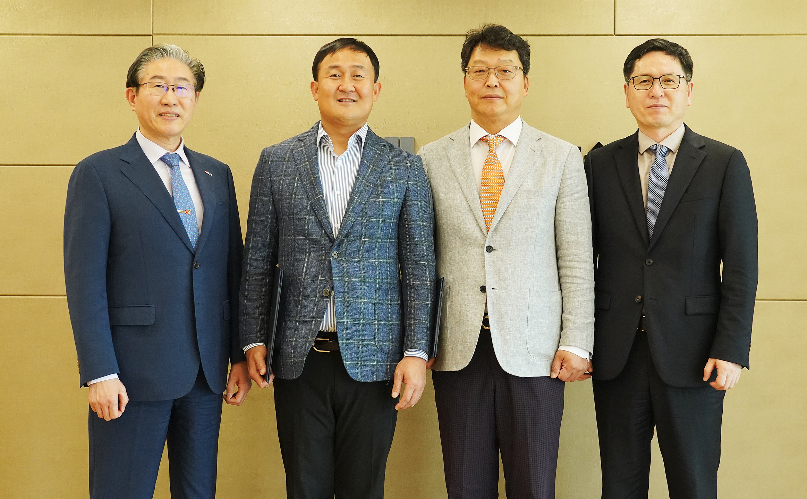▲ (From the left) President Kichul Lim, Yangji Accounting Firm’s representative accountant Hyo-seok Park, Ilsam Law Firm’s representative attorney Jae-hoon Shim, and Vice President for Academic Affairs Sang-Don Kim

The Gwangju Institute of Science and Technology (GIST, President Kichul Lim) announced that it has newly appointed two experts in accounting and law as integrity citizen auditors in order to improve the institution's integrity and become a model institution with integrity and a trusted school.

Newly appointed as GIST integrity citizen auditors this year are Jae-Hoon Shim, CEO of Ilsam Law Firm, and Hyo-seok Park, CEO of Yangji Accounting Firm, who have extensive knowledge and experience in science, technology, education, etc., and are experts who can point out and discover corruption factors. They will perform tasks such as monitoring and evaluating the work and projects performed and suggesting improvements and corrections of unreasonable systems and practices for one year.

The appointment ceremony was held on Monday, April 29, in the president's office on the 5th floor of the administrative building with five people in attendance, including President Kichul Lim, Vice President for Academic Affairs Sang-Don Kim, attorney Jae-hoon Shim of Ilsam Law Firm, accountant Hyo-seok Park of Yangji Accounting Firm, and Kiwook Seong, general affairs team leader of the Ministry of Public Administration and Security.

With the goal of achieving a comprehensive integrity level of 3 or higher, GIST has expanded the active participation of management starting this year, with the president directly serving as chair of the Special Committee on Integrity Improvement. By appointing external experts as integrity citizen auditors every year, GIST plans to promote improvements in unreasonable systems or operational conditions in areas where integrity is weak among the work or projects performed by the organization.

The Citizen Integrity Auditor may recommend corrections or request an audit of corruption activities found through monitoring and evaluation of integrity vulnerable areas for the work or business conducted by GIST, and may recommend or express opinions to the President if it is deemed necessary to improve unreasonable systems, practices, business procedures or operations in this regard.

President Kichul Lim said, "In order to improve integrity and spread awareness of integrity, we are providing training to improve awareness among all members. Efforts are needed from all members to improve integrity, such as by establishing an integrity citizen auditor."

Meanwhile, after the Citizen Integrity Auditor Appointment Ceremony, GIST plans to regularly hold joint meetings of Citizen Integrity Auditor and Integrity Advisory Group to revitalize the integrity exchange network and strengthen advisory activities. In addition, GIST is preparing for the Special Committee on Integrity Improvement in May to improve overall integrity.



