“This weekend, my family has made a reservation for a science experience.” ‘Self-driving undersea exploration’ and ‘real-time AI voice dubbing’ at the GIST booth at the 2024 Korea Science Festival!

- GIST participates in the ‘2024 Korea Science Festival’, the largest science event in Korea... Co-hosted by the Ministry of Science and ICT and Daejeon City, it will be held for 4 days from the 25th (Thursday)
- Operate an exhibition booth to display excellent research results in the fields of cutting-edge mobility (Professor SeungJun Kim) and audio AI (Professor Hong Kook Kim) to communicate with visitors

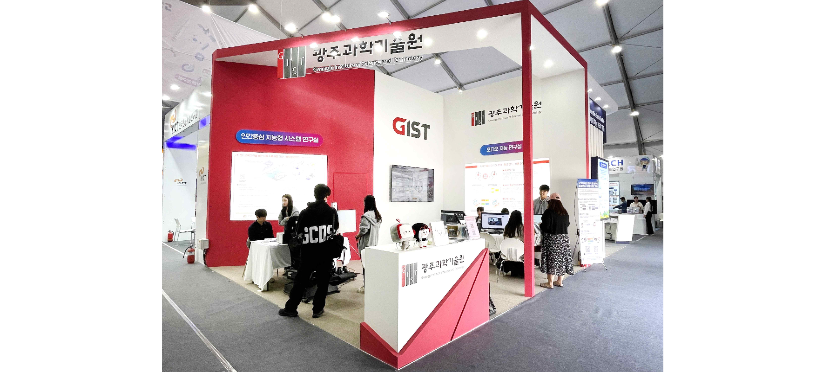▲ GIST set up a booth in the 'Science Museum' part of the '2024 Korea Science Festival', and is exhibiting ▴'Autonomous Vehicle Multisensory Immersive Content' created by the 'Human-centered Intelligent System Lab (Professor SeungJun Kim)' and ▴'Speech Recognition and Automatic Translation/Speech Modulation/Auto-Dubbing Technology Content' developed by the 'Audio Intelligence Lab (Professor Hong Kook Kim)'.

The Gwangju Institute of Science and Technology (GIST, President Kichul Lim) will participate in the ‘2024 University Science Festival’ and showcase excellent research results in the fields of advanced mobility and audio artificial intelligence (AI).

The ‘Korea Science Festival’, which celebrated its 28th anniversary this year, is Korea’s largest science event held annually since 1997. People can enjoy a richer program at the ‘Korea Science Festival’, which focuses on experiencing science, technology and culture, and the ‘Korea Science and Technology Exhibition’, which focuses on exhibitions of national strategic technology research results.

GIST set up a booth in the 'Science Museum' section, an exhibition space for the latest R&D research results, including the 12 national strategic technologies, and presented the ▴'self-driving vehicle' created by the 'Human-Centered Intelligent Systems Lab' (advisor: Professor SeungJun Kim of the Institute of Integrated Technology). Visitors can directly experience ▴'speech recognition and automatic translation/voice modulation/automatic dubbing technology content using artificial intelligence' developed in the 'Sensory Immersive Content' and 'Audio Intelligence Lab' (advisor: Professor Hong Kook Kim of the School of Electrical Engineering and Computer Science).

▴ At the ‘Autonomous Vehicle Multi-Sensory Immersive Content’ booth, visual and auditory information is provided through virtual reality (VR). By providing a multi-sensory system, including haptic sensations through electrical stimulation, people can experience more vivid and realistic autonomous driving in an undersea virtual environment.

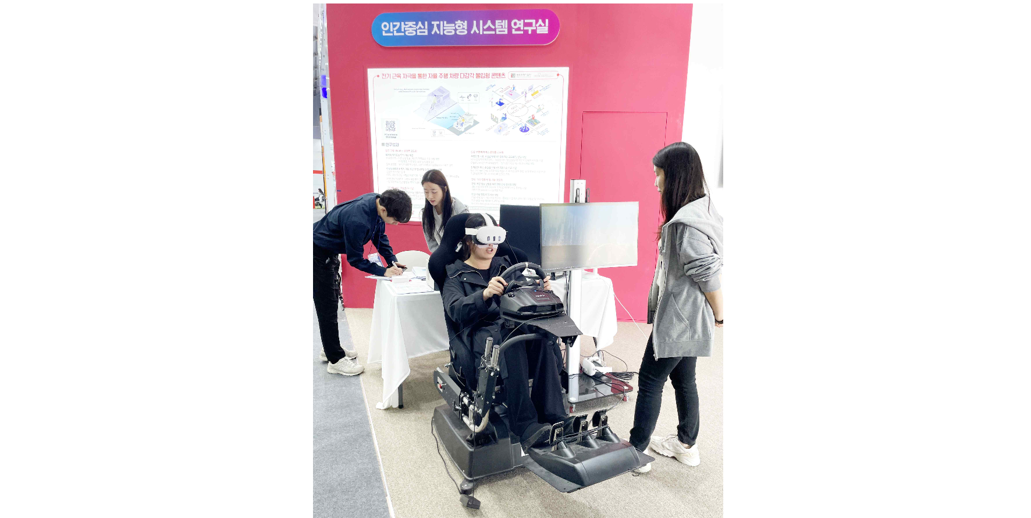▲ Visitors are experiencing the ‘autonomous vehicle multi-sensory immersive content’ exhibition booth created by the ‘Human-Centered Intelligent Systems Lab (Professor SeungJun Kim)’.

▴ In the ‘Voice recognition and automatic translation/voice modulation/automatic dubbing technology contents using artificial intelligence’ booth, familiar dramas and YouTube contents are played in the visitors’ own voices. It provides an interesting experience using artificial intelligence through a program that automatically translates words in Korean into English.

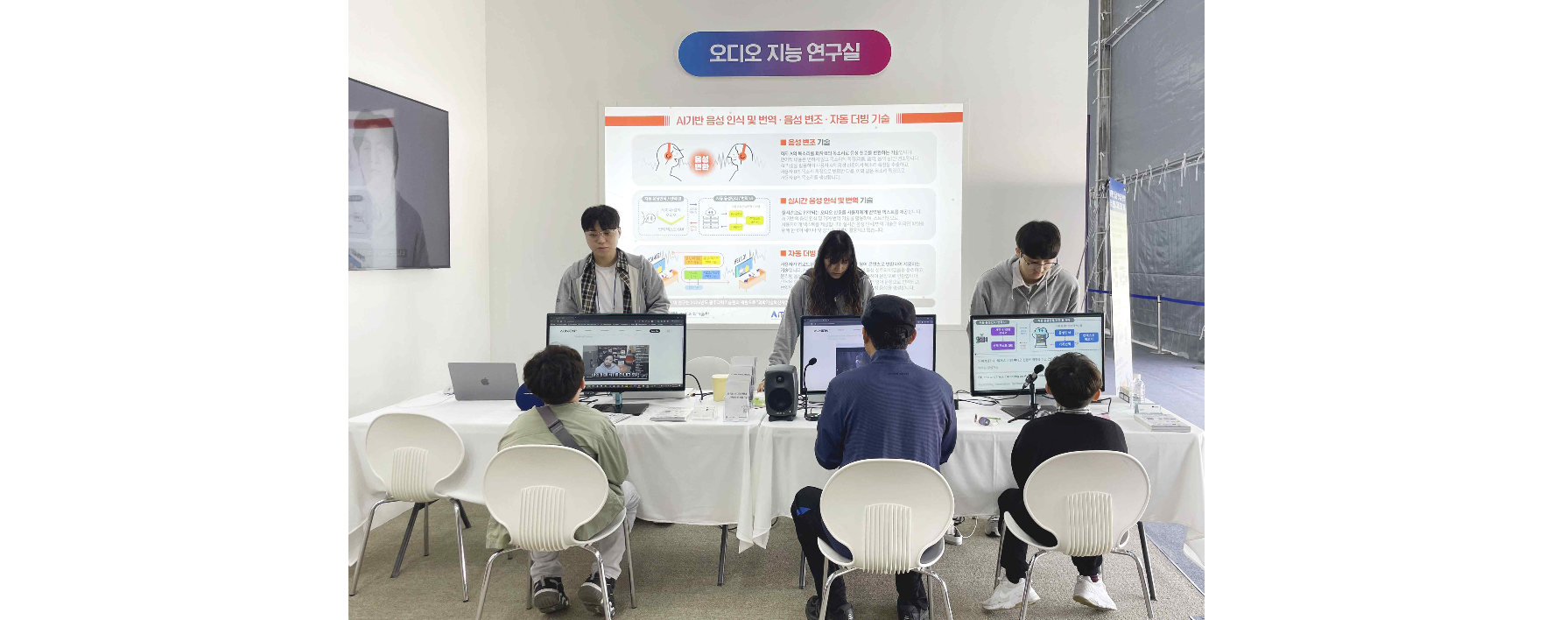▲ Visitors are experiencing the ‘Voice recognition and automatic translation/voice modulation/automatic dubbing technology content using artificial intelligence’ exhibition booth developed by the ‘Audio Intelligence Lab (Professor Hong Kook Kim)’.

In particular, at the opening ceremony on the 25th (Thursday), the winner of '2023 Korea Science Festival Fame-Rap Season 1' and rapper 'Flunder (real name Dong-woo Kim)', who is currently enrolled in the bachelor's program in the DepartmSchool of Electrical Engineering and Computer Science at GIST, will present a congratulatory performance.

President Kichul Lim said, "In Daejeon, the city of science, an opportunity was created to publicize GIST's excellent research results in the cutting-edge mobility and AI fields and to communicate more closely with the public by presenting content that visitors can directly experience. GIST will continue to do its best to contribute to the development of national science and technology through excellent research results and technology development that enable more people to feel and experience science in their daily lives."

Meanwhile, the '2024 Korea Science Festival' is hosted by the Ministry of Science and ICT and Daejeon Metropolitan City and co-hosted by the National Research Foundation of Korea, Korea Foundation for the Advancement of Science and Creativity, and Daejeon Tourism Organization, and will be held from April 25th (Thursday) to 28th (Sunday) at the Daejeon Expo Citizen Square and Expo Science Park.

This year, the slogan was ‘The World’s Largest Laboratory’, meaning that the moment people look at the world with curiosity, they all become inquiring scientists and their daily lives are closely related to science.

