GIST appoints four energy experts as adjunct professors at the Research Institute for Solar and Sustainable Energies

- Four experts in the energy field from local research institutes were appointed as adjunct professors... Expected to promote joint research, discover leading research tasks, and provide vivid field experience education
- It is also the beginning of closer cooperation between GIST and local research institutes... It will become a cornerstone of contribution fot industrial development in the Gwangju region

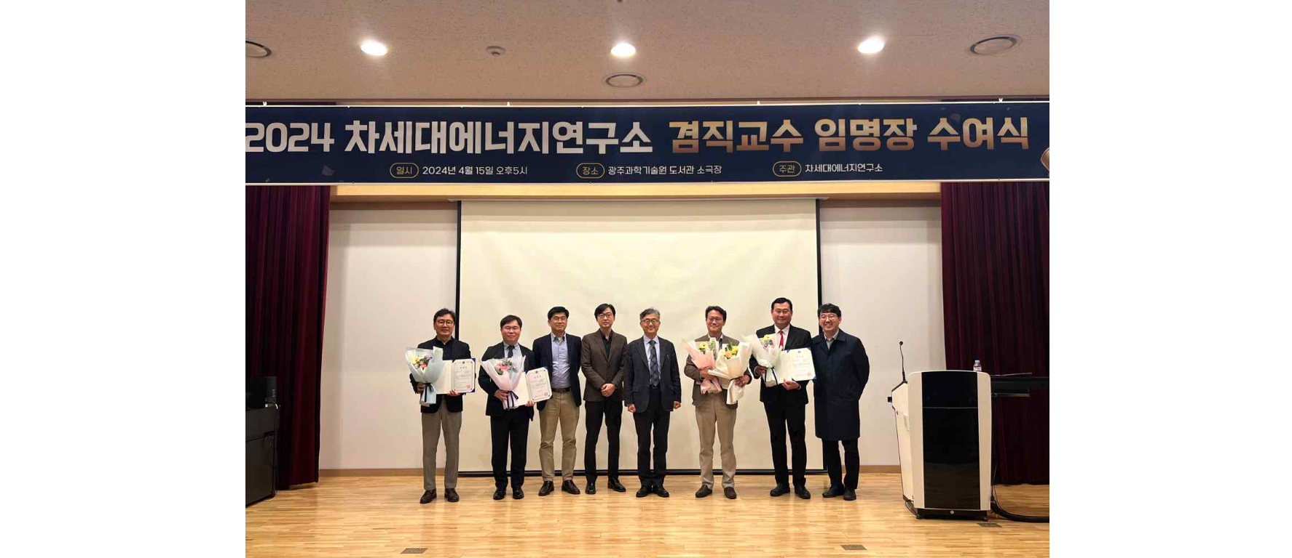▲ GIST Research Institute for Solar and Sustainable Energies is holding an adjunct professor appointment ceremony and taking a commemorative photo. (From left) Korea Institute of Industrial Technology Senior Researcher Tae-won Kim, Korea Institute of Energy Research Director Jung-jae Woo, Korea Institute of Industrial Technology Director Hyeon-rok Cha, GIST Research Institute for Solar and Sustainable Energies Director Sanghan Lee, GIST Vice President for R&DB Kwanghee Lee, Korea Automobile Research Institute Center Director Hyeon-cheol Lee, Green Energy Research Institute Director Seung-heon Song, GIST Next Generation Energy Research Center Senior Researcher Hongkyu Kang

TThe Gwangju Institute of Science and Technology (GIST, President Kichul Lim) announced that it had appointed four energy experts as adjunct professors at the Research Institute for Solar and Sustainable Energies (Director Sanghan Lee).

GIST held an adjunct professor appointment ceremony for ▴ Korea Institute of Industrial Technology Senior Researcher Tae-won Kim ▴ Green Energy Research Institute Director Seung-heon Song ▴ Korea Institute of Energy Research Director Jung-jae Woo and ▴ Korea Automobile Research Institute Center Director Hyeon-cheol Lee on April 15 (Mon), which was attended by GIST Vice President for R&DB Kwanghee Lee, Research Institute for Solar and Sustainable Energies Director Sanghan Lee, and Korea Institute of Industrial Technology Director Hyeon-rok Cha.

The newly appointed adjunct professors are currently conducting a lecture on ‘Next-generation energy technology for carbon neutrality and RE100 realization.’

GIST Vice President for R&DB Kwanghee Lee said, "The appointment of these adjunct professor at the Research Institute for Solar and Sustainable Energies is also significant in that it will deliver vivid field experience to GIST students while promoting joint research and discovering leading research projects through cooperation with each regional research institute."

He also said, "I believe that the professors will play a significant role in improving the quality of research and education at GIST."

Director Sanghan Lee said, "We expect that experts who have achieved various achievements and demonstrated leadership in the energy field will now provide great inspiration and help to GIST students. This appointment as an adjunct professor is the beginning of closer cooperation between GIST and local research institutes and will further serve as a cornerstone for contributing to the industrial development of the Gwangju region."

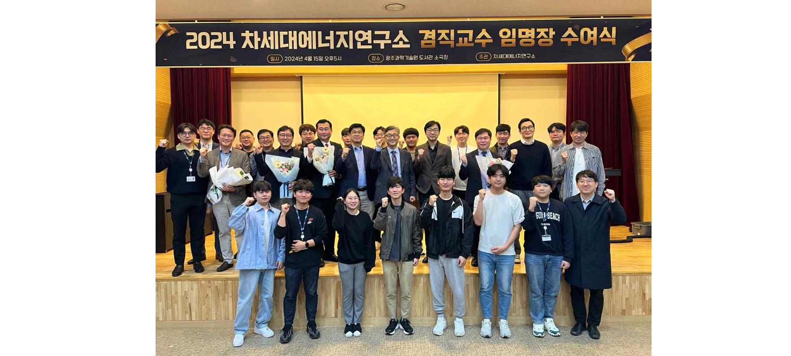▲ GIST Research Institute for Solar and Sustainable Energies held an adjunct professor appointment ceremony and attendees took a commemorative photo.

Meanwhile, the Research Institute for Solar and Sustainable Energies conducts cutting-edge research on new and renewable energy, such as next-generation solar cells, while establishing a joint utilization system for energy-related research resources and promoting technology development and commercialization through industry-academia-research cooperative research.



