GIST begins full-fledged push to attract ‘Korean-style extreme aging research cluster’ to Gwangju Metropolitan City

- GIST Senior-Friendly Industry Support Center holds ‘Korean-style extreme aging research cluster construction project planning seminar’
- Establishing a strategy to attract an extreme aging cluster to Gwangju Metropolitan City

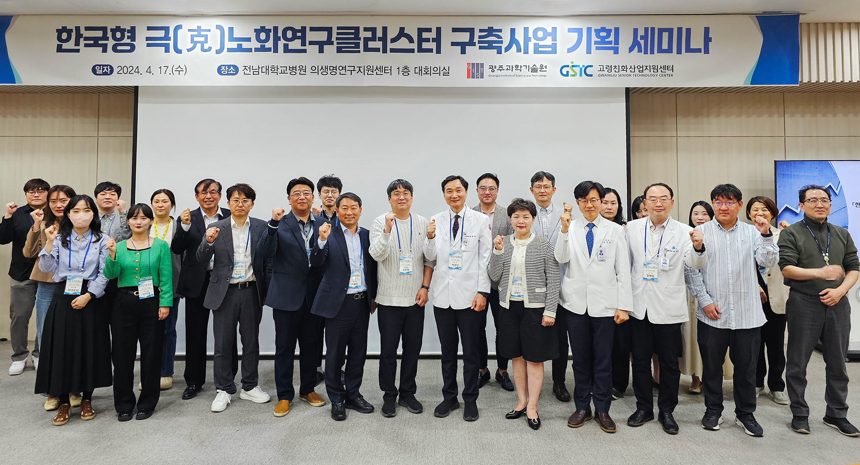▲ GIST Senior-Friendly Industry Support Center held a planning seminar for the Korean-style extreme aging research cluster construction project and attendees took commemorative photos.

The Gwangju Institute of Science and Technology (GIST, President Kichul Lim) and the Senior-Friendly Industry Support Center (Center Director Chang-Myung Oh) announced on the 22nd (Monday) that they have successfully concluded an industry-academia-research-industry cooperation seminar to attract a Korean-style extreme aging research cluster to the Gwangju area.

The seminar for planning the ‘Korean Extreme Aging Research Cluster Construction Project’ was held in the conference room on the first floor of the Biomedical Research Support Center of Jeonnam University Hospital on the 17th (Wednesday).

The seminar was designed to establish a strategy for attracting a future extreme aging cluster to the Gwangju region by sharing the current status of anti-aging and reverse aging research among innovative organizations and related groups, focusing on extreme aging research and medical industry trends, which are key to the region's future growth.

On this day, GIST Senior-Friendly Industry Support Center Director Chang-Myung Oh, Chonnam National University Hospital Professor Gwang-seong Park (Aging Science Research Institute Director), and Gwangju Metropolitan City Robot Home Appliance Medical Industry Department Team Leader Yong-beom Park introduced the current status of planning and implementation. Jae-il Park, senior researcher at the Korea Basic Science Institute (KBSI), and Woo-jin Park, director of Gwangju Techno Park Medihealth Care Center, participated as presenters.

Center Director Chang-Myung Oh introduced the Senior-Friendly Industry Support Center and announced the current status of the Korean Extreme Aging Research Cluster project plan and future plans. Korea Basic Science Institute (KBSI) senior researcher Jae-il Park and Gwangju Techno Park Medi Healthcare Center director Woo-jin Park respectively introduced ▴ Korea Institute for Basic Science (KBSI) and research promotion cases related to extreme aging, and ▴ Promotion of Gwangju medical industry according to aging-related industry trends and prospects.

Center Director Chang-Myung Oh said, "Based on the data presented at this seminar and reflecting expert opinions, we plan to complete a planning report on ‘Establishing a Korean-style Extreme Aging Research Cluster’, which is currently being promoted by the Senior-Friendly Industry Support Center. By successfully attracting this cluster to Gwangju, we will lead the construction of the region's future industrial base by revitalizing medical, healthcare, and senior-friendly industries."

Meanwhile, the GIST Senior-Friendly Industry Support Center has established a long-term cohort of clinical information, digital information, and medical my data for the elderly, and is carrying out planning tasks to create a cluster, such as providing extreme aging technology R&D and commercialization services based on this, in the Gwangju Techno Park area with support from a new government-funded project for future growth. (Project name: Korean-style extreme aging research cluster construction project, Project period: 2024.03.01~2024.04.30)



