GIST-Vietnam Academy of Science and Technology (VAST) is actively pursuing research cooperation in the field of laser and optical technology with major research institutes

- GIST Advanced Photonics Research Institute is expected to lead international cooperation in the field of laser and photonics in ASEAN countries by signing an MOU with the Institute of Materials Science (IMS) following the Institute of Physics (IOP) under VAST
- Plans to continue to expand basic and applied technology research cooperation in the laser and photonics field with major research institutes in Vietnam and ASEAN

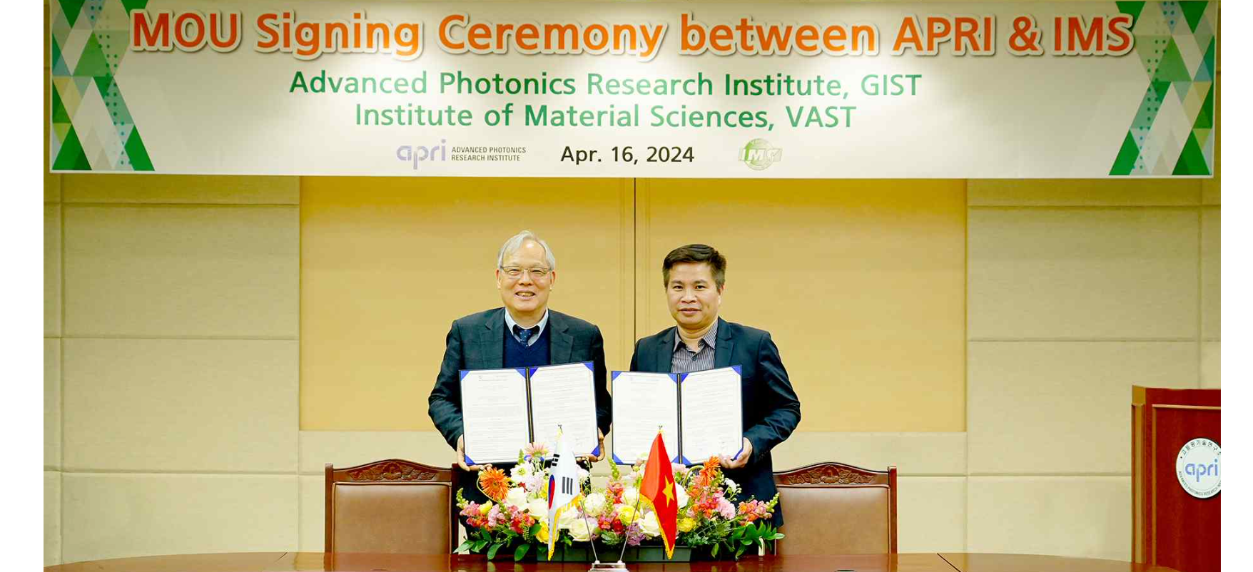▲ GIST Advanced Photonics Research Institute and the Institute of Materials Science (IMS) under the Vietnam Academy of Science and Technology (VAST) signed an MOU for research cooperation in the field of laser and optical technology on the 16th (Tuesday) and are taking a commemorative photo. (From left) GIST Advanced Photonics Research Institute Director Do-Kyeong Ko and Tran Quoc Tien, Deputy Director of the Vietnam Institute of Materials Science (IMS)

The Gwangju Institute of Science and Technology (GIST, President Kichul Lim) announced today (Thursday, April 18) that the Advanced Photonics Research Institute (APRI) and major research institutes under the Vietnam Advanced Institute of Science and Technology (VAST), including the Institute of Physics (IOP), Institute of Material Sciences (IMS), and University of Science and Technology of Hanoi (USTH), have signed an MOU for research cooperation in the field of laser and optical technology, and held a workshop to discuss ways to collaborate in joint research areas.

* Vietnam Academy of Science and Technology: Established in 1975, it is Vietnam's largest national research institute and a national science and technology policy research advisory organization directly under the Prime Minister. It has approximately 3,500 researchers in over 30 affiliated research institutes and educational institutions.

At the signing ceremony between GIST and the Institute of Materials Science (IMS) held at GIST on Tuesday (16th), GIST Director Do-Kyeong Ko, Institute of Physics (IOP) Director Dinh Van Trung, Institute of Materials Science and Technology (IMS) Deputy Director Tran Quoc Tien, University of Science and Technology Hanoi (USTH) Professor Ngo Quang Minh, and about 10 other officials attended to discuss ▴ joint research in areas of mutual interest ▴ and cooperation in research manpower exchange.

In addition, at the workshop held on the 17th (Wednesday), research areas being promoted by each institution in both countries were shared, and discussions were held to promote specific joint research.

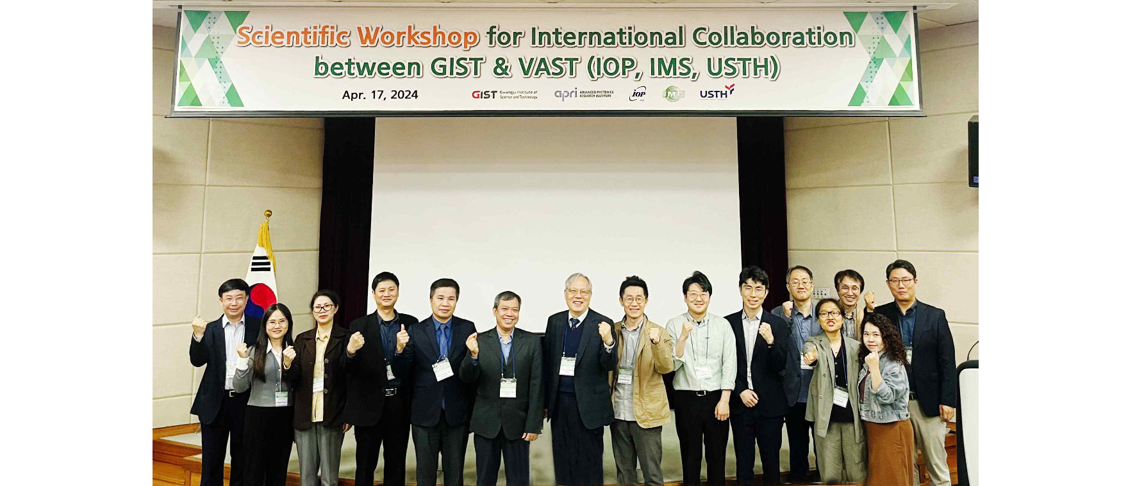▲ GIST Advanced Photonics Research Institute and three institutions (IOP, IMS, USTH) under the Vietnam Academy of Science and Technology (VAST) held a workshop for international joint research cooperation in the field of laser, optical technology and materials on the 17th (Wednesday), and attendees celebrated the event and took a commemorative photo.

Recognizing the need for international joint research with the Vietnam Institute of Physics (IOP), the Advanced Photonics Research Institute has been building trust through continuous exchanges, signing MOUs, and publishing joint research papers since 2017 and are expanding international joint research cooperation with major research institutes under Vietnam based on this additional MOU with the Institute of Materials Science (IMS).

Advanced Photonics Research Institute Director Do-Kyeong Ko said, "Our institute has been conducting various international joint research and operating the Asian Laser Center since 2009 and has been leading international cooperation in Asia and serving as a research hub in the laser field by holding summer schools related to laser/optical technology."



