“Real-time identification of fishing gear in operation using marine IoT technology” GIST holds technology transfer briefing session and fishermen meeting for ‘Automatic Fishing Gear Identification Monitoring System’

- Reduction of maritime accidents and contribution to protecting the marine ecosystem... Expectations for sustainable development of the national fisheries industry
- The first step in a pilot project for public-private-industry-academia cooperation to introduce and commercialize the real-name research electronic equipment system

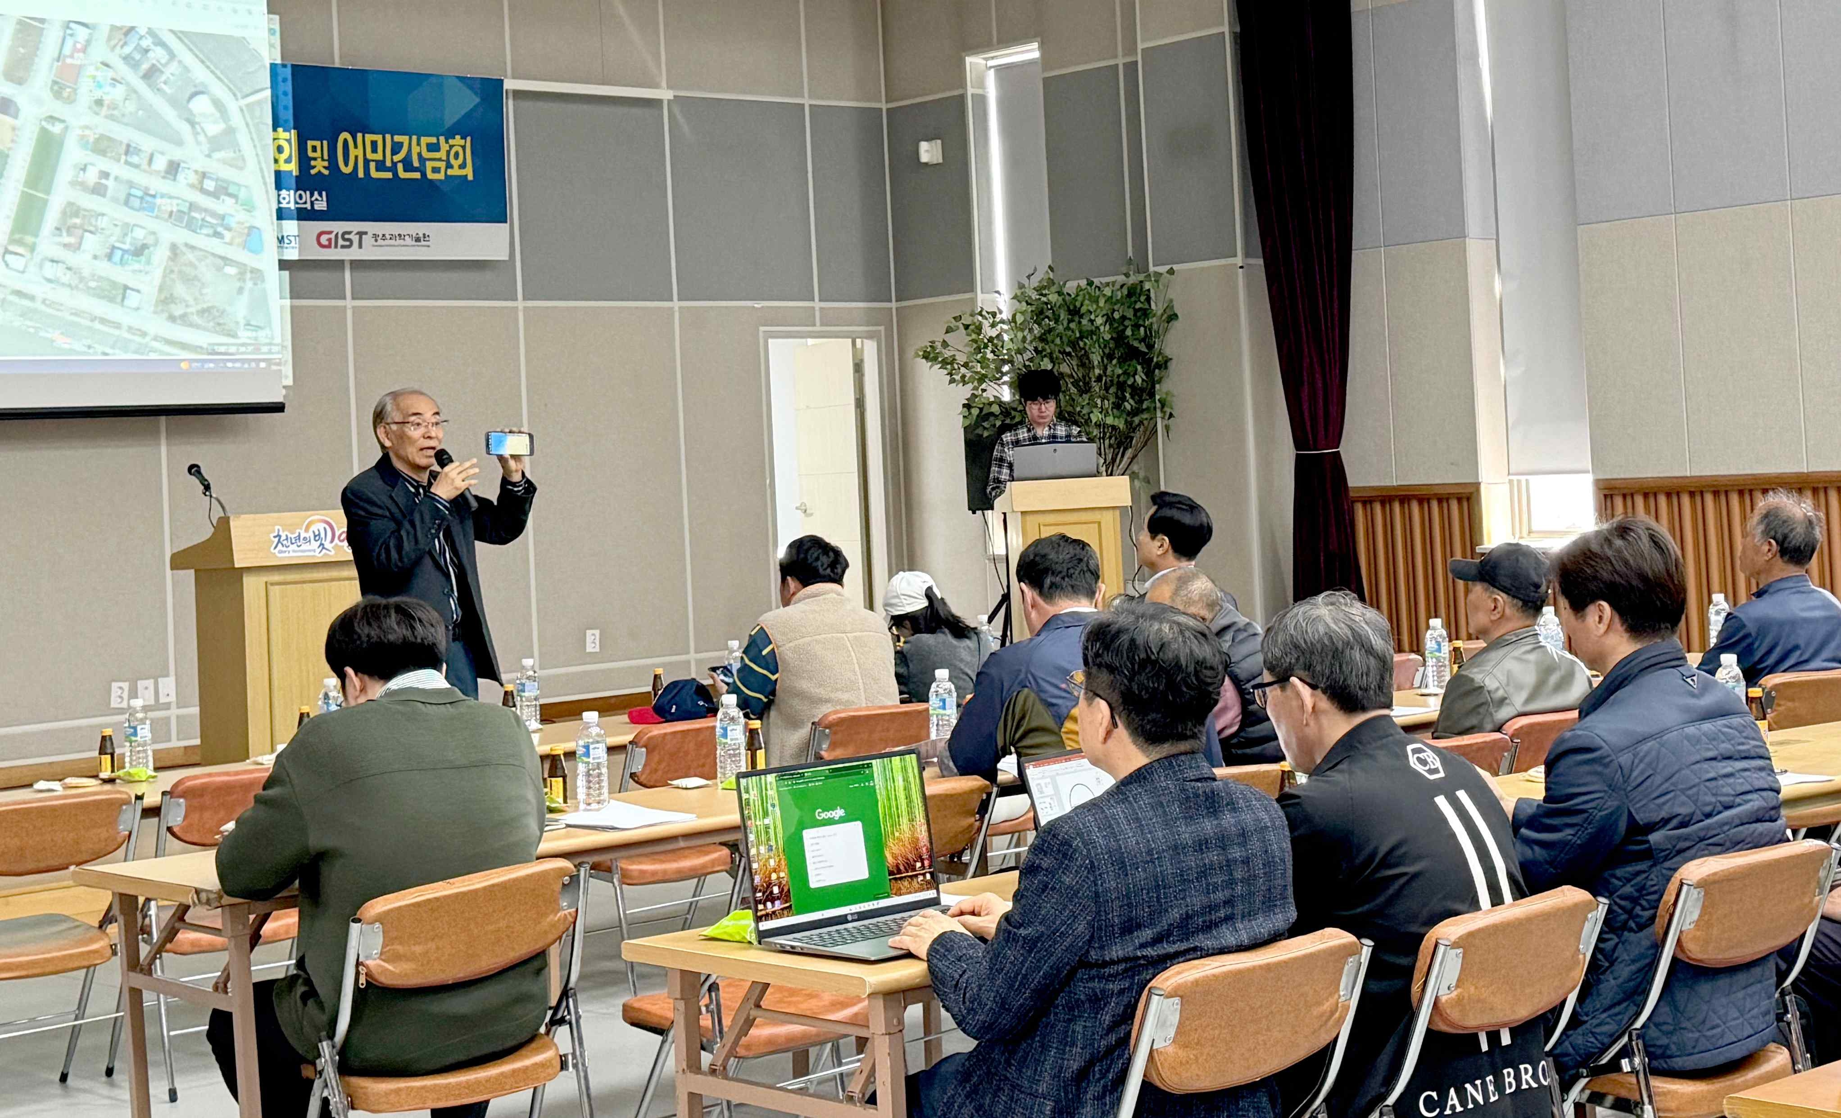▲ A technology transfer briefing session and a meeting with fishermen for the ‘Automatic Fishing Gear Identification Monitoring System’ are being held.

The Gwangju Institute of Science and Technology (GIST, President Kichul Lim) announced that the Information and Communication Convergence Research Center held a technology transfer briefing session and a meeting with fishermen for the ‘Automatic Fishing Gear Identification Monitoring System’.

The 'Automatic Fishing Gear Identification Monitoring System' being developed by the Information and Communication Convergence Research Center is based on maritime IoT (Internet of Things) technology and attaches an electronic buoy* that transmits location information of each fishing gear, allowing it to be used on fishing boats, management vessels (fishery management team), and on land. It is a system that can monitor the owner, type, and location of fishing gear in real time through wireless communication.

* buoy: An object that is floated on the water and used as a target. In case of fishing activities, it is used to indicate the location of fishing gear or anchor.

By introducing this system, information on fishing gear in operation can be checked in real time by fishermen, management vessels, and the onshore integrated control center, thereby reducing maritime accidents. It is expected that management of lost and abandoned fishing gear will help protect marine ecosystems and ultimately promote sustainable development of the national fisheries industry.

The event was held to discuss the Ministry of Oceans and Fisheries’ ‘Development of an automatic fishing gear identification monitoring system (Researcher: Kiseon Kim, Research period: 2017. 4. 28. ~ 2024. 6. 30.)’ ▴ technology transfer briefing session for related industries ▴ held at the Beopseong-myeon Community Center in Yeonggwang-gun, Jeollanam-do on Friday the 12th in the form of a meeting for fishermen.

About 50 people attended the briefing session and meeting, including fishermen from Beopseongpo in Yeonggwang-gun, Dolsan in Yeosu, Na Lodo in Goheung-gun, Mokpo South Port, and North Port, and participated in the system verification, as well as officials from the Korea Institute for Oceans and Fisheries Science and Technology Promotion, and businesspeople from the same industry.

The Information and Communication Convergence Research Center has been developing related technologies as the lead organization for the ‘Development of an Automatic Fishing Gear Identification Monitoring System’ project since 2017 to realize healthy oceans and sustainable fisheries.

On this day, the center introduced the research results and demonstration products of the systems developed to date over the past seven years and disclosed the results of demonstrations in real sea areas led by fishermen over the past two years.

In addition, future technology transfer plans for the ‘Automatic Fishing Gear Identification Monitoring System’, which is the result of the Ministry of Oceans and Fisheries' commercialization technology development project, and the direction of the fishermen usability evaluation and system pilot distribution project according to actual sea area demonstration were discussed in detail.

The center secured results in terms of the fishing environment by conducting a small-scale test run of real-sea area demonstrations on fishing boats operating in 2021, and in the process, cooperated with Jeollanam-do Provincial Office to derive results in terms of management.

Since 22 years, the feasibility of dissemination and practical use of the system has been confirmed by expanding the actual sea area demonstration using about 30 fishing boats led by fishermen for a total of more than 3,000 hours.

A fisherman who participated in the briefing session said, "Fishermen are also very interested in national policies for sustainable fisheries and improvement of the fishing environment. Once the field application of this technology related to electronic fishing gear monitoring begins in earnest, the effectiveness of the real-name fishing gear system will be greatly strengthened and the catch management and generation of waste fishing gear will be dramatically reduced."

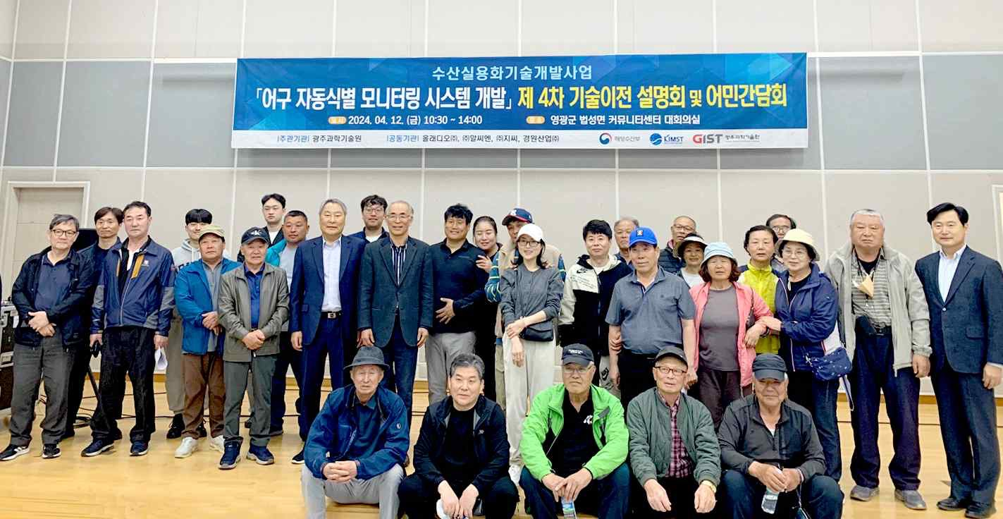▲ GIST Information and Communication Convergence Research Center is holding a technology transfer briefing session and a meeting with fishermen for the ‘Automatic Fishing Gear Identification Monitoring System’ and taking commemorative photos.

Research director Kiseon Kim said, "It is part of the next-generation gear management system that can be monitored in real time by management vessels and onshore control centers that support the safety and fishing activities of fishing vessels when necessary. The meeting provided an opportunity for fishermen to gain a better understanding of the technology and to share their views on the feasibility of adopting the technology in the field."



