GIST-KDI School signs MOU for educational cooperation in data science and AI fields

- Agreement to cooperate in three areas, including educational cooperation such as credit exchange, joint research performance, and joint promotion... Synergy is expected through establishment of an international academic network and sharing of expertise between both educational institutions
- GIST plans to open Korea's first AI Policy and Strategy Graduate School in September and operate campuses in Seoul, Sejong, and Gwangju... Training innovative policy planners with the ability to utilize AI and data science through cooperation with KDI School

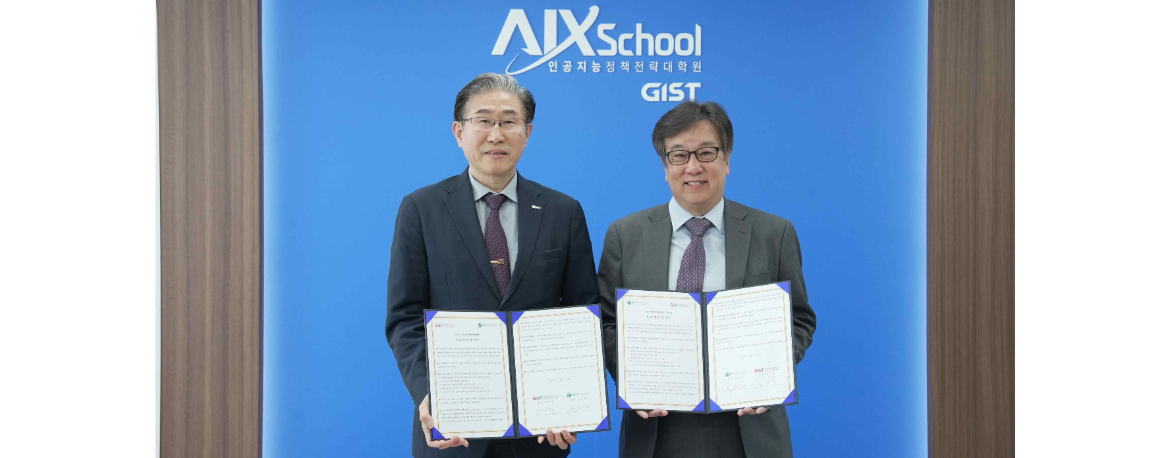▲ The Gwangju Institute of Science and Technology (GIST) signed a business agreement (MOU) with KDI School of International Policy (KDI School) on the 12th (Friday) for educational cooperation in the field of data science and artificial intelligence (AI) policy and took a commemorative photo. (From left) GIST President Kichul Lim, KDI School of Public Policy and Management President Dong-cheol Cho

The Gwangju Institute of Science and Technology (GIST, President Kichul Lim) announced that it has signed a business agreement (MOU) with KDI School of International Policy (KDI School, President Dong-cheol Cho) for educational cooperation in the field of data science and artificial intelligence (AI) policy.

The agreement ceremony was held on Friday, April 12th with GIST President Kichul Lim , AI Policy and Strategy Graduate School Director Joon Ha Kim, Vice Dean Dukjo Kong, and KDI School President Dong-cheol Cho. It was held at the GIST AI Policy and Strategy Graduate School, Seoul Campus, with about 20 people in attendance, including Director Jong-il Yoo and other key officials.

The main contents of the agreement included ▴ educational cooperation, including exchange of credits, ▴ conducting joint research, and ▴ joint promotion of projects and events promoted by both organizations. GIST and KDI School plan to form and operate a working task force to come up with specific and practical cooperation measures.

In particular, at the agreement ceremony on this day, the educational philosophy and curriculum of the AI Policy and Strategy Graduate School (Dean Joon Ha Kim), which GIST will open for the first time in Korea in September, and its differences from existing graduate schools were shared, including discussions on ▴ innovative talent training plan through AI convergence education and research and ▴ in depth ways to respond to rapid developments in the big data and AI fields.

GIST President Kichul Lim said, "It is expected that the synergy effect will be significant by establishing an international academic network and sharing diverse perspectives and expertise through human exchange and cooperation between the two institutions. In particular, we will actively cooperate for the sustainable development of the AI Policy and Strategy Graduate School and to seek innovative policy directions."

KDI School Director Jong-il Yoo said, "As the government has announced the establishment of a National AI Committee, it is very important to establish innovative and effective policies for fostering the AI industry and technology. We will strive to cultivate innovative policy planners with the ability to utilize AI and data science through policy convergence education and practical training."

Meanwhile, GIST AI Policy and Strategy Graduate School plans to operate on three campuses, including Seoul, Sejong, and Gwangju and plans to provide online and offline education by recruiting not only full-time GIST faculty but also chief technology officer (CTO) level professors from domestic and foreign global companies."

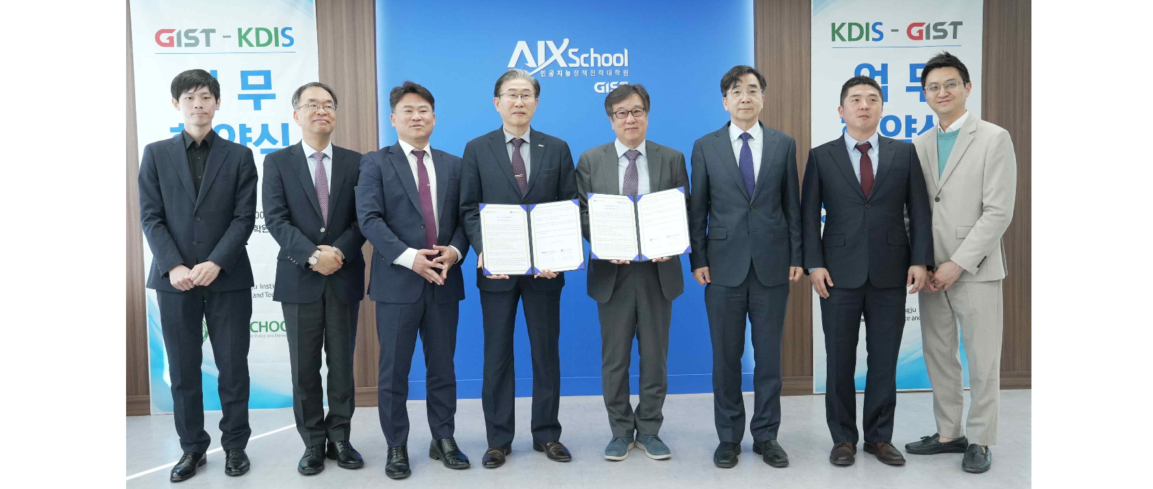▲ (From left) GIST Professor Do Hyun Park, Professor Yong-Ju Lee, Director of AI Policy and Strategy Graduate School Dean Joon Ha Kim, President Kichul Lim, KDI Graduate School of International Policy President Dong-cheol Cho, KDI School Director Jong-il Yoo, Professor Jaehyuk Park, and GIST AI Policy and Strategy Graduate School Vice Dean Dukjo Kong

GIST Graduate School of AI Policy and Strategy plans to focus on AI+X, or how to utilize AI in real life, with a differentiated curriculum from other AI graduate schools. GIST officials announced that they will continue to nurture human resources in specialized AI science technology and AI industrial application fields.



