GIST and Korea Institute of Energy Research (KIER) begin research cooperation in the field of environmental engineering and energy

<GIST School of Earth Sciences and Environmental Engineering – KIER Gwangju Eco-Friendly Energy Research Center MOU signed>
- Discovering of leading research projects in the energy field, promotion of joint research, training of professional specialists, and exchange and cooperation
- GIST School of Earth Sciences and Environmental Engineering will change its name to ‘School of Environmental and Energy Engineering’ in September... Leading the next generation of environmental convergence technology

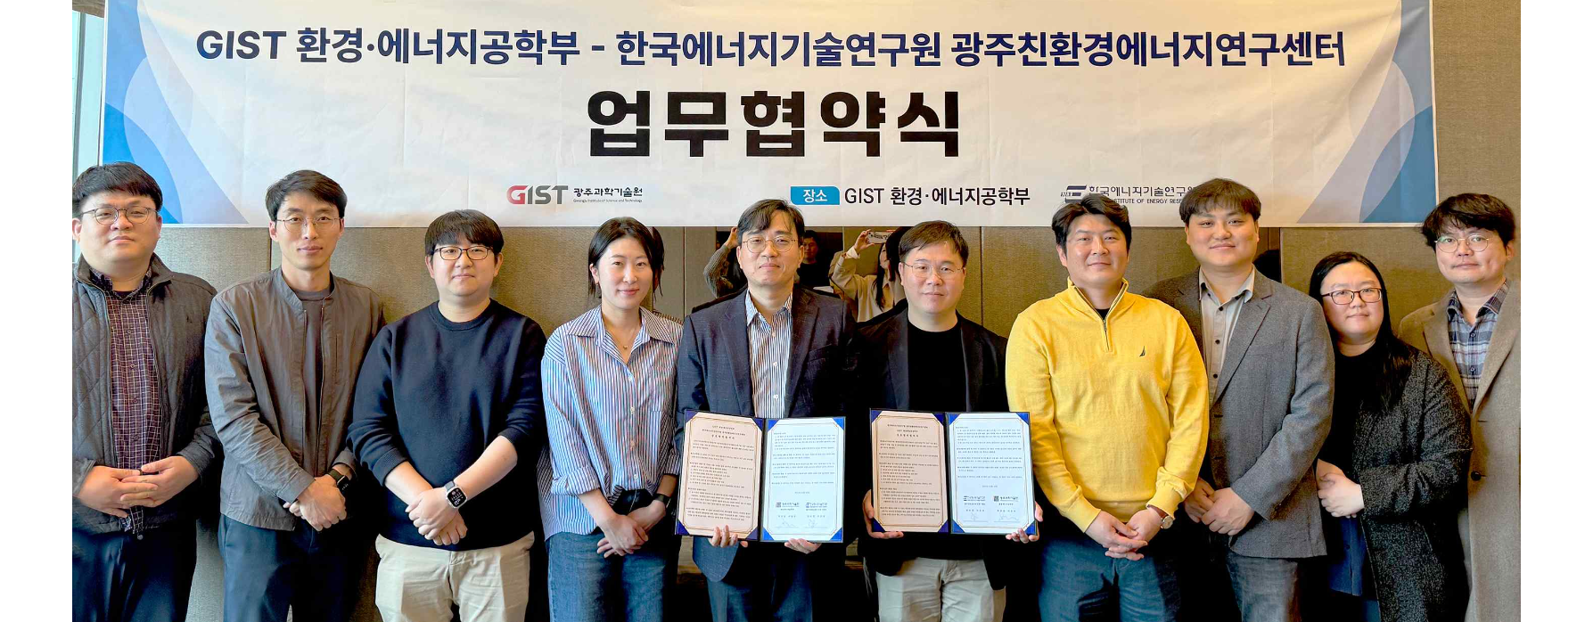▲ GIST School of Earth Sciences and Environmental Engineering and the Gwangju Eco-Energy Research Center of the Korea Institute of Energy Research signed a business agreement and took a commemorative photo.

The Gwangju Institute of Science and Technology (GIST, President Kichul Lim) announced on the 9th that the School of Earth Sciences and Environmental Engineering and the Gwangju Eco-Energy Research Center of the Korea Institute of Energy Research signed a business agreement to conduct joint research and foster talent in the energy field.

The agreement ceremony was held at GIST with the attendance of about 10 officials, including GIST School of Earth Sciences and Environmental Engineering Dean Yunho Lee and Gwangju Eco-Energy Research Center of the Korea Institute of Energy Research Director Jung-je Woo.

The main contents of the agreement are ▴ promoting joint research in areas of mutual interest, such as the energy field ▴ cultivating professional experts and exchanging cooperation to strengthen research capabilities and ▴ discovering leading research projects for collaborative research.

Dean Yunho Lee said, "This agreement is meaningful in that it allows us to contribute to the establishment of next-generation environmental convergence technology by combining our department's research capabilities in the field of environmental engineering into the energy field. Starting in September, the GIST School of Earth Sciences and Environmental Engineering will change its name to the School of Environmental and Energy Engineering to develop world-class environmental convergence technology and focus on research areas such as climate crisis, carbon neutrality, and energy storage and conversion. We plan to further expand our research areas, including the use of artificial intelligence."

Gwangju Eco-Energy Research Center of the Korea Institute of Energy Research Director Jung-je Woo said, "Our center is conducting research on eco-friendly energy storage technologies to shift to a sustainable energy paradigm and solve environmental problems. It is expected that the agreement with GIST will not only strengthen research capabilities in the energy sector but also create synergies in nurturing talented people"



