“Pursuing sustainable development and innovation with future generations” GIST declares ‘ESG management’

- President Kichul Lim, “It is time to embrace in our minds and hearts the noble task of resolving society’s great challenges and finding a path to sustainable prosperity for future generations.”
- Emphasis on the noble sense of responsibility contained in the ‘GIST spirit’ such as “We serve society” and “We thrive together with future generations”

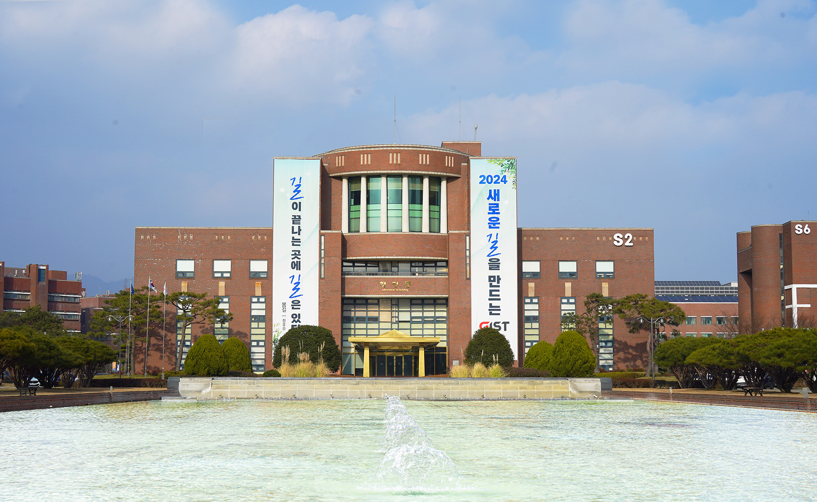▲ Panoramic view of GIST Administrative Building

The Gwangju Institute of Science and Technology (GIST, President Kichul Lim) declared ‘ESG (Environmental, Social, and Governance) Management’ for sustainable development and innovation through step-by-step strategy establishment and implementation. It was announced that an ESG Committee would be formed and President Kichul Lim would personally serve as chairman to strengthen responsible management.

ESG management, which has recently been applied by the world's leading universities and various industries, is a management activity that creates social value for an institution and pursues sustainable development through non-financial factors such as ‘eco-friendliness, social responsibility, and governance.’ The ‘New Government Public Institution Innovation Guidelines’ announced in 2022 also emphasizes support for ESG management, and expectations for the implementation of ESG management by each public institution are also increasing.

President Kichul Lim, who was appointed as the 9th president of GIST in July last year, announced ‘ESG management’ through a letter to members on Friday, March 29th. GIST announced that it plans to continue sustainable growth with future generations.

After taking office, President Kichul Lim presented a clear vision of creating better future values for humanity and contributing to solving global challenges through the ‘Vision 2053 Declaration’ (November 16, 2023). In a situation where global standards for ESG management are gradually being strengthened, new goals have been additionally set to put this into practice.

The goal that GIST aims to achieve through ESG management are ▴ (E) Contribution to a sustainable future ▴ (S) Spreading positive influence in the local community and the international community with social responsibility and inclusiveness as core values ▴ (G) Secure the trust of all stakeholders through a transparent and responsible governance structure and to create an ethical and sustainable research and education environment.

To achieve this goal, GIST presented three key tasks: ▴ strengthening environmental awareness and practice ▴ increasing social responsibility ▴ improving transparency and reliability. Based on this, the plan is to select detailed implementation tasks and accelerate innovation for sustainable development.

President Kichul Lim said, "As we navigate an era of unprecedented challenges and opportunities, the need for systematic management of environmental, social, and governance (ESG) responsibilities has become more important than ever. By adopting ESG management, we will operate our institution to become examples for the world and contribute more effectively to solving the critical environmental and social challenges of our time."

President Lim also said, "Our goal is to promote environmental sustainability, strengthen social contribution, and maintain the highest governance and ethical standards. In the future, we will continue to engage in activities such as reducing carbon emissions and responding to climate change, and will strive to establish GIST as a socially recognized central science and technology research institute."

Planning Dean Hisam Kim announced that they will soon form an ESG Committee with President Im Ki-cheol as the chairman, and that ESG management will be implemented in earnest, starting with disclosing ESG-related information on the website.

Dean Kim said, "When freshmen at GIST enroll, they recite the ‘GIST Spirit’, which contains the values of ESG management, such as ‘We serve society’ and ‘We thrive together with future generations.’ We are establishing this noble sense of responsibility as an internal culture."

Meanwhile, since its opening in 1993, GIST has focused on nurturing high-level scientific and technological talents with a global perspective and future-oriented thinking, and on cutting-edge scientific and technological research and development to create a better world.

In particular, in a recent announcement by Elsevier, a global academic information analysis company, 17.4% of GIST's full-time environmental engineering faculty were selected as the world's top 2% researchers, showing that GIST has world-class research capabilities in the environmental field. It has a solid foundation for promoting ESG management, including being selected as the ‘2023 Excellent Institution for Recruitment and Employment Target System for Female Scientists and Engineers.’

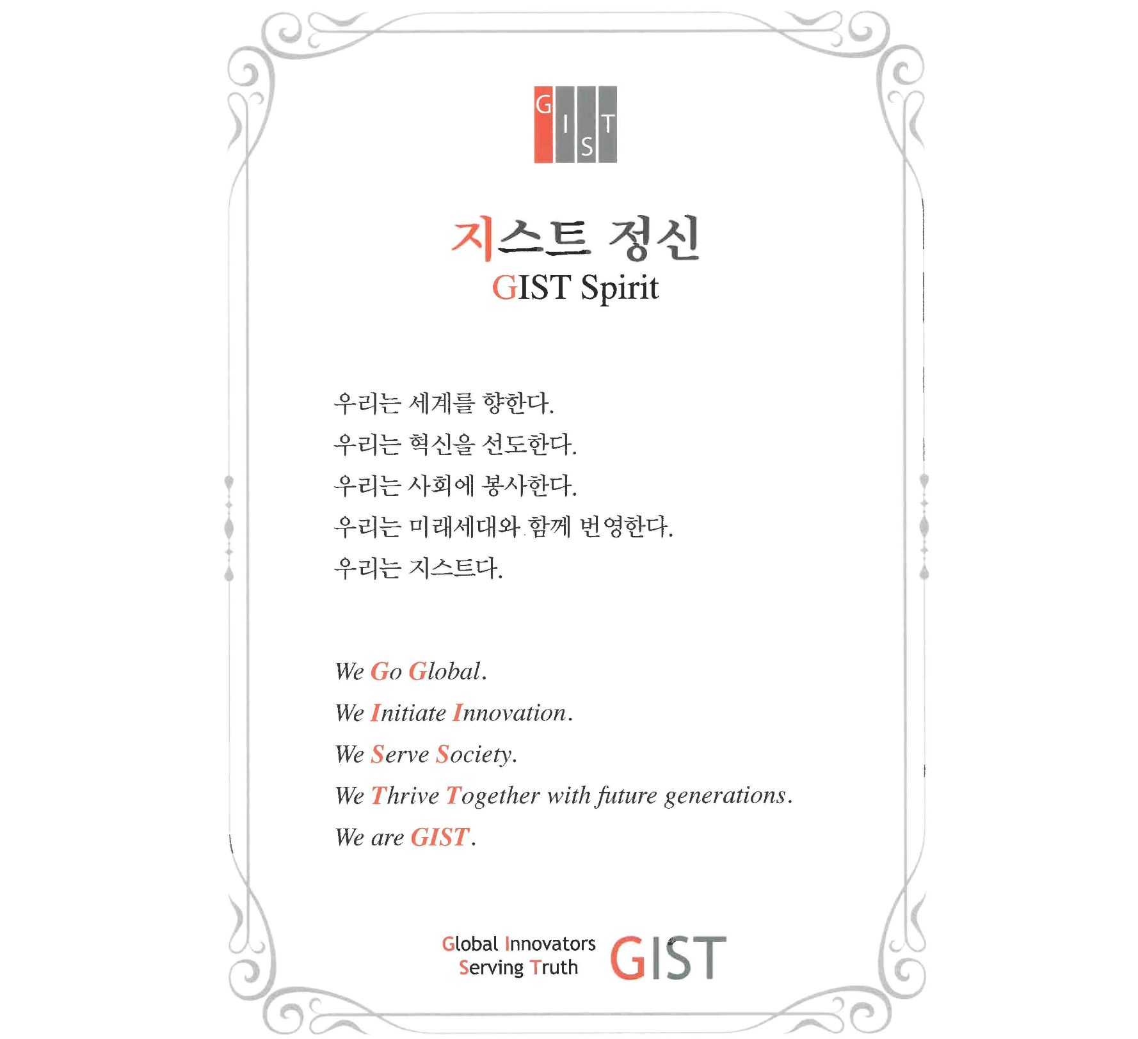▲ ESG philosophy engraved in the ‘GIST Spirit’ recited at the GIST entrance ceremony



