GIST Academy invites author Yeoul Jeong to give a special lecture at the March Breakfast Forum on ‘To Me Who Doesn't Care About Me’

- Take time to heal your tired life with literature and art under the theme of ‘Studying humanities to take care of yourself’
- Based on the best-selling book, a way to enjoy art and reflect on yourself through literature is presented

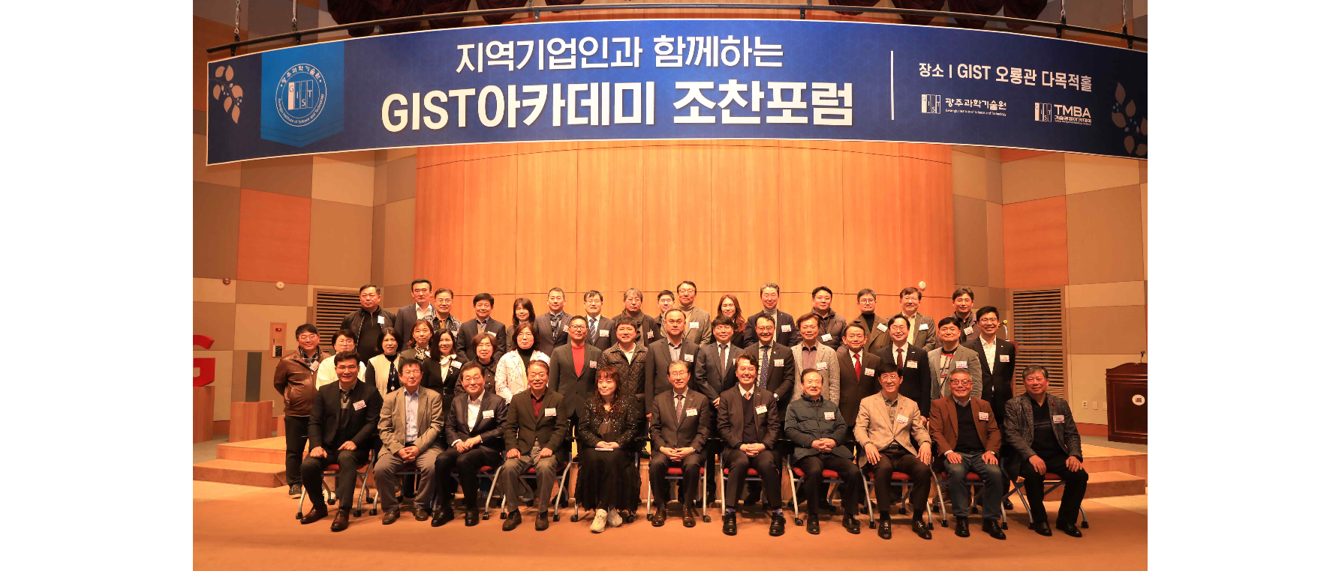▲ GIST Academy is holding a breakfast forum in March at Oryong Hall, inviting artist Yeoul Jeong, and taking a commemorative photo.

The Gwangju Institute of Science and Technology (GIST, President Lim Ki-cheol) held a breakfast forum in March at the Oryong Hall on Tuesday, March 26, with about 60 representative business leaders from the Gwangju and Jeonnam regions in attendance, and author Yeoul Jeong, who has explored the beauty of literature and art as a literary critic and essayist.

Writer Yeoul Jeong, an editorial committee member and literary critic at <World Literature>, has written <A Time for Literature>, <To Me Who Doesn't Care About Me>, <A Museum Just for Me>, <The Courage to Write to the End>, and <Things I Wish I Had Known Back then>.

In addition to the serialization of Naver’s premium content ‘Salon de Muse’, he is also active as a host of KBS Radio’s ‘Yeoul Jeong’s Library’ and Naver Audio Clip ‘Monthly Yeoul Jeong’.

On this day, author Jeong crosses various fields such as humanities, history, psychology, and philosophy under the theme of 'studying humanities to take care of myself' and asks modern people to reflect on what their 'true self' is and gave a lecture healing their tired lives with literature and art.

In this day's lecture, author Jeong presented ways to enjoy art and reflect on oneself through literature based on his books <A Museum Just for Me> and <A Time for Literature>.

Artist Jeong, who opened his lecture with the question, “What kind of paintings do I like?” said that paintings that stick in your mind the moment you see them and that you always want to keep by your side, or paintings that spread in your mind without any reason, can be called “life paintings.” He explained that each person's 'picture of life' represents that person's story.

He also emphasized the power of literature to console people's sorrow and soothe their wounds, saying, "I think literature is a letter filled with the language of love and hope transfused through stories."

Artist Jeong said that great works of art create ‘their own independent room’ in the heart, and that whenever all efforts are in vain and the world feels cold, the ‘healing space of the heart’ created by a work of art is used. He honestly shared his experience of gaining strength through it.

He finally said, “A writer is a storyteller who writes letters every day through literature to modern people who are enduring each day,” and “I look forward to the day when the language of love and hope will reach readers, even in all those moments when there is no reply at all.” “I will do it,” he said, concluding the day’s lecture.

GIST Academy operates the Technology Management Academy (GTMBA, opened in 2010) as a non-degree program at GIST, and on the last Tuesday of the months 3.5.6.9.10, the GIST Academy Breakfast Forum invites experts from various fields as lecturers for academy alumni and executives of local companies.

In particular, for the balanced development of local industries, an additional GTMBA program will be opened in the eastern region (Yeosu, Suncheon, and Gwangyang) in September, and classes will be held in Suncheon City on topics such as the latest science and technology and global management issues.



