"Foreign students also take Korean language seminar classes!" GIST builds AI voice recognition and automatic translation system in classrooms

- Utilizing AI-based voice signal processing technology, Korean voice → English subtitles automatically generated... Translation accuracy over 90%
- The fruit of Professor Hong Kook Kim’s ‘laboratory start-up’ AunionAI Co., Ltd. applied ‘AI-based automatic dubbing solution’

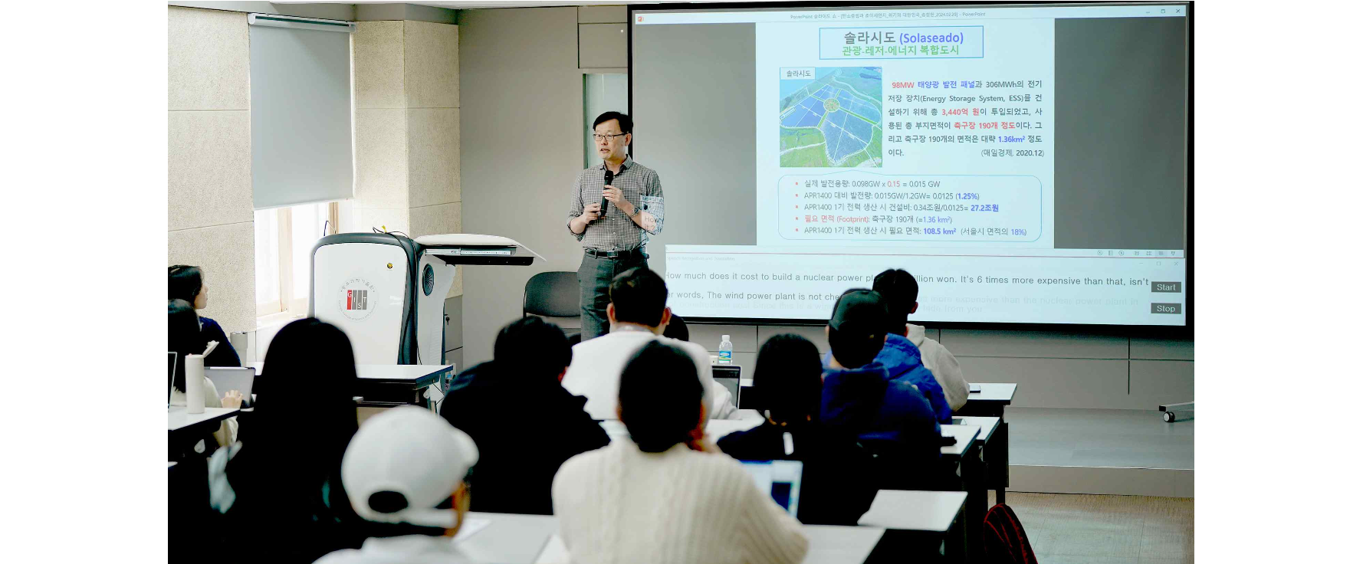▲ School of Earth Sciences and Environmental Engineering classroom (Room 210) where a seminar is being held using the artificial intelligence (AI) voice recognition automatic translation system developed by GIST Professor Hong Kook Kim's start-up company AunionAI Co., Ltd.

The Gwangju Institute of Science and Technology (GIST, President Kichul Lim) collaborated with AunionAI Co., Ltd. (CEO Hong Kook Kim, School of Electrical Engineering and Computer Science professor), a faculty-founded startup, to demonstrate an artificial intelligence (AI) voice recognition automatic translation system built in a classroom. As a result of the operation, it was announced on the 26th that it is receiving a good response from foreign students.

The voice recognition automatic translation system, which is currently being piloted in the School of Earth Sciences and Environmental Engineering classroom (Room 210), provides real-time translation of Korean speech into English.

The AI-based voice signal processing technology used in the classroom was developed by Professor Hong Kook Kim's research team currently shows an accuracy of over 90%. Translation accuracy can be further improved by repeatedly learning technical terms used in major classes and seminars with AI.

The AI voice recognition automatic translation system transmits Korean audio signals collected in real time in the classroom to its own web server. The transmitted audio signals are converted into English sentences through an AI-based voice recognition and translation model and sent to the classroom.

The proportion of foreign graduate students at GIST reaches 10% (130 out of 1,338 enrolled students). In particular, the School of Earth Sciences and Environmental Engineering has a multinational student body with approximately 20% of its students being foreign students (35 out of 184).

Since GIST began operating graduate courses in 1995, it has maintained the principle of 100% English lectures for major subjects. In order to respond to situations where seminars with invited speakers have no choice but to be conducted in Korean, GIST worked with AunionAI Co., Ltd. to build an AI voice recognition automatic translation system classroom and plans to gradually expand the operation due to the high level of satisfaction among foreign students.

Meanwhile, AunionAI Co., Ltd. has an ‘automatic dubbing solution’ that reproduces media content in local languages for the globalization of K-content.

The solution includes technologies such as voice separation, voice recognition, machine translation, and voice synthesis developed in-house using AI technology. AunionAI Co., Ltd.’s ‘automatic dubbing solution’ automatically creates dubbed content by simply uploading the content.

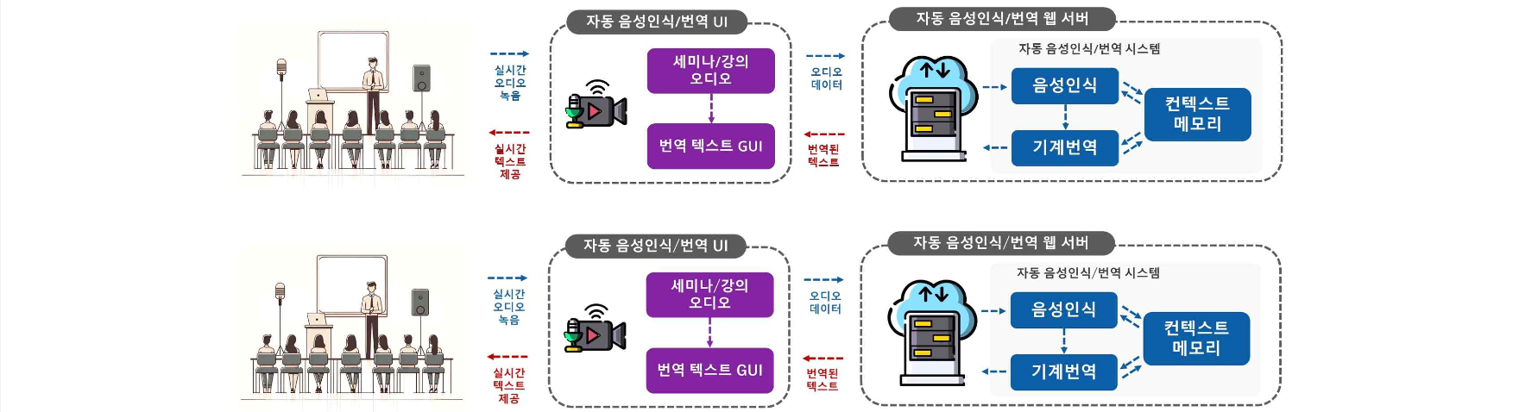▲ AI voice recognition automatic translation system configuration diagram

Professor Hong Kook Kim, "This achievement is an application of AI-based voice signal processing technology, which is the main business item of ‘laboratory startup’, and is significant in that it can provide equal educational opportunities to foreign students in the educational field through automatic translation technology. In order to expand online automatic translation-based education in the future, this pilot construction is expected to be advanced and expanded to apply to GIST regular subjects."



