‘The future of the region is wide open with science and technology’ GIST holds the 2024 Gwangju Special Zone Science and Technology Commercialization Fair

- Various programs will be held for 3 days starting from Friday the 22nd, including exhibitions, competitions, seminars, etc. of the achievements for industry-academic linkages in the Gwangju Special Zone
- Expectations to discover commercialization issues and spread technological know-how regarding national strategic technologies and special zone specialized technologies

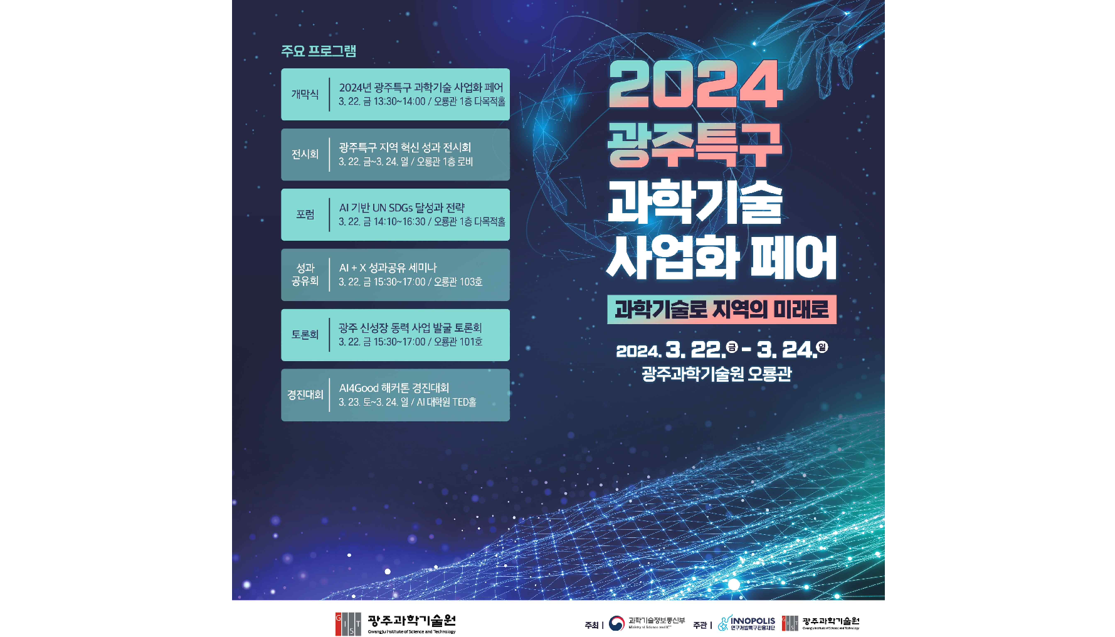▲ ‘2024 Gwangju Special Zone Science and Technology Commercialization Fair’ promotional poster

The Gwangju Institute of Science and Technology (GIST, President Kichuk Lim), together with the Gwangju Research and Development Special Zone Promotion Foundation, announced that the '2024 Gwangju Special Zone Science and Technology Commercialization Fair' will be held for three days from March 22 (Fri) to 24 (Sun) at GIST Oryong Hall and AI Graduate School.

This event is an opportunity for industry-academia-related innovation entities in the Gwangju Special Zone to discover commercialization issues for national strategic technologies and special zone-specific technologies and to spread technological know-how. As part of the ‘Innovation Entity Network Operation Project’, one of the projects of the Gwangju Research and Development Special Zone Promotion Foundation that GIST has been carrying out since last year, various programs such as competitions and seminars, as well as exhibitions of achievements, will be held.

Starting with the opening ceremony on the 22nd (Friday), the first day of the event will include ▴ Gwangju Special Zone Regional Innovation Performance Exhibition (Oryong Hall 1st floor, 22-24th) ▴ Forum on AI-based UN SDGs achievement and strategy (Oryong Hall 1st floor, 22nd) Sunday) ▴ AI+X Performance Sharing Seminar (Oryong Hall, Room 103, 22nd) ▴ Gwangju New Growth Engine Business Discovery Discussion (Oryong Hall, Room 101, 22nd) ▴ AI4Good Hackathon Competition (AI Graduate School, 23rd-24th).

In particular, this event was attended by universities and graduate schools in the Gwangju Special Zone in order to exhibit and share innovative products utilizing excellent technologies related to national strategic technology and regional specialized fields, and it provided an opportunity to introduce innovative products from professional research institutes and start-up companies so that the interested public could also view them comfortably.

At the ‘AI-based UN SDGs Achievement and Strategy Forum’ held on Friday the 22nd, Professor Taejun Lee (KDI Graduate School of International Policy) will present various presentations on DX, climate change, and global cooperation in R&D with small and medium-sized enterprises through the application and utilization of AI technology. A panel discussion will be held in the multi-purpose hall of Oryong Building, with participation from industry, academia and research experts, including Commercial Director Yong-woo Lim (Technology Innovation, Quebec Government Representative to Korea), Research Fellow Seung-yu Lee (KDI Graduate School of International Policy OGI Lab), and Executive Director Moon-gu Park (Samjeong KPMG).

In addition, on the afternoon of the 22nd, AI+X performance was held to share various business linkages through the convergence of AI technology, mobility, optical convergence, semiconductor, and biotechnology, which are the main industries of Gwangju Special Zone, and to explore development strategies for local industries that will become more advanced in the future with the seminar held in Room 103 of Oryong Hall. As part of the effort to discover new growth engine projects in the Gwangju Special Zone, a discussion session on cooperation measures between working-level researchers and professional researchers in the Gwangju Special Zone will be held in Room 101 of Oryong Hall, along with presentations by CEO Dong-nam Kim (Navion Co., Ltd.) and attorney Jeong-hoon Kim (Cox Patent).

'AI4Good Hacker' was established as an opportunity to implement creative and original AI solutions for domestic AI experts (college and graduate students) to create solutions using AI technology with the goal of achieving UN SDGs (United Nations Sustainable Development Goals). The ‘Tone Contest’ will be held at the GIST AI Graduate School TED Hall for two days on the 23rd and 24th.

GIST President Kichul Lim, who hosted this event, said, "We hope that Gwangju Special Zone's industrial-academia-related innovation entities will create a new turning point that can revitalize all fields, including the Gwangju local community and economy, by discovering commercialization issues for national strategic technologies and special zone-specific technologies and spreading technological know-how."



