GIST rolled up its sleeves to improve integrity with all faculty and staff, including the president, participating in integrity training

- To improve university integrity and transparent research and administration through general education on the Anti-Graft and Corrupt Practices Act and the Conflict of Interest Prevention Act... this year, education to establish integrity values and improve management will expand
- Expression of will to improve integrity through participation in education by management, including the president

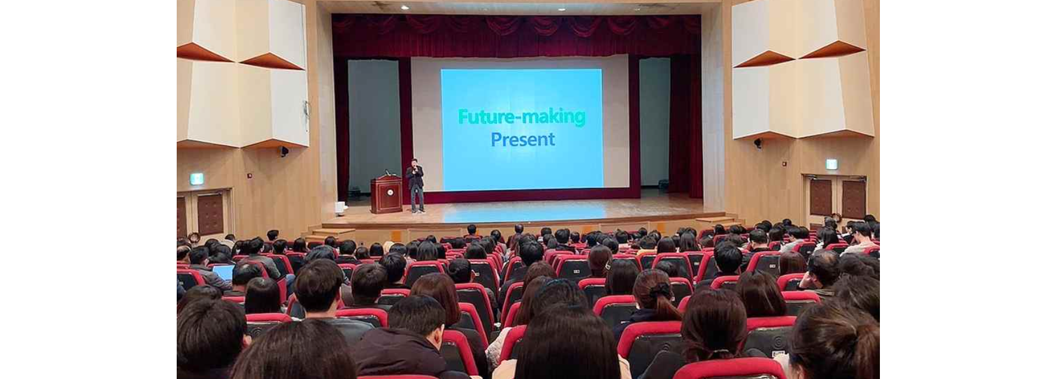▲ GIST is conducting the first integrity training in 2024 for all faculty and staff to improve institutional integrity

The Gwangju Institute of Science and Technology (GIST, President Kichul Lim) conducted the first integrity training in 2024 for all faculty and staff on March 7 (Thursday) to improve institutional integrity based on an organizational culture of consideration and trust.

The training was attended by approximately 350 people, including President Kichul Lim and Vice President for Academic Affairs Sang-Don Kim, as well as key officials, professors, and staff. Joo-hyeon Lee, Deputy Director of the KAIST Human Rights Ethics Center, a professional lecturer in integrity education, was invited to discuss ▴ Anti-Corruption Act ▴Conflict of Interest Prevention Act ▴ Code of Conduct ▴ Public Interest Reporter Protection Act and the public finance recovery system.

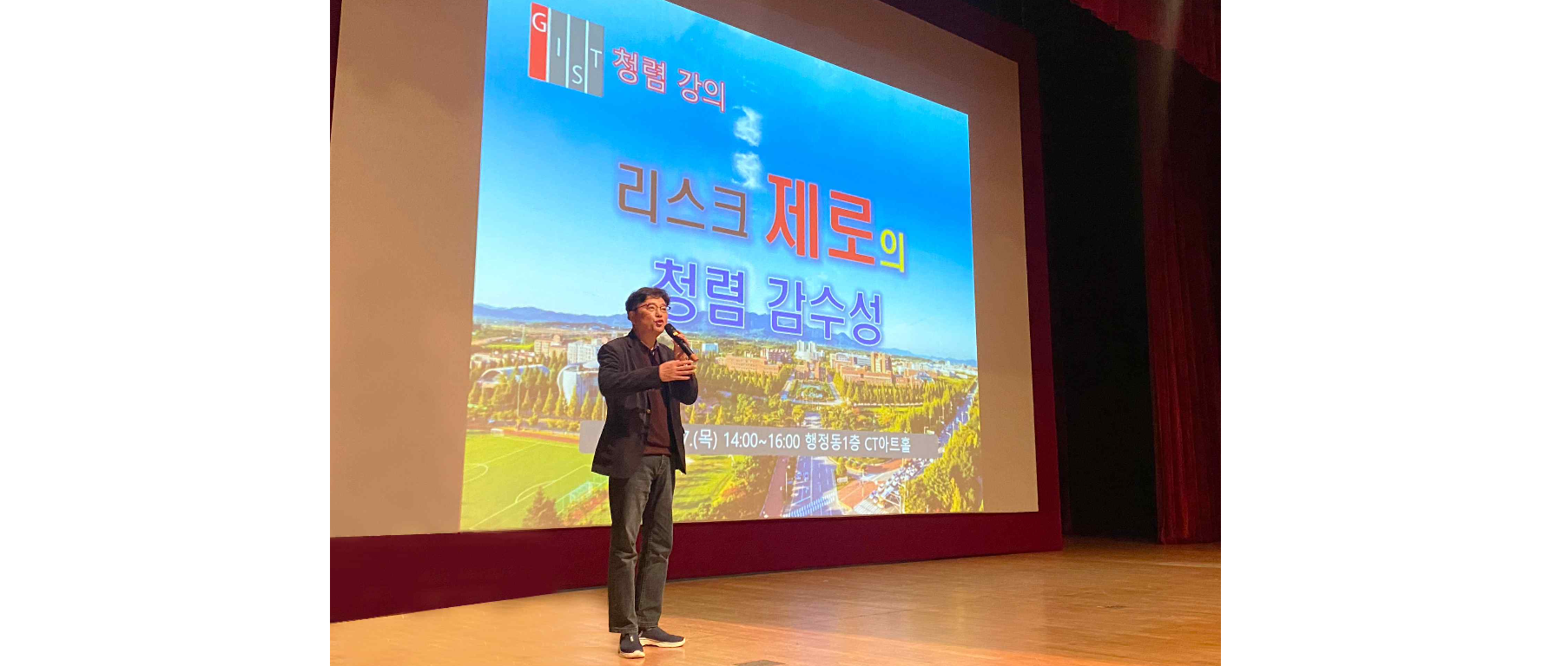▲ GIST is conducting the first integrity training in 2024 for all faculty and staff to improve institutional integrity.

In order to improve the results of the National Rights and Interests Commission's integrity measurement, which has been evaluated as a lower grade every year despite the importance of integrity, GIST has expanded the active participation of the management, with the president himself serving as the chairman of the Special Committee for Integrity Improvement, with the goal of achieving a comprehensive integrity rating of 3 or higher in the future, in accordance with the Enforcement Decree of the Anti-Corruption Rights and Interests Act and the Operational Guidelines for Anti-Corruption Education.

Since taking office, President Lim has promoted practical measures to establish and internalize the right values of integrity, such as ▴ strengthening integrity-enhancing activities through the participation of the president and management and ▴ creating an atmosphere of integrity through attention to and improvement of employees in areas of weak integrity.

President Kichul Lim said, "In order to improve integrity, it is most important to improve awareness among all members and spread correct awareness of integrity. GIST will work with all members to become an exemplary institution with integrity and a trusted school through various programs to improve awareness of institutional integrity."

Meanwhile, GIST plans to conduct integrity education in May and August of this year to eradicate corruption and improve integrity. In addition, to improve overall integrity, the Integrity Improvement Special Committee, Integrity Citizen Auditor, and Integrity Advisory Group were newly formed, and various campaign activities such as operating an integrity promotional booth are planned to be carried out.

