GIST Oryong Art Hall opens exhibition of ‘Korean folk paintings that convey good fortune’ filled with the scent of spring

- The 2nd invitational exhibition will be held from March 11th (Monday) to April 26th (Friday) in 2024
- A total of 22 traditional folk painting artists, including representative artist Hye-sook Seong, participated... 25 works exhibited

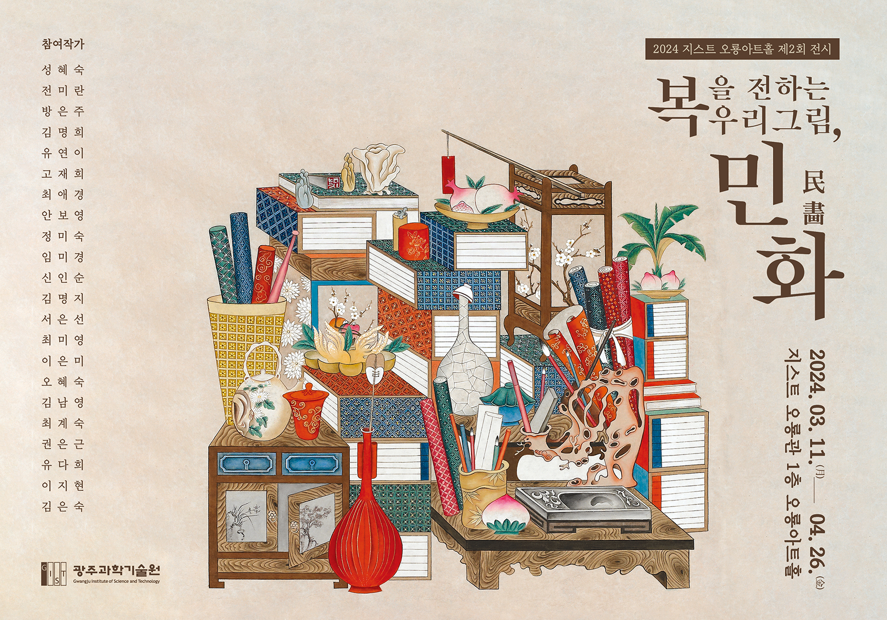▲ Poster for the 2024 Oryong Art Hall 2nd exhibition ‘Korean folk paintings that convey good fortune’

Korean paintings and folk paintings that simply express the lifestyles and customs of the common people can be found at the Gwangju Institute of Science and Technology (GIST, President Kichul Lim).

GIST announced that it will hold ‘Korean folk paintings that convey good fortune’ for about two months from March 11 to April 26 as the second invitational exhibition at Oryong Art Hall this year.

At the exhibition, you can see 25 works by 22 traditional folk painting artists, and beautiful folk paintings such as flowers and birds, sun, moon, Jangsaengdo, and peonies will colorfully decorate the walls of Oryong Art Hall.

In addition, 'Chaekgado', which vividly depicts the study of Korean ancestors, 'Magpie and Tiger', a frequent subject of folk paintings, and 'Munjado', which consists of a font by drawing contents such as ancient stories related to the meaning of letters in the strokes of Chinese characters, Gapjinnyeon. Visitors can also see the commemorative ‘Cheongryong Island’.

The motifs in the folk paintings in this exhibition contain universal human wishes and dreams that transcend time, so viewers of the paintings are expected to be able to feel the small happiness of everyday life.

Hye-sook Seong, representing 22 artists, won the grand prize at the Korean Traditional Folk Painting Association Contest and the Special Award at the Korean Folk Painting Association Contest and has won the Grand Prize at the Shenzhen International Art Fair of the Korean Contemporary Art Association and the Encouragement Award at the Imperial Crafts Festival of Korea.

Artist Seong is a local artist who has mainly focused on folk painting for about 20 years. He is currently serving as an invited artist of the Korean Modern Folk Painting Association, the head of the Gwangju and Jeonnam branches of the Korean Folk Painting Association, the director of the Korean Traditional Folk Painting Association, and the director of the Baekya Folk Painting Research Institute.

Artist Hye-sook Seong said, "I believe that folk paintings are paintings that truly embody the soul and spirit of Korea. I hope that both GIST students, who will become great scientists and researchers, and local residents who visit GIST's spring campus, with its beautiful cherry blossom trees, will feel a small but unique happiness in their busy daily lives through this exhibition."

Artist Choi Soon-im Choi, director of Oryong Art Hall, said, "Folk paintings are widely incorporated into our daily culture, decorating everything from the luxurious folding screens of the royal family to the closet doors of simple private houses. We hope that this exhibition of 22 traditional folk painting artists who have inherited the great cultural heritage of our ancestors' sincere lives to the present will provide a feeling of peace of mind and happiness."

The exhibition ‘Korean folk paintings that convey good fortune’, which will be held at the GIST Oryong Art Hall until April 26, can be viewed by anyone interested from 9 a.m. to 6 p.m. on weekdays. (Inquiries about opening on weekends/T.062-715-2628)

Meanwhile, Oryong Art Hall is an exhibition space created on the inner walls of the first and second floors of Oryong Hall, a multi-purpose building for events, meetings, lectures, seminars, etc., to provide a venue for strengthening exchanges and cooperation with the local community by GIST, which has grown due to the interest of local residents. Starting with the first invitational exhibition in December 2022, it is fulfilling its role as an ‘open culture and arts space’ through a total of 8 exhibitions, including the current ‘Our paintings and folk paintings that convey good fortune’ exhibition.



