GIST and Goheung-gun signed an MoU to foster outstanding talent in the aerospace industry and develop the industry

- Conduct joint research and development to successfully build a space launch vehicle industrial cluster... Expected to foster systematic talent in the region-based aerospace field

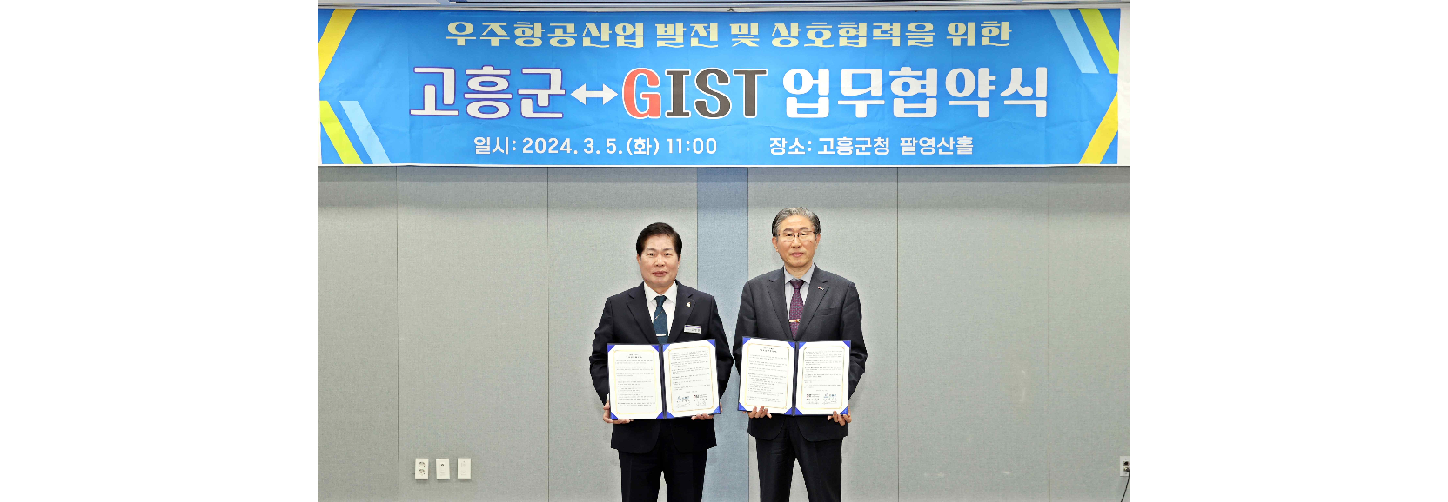▲ GIST and Goheung-gun are taking a commemorative photo after signing a business agreement for the development of the aerospace industry. (From left) Goheung County Governor Young-min Gong and GIST President Kichul Lim

The Gwangju Institute of Science and Technology (GIST, President Kichul Lim) announced that it has signed a business agreement (MoU) with Goheung-gun (Governor Young-min Gong) to foster outstanding talent in the aerospace industry and develop the industry.

The agreement ceremony was held on Tuesday, March 5th at the Palyeongsan Hall of the Goheung County Office with GIST President Kichul Lim, Goheung County Governor Young-min Gong, and key officials in attendance.

The main contents of the agreement include: ▴ systematic training of talent in the region-based aerospace field ▴ establishment of a joint campus in the region for the successful establishment of a space launch vehicle industrial cluster ▴ conduct joint research and development to strengthen corporate competitiveness ▴ joint use of research facilities and equipment in the aerospace field ▴ cooperation in establishing the GIST Techno Management Business Academy (GTMBA) curriculum and selection of scholarship students.

Goheung County Governor Young-min Gong said, "Through this agreement, we will foster experts tailored to companies in Goheung, the ‘center city of aerospace,’ and promote the establishment of a curriculum to strengthen corporate competitiveness. Cooperation with GIST is expected to give momentum to the promotion of the space launch vehicle cluster construction project to be established by 2031."

GIST President Kichul Lim said, "It is very meaningful and gratifying to promise mutual cooperation for the development of the aerospace field with Goheung-gun, the ‘aerospace hub city’. Based on close cooperation with Goheung-gun, GIST will train creative and competent aerospace experts in the aerospace industry and will spare no effort in supporting them to succeed in the aerospace industry."

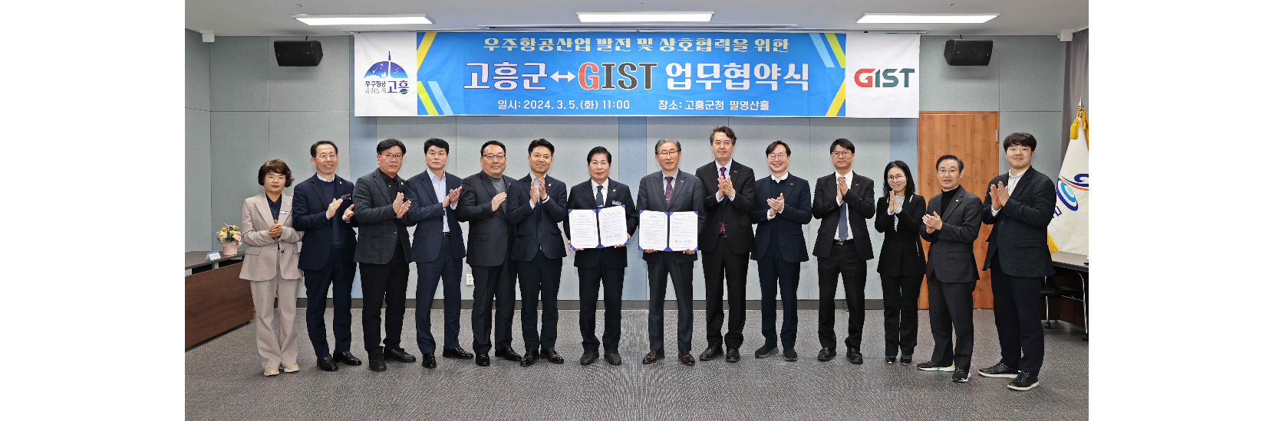▲ Participants are taking commemorative photos after GIST and Goheung-gun signed a business agreement for the development of the aerospace industry.

Meanwhile, while the national government is making all-out efforts to strengthen competitiveness in the aerospace sector, including the opening of the Korea Aerospace Administration, GIST is taking a multifaceted approach to R&D for the 'new space era' by developing inter-satellite communication technology using lasers and researching various biological and medical issues that may arise in space flight.



