GIST Techno Management Business Academy (GTMBA) holds its 14th entrance ceremony... 51 leaders from various fields of society are admitted

- At the entrance ceremony, Gyeong-seop Shim, CEO of Intop Technology Co., Ltd., donated 10 million won for cooperation and mutual development with the region
- Provides a venue for exchanging knowledge of the latest industrial technology and expanding a broad human network for successful management activities in a business environment in the digital transition period

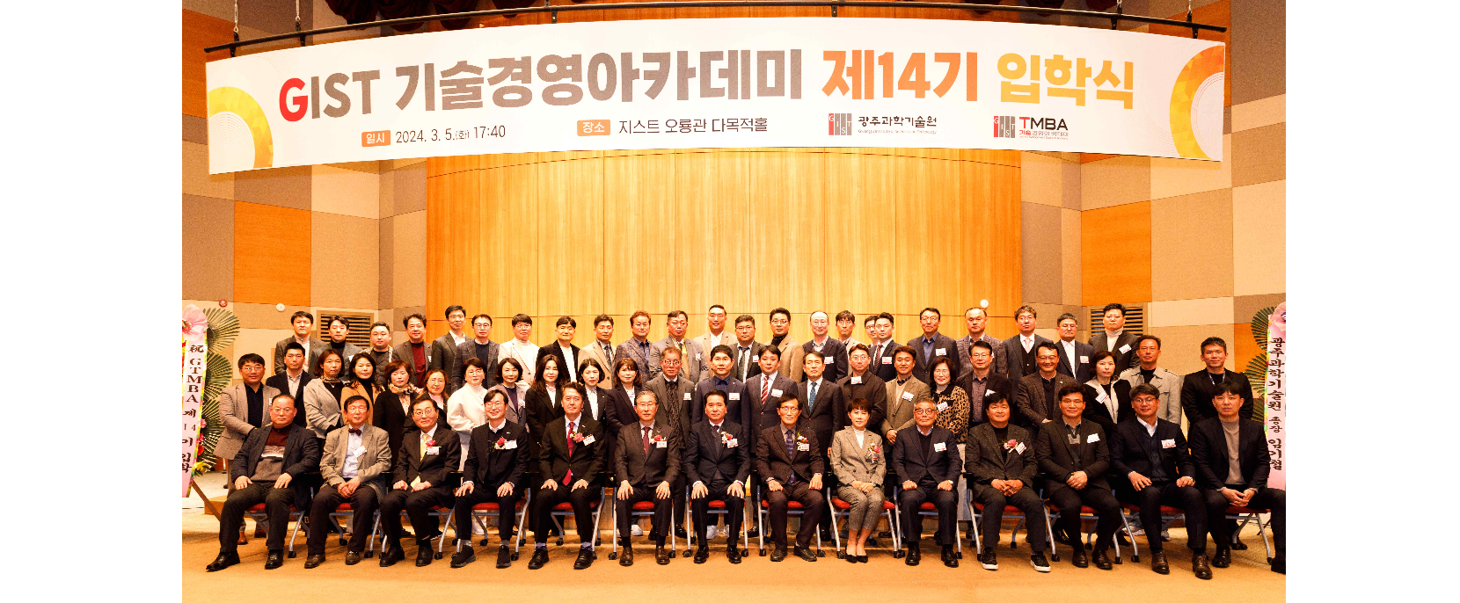▲ GTMBA held its 14th entrance ceremony at Oryong Hall on Tuesday, March 5th, and is taking commemorative photos.

The Gwangju Institute of Science and Technology (GIST, President Kichul Lim) and Techno Management Business Academy (GTMBA, Director Jae Gwan Kim) held its 14th entrance ceremony on Tuesday, March 5.

The event was held at Oryong Hall with the attendance of 51 GTMBA students and key officials including President Kichul Lim, Vice President for External Affairs Yonghwa Chung, Alumni Association President Yun-seop Kim, and GTMBA Director Jae Gwan Kim.

Meanwhile, a development fund donation ceremony was also held on this day by Gyeong-seop Shim, CEO of Intop Technology Co., Ltd., president of the 13th alumni association. The 10 million won donated by CEO Shim will be used for cooperation and mutual development with the region.

Established in 2004, Intop Technic Co., Ltd. is a company specializing in manufacturing primary and secondary battery production facilities and factory automation equipment. Based on its lithium primary battery manufacturing line manufacturing technology, it is recognized for its excellent quality in the cylindrical rotary equipment field and is achieving remarkable growth every year.

CEO Gyeong-seop Shim said, "With the hope for regional and national economic development, I decided to donate a development fund with the hope that GIST will go beyond the remarkable development and success it has achieved so far and stand tall as a world-class educational institution. I am confident that if GTMBA alumni practice sharing and giving as a central force in the local community, we will grow together with GIST."

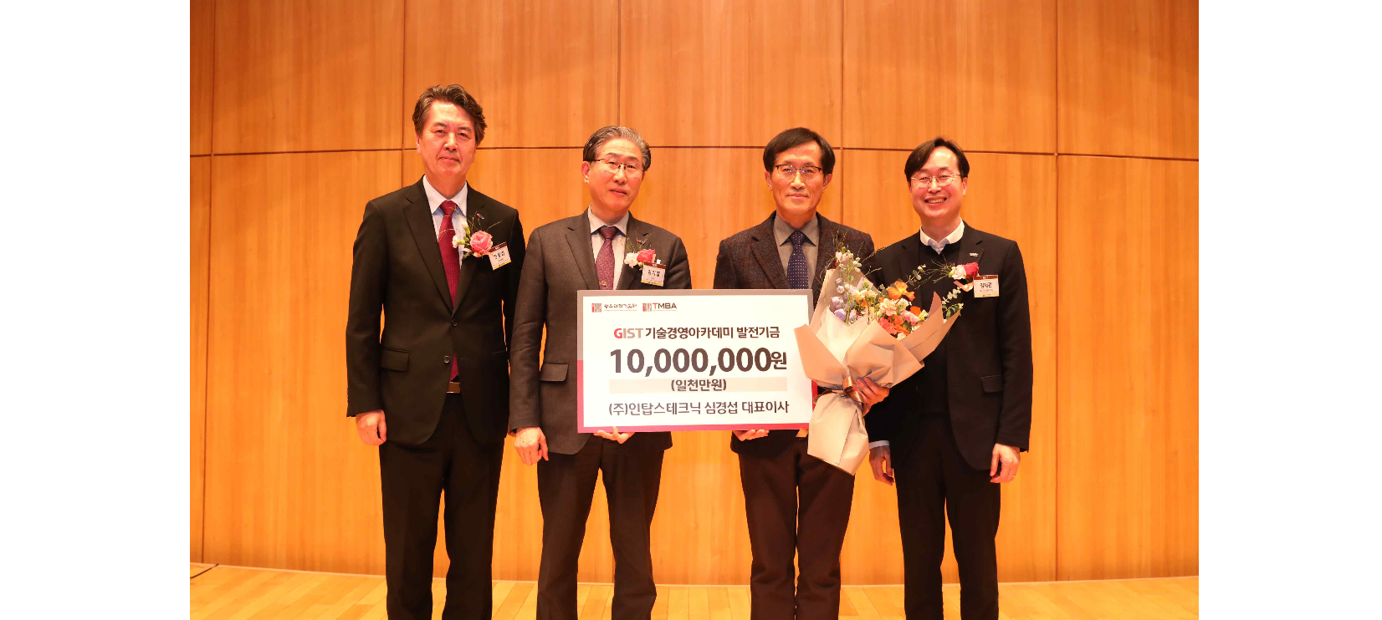▲ GTMBA is holding its 14th entrance ceremony at Oryong Hall on Tuesday, March 5th, and the 13th alumni president, Gyeong-seop Shim, and is holding a donation ceremony for the development fund. (From left) Vice President for External Affairs Yonghwa Chung, President Kichul Lim, Gyeong-seop Shim, CEO of Intop Technique Co., Ltd., and GTMBA Director Jae Gwan Kim.

President Kichul Lim said in his welcoming speech that day, "This year er expect to provide a venue for the exchange of the latest industrial technology knowledge information and a wide range of human networks for successful management activities in the digital transition business environment by organizing the nation's highest-level instructors and curriculum."

He also said, "GTMBA alumni will be able to create groundbreaking growth momentum through GIST's unique programs and cooperation between local, industrial, and academia, such as new start-ups, technology transfer, patents, and research institute establishment."

GIST Academy, now in its 14th year since opening the Top Technology Management Course in 2010, serves as a hub for industry-academia cooperation and business through systematic CEO education programs. Approximately 530 alumni produced to date are active as global leaders in various fields of society.

In particular, for the balanced development of local industries, an additional program in the eastern region (Yeosu, Suncheon, Gwangyang) will be opened in September and classes will be held in Suncheon City on topics such as the latest science and technology and global management issues.



