“As an R&D base supporting cutting-edge device analysis research,” GIST holds a sign-hanging ceremony at the Institute for Research Facilities

-Introduction of cutting-edge research equipment and advancement of equipment operation system to strengthen university research competitiveness
- Online one-stop service provided through the research equipment integrated management system (gaia.gist.ac.kr)

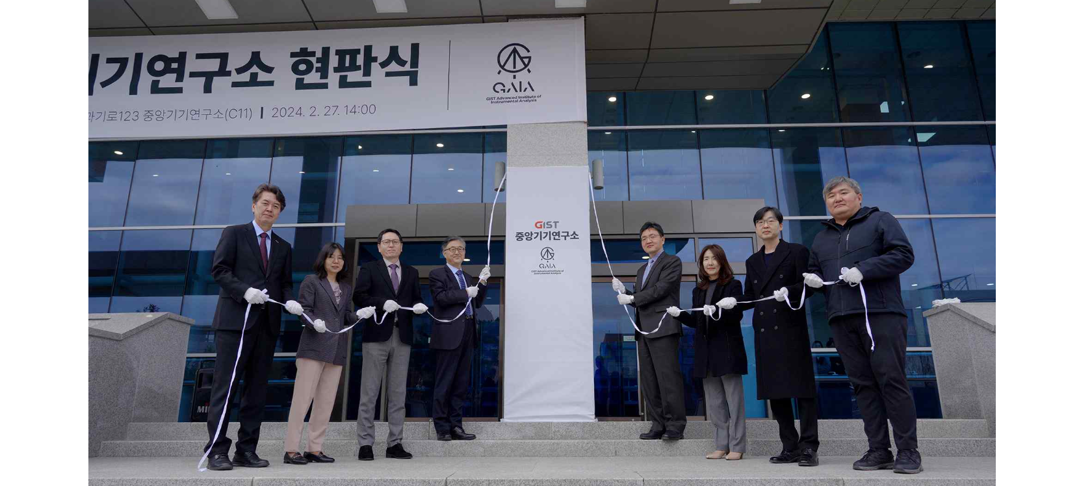▲ GIST Institute for Research Facilities Center is holding a sign hanging and tape cutting ceremony on the 27th (Tuesday). (From left) GIST Vice President for External Affairs Yonghwa Chung, Library and Information Resources Dean Hyunju Lee, Vice President for Academic Affairs Sang-Don Kim, Vice President for R&DB Kwanghee Lee, Institute for Research Facilities Director Tae-Young Kim, Institute for Artificial Intelligence Director Hojung Nam, Research Institute for Solar and Sustainable Energies Director Sanghan Lee, and International Environmental Research Institute Director Jin-Ho Yoon

The Gwangju Institute of Science and Technology (GIST, President Kichul Lim) announced that it held a signboard hanging ceremony at the Institute for Research Facilities (Director Tae-Young Kim, Professor of the School of Earth Sciences and Environmental Engineering) on Tuesday, February 27.

The 'GIST Advanced Institute of Instrumental Analysis (GAIA)', which opened as the 'Central Research Instrument Center' in June 2019 in order to build cutting-edge research equipment and centralize major research equipment within the university, is aimed at improving research efficiency and joint use. In order to maximize its performance and become the center of research and development in the southwestern region, it was upgraded to a research institute in November last year.

The sign-hanging ceremony held on this day to announce the new start of the ‘Institute for Research Facilities’ system was attended by Vice President for R&DB Kwanghee Lee, research institute officials, and equipment analysis experts from the four major science and technology institutes.

The institute is organized into four research equipment operation departments (electron microscopy, biospectroscopy, mass, and surface/property) and five research divisions (instrumentation, data analysis, environmental analysis, analytical equipment development (planned), and electronic equipment support (planned)).

Representative analysis equipment owned or planned by the laboratory include: ▴ High-resolution double spherical aberration-corrected transmission electron microscope (Cs-TEM) ▴ Confocal Laser Scanning Microscope (CLSM) ▴ Holotomography ▴ Liquid/Gas Chromatography Quadrupole Time Flight Vehicle Mass Spectrometry (LC/GC-QTOF-MS) ▴ 600MHz nuclear magnetic resonance spectroscopy (600MHz NMR) ▴ Spectroscopic ellipsometer (Ellipsometer) ▴ X-ray photoelectron spectroscopy (XPS) ▴ X-ray diffraction analyzer (XRD) ▴ a high-speed 5-axis machining center, and a new one this year ▴ Cryogenic high-resolution transmission electron microscopy (Cryo-EM) ▴ X-ray photoelectron spectroscopy (XPS) ▴ Advanced and expensive equipment such as environmental scanning electron microscope (E-SEM).

All equipment built at the Institute for Research Facilities is subject to joint use services, and all usage procedures, including real-time reservations and analysis results, are provided to users as an online one-stop service through the 'Research Equipment Integrated Management System (gaia.gist.ac.kr)'.

In addition, the research institute opened user training courses to increase accessibility to research equipment and to use it efficiently, and seminars are held regularly to improve analysis methods and research capabilities.

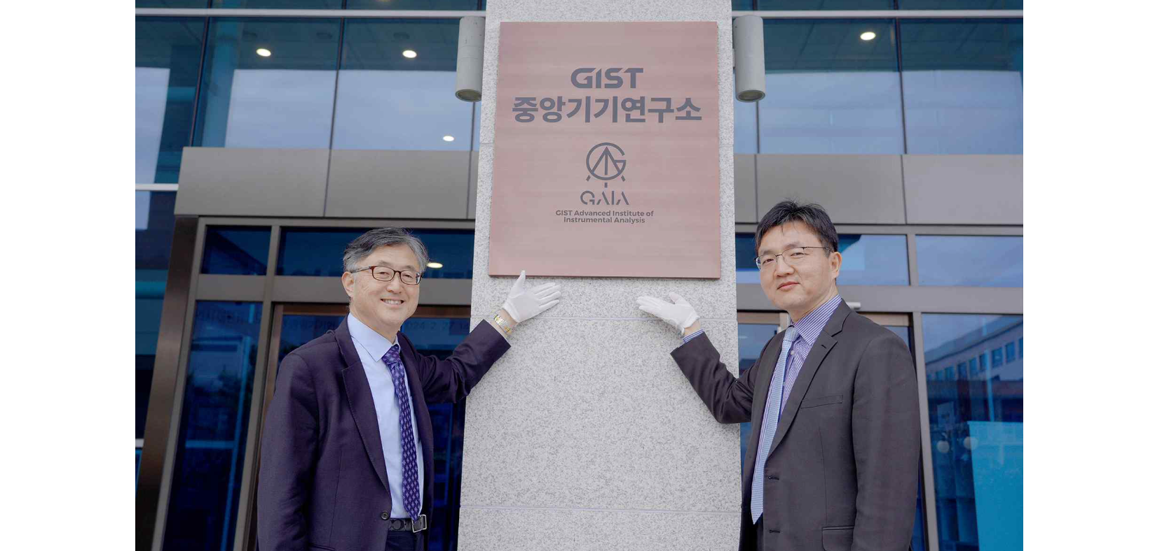▲ Vice President for R&DB Kwanghee Lee (left) and Institute for Research Facilities Director Tae-Young Kim (right) are taking a commemorative photo at the GIST Institute for Research Facilities signboard hanging ceremony held on Tuesday the 27th.

Vice President for R&DB Kwanghee Lee said, "In order to strengthen the research competitiveness of the entire university, it is necessary to introduce cutting-edge research equipment and upgrade the equipment operation system. We hope that the Central Instrumentation Research Institute will take the lead in providing a better research and development environment by developing the latest analysis technology and supporting innovative research."

Institute for Research Facilities Director Tae-Young Kim said, "We will promote joint use through the construction of new cutting-edge research equipment and establish a cooperative analysis research system to grow into a ‘base for domestic and international instrument analysis research and development’. We will actively support the highest level of instrumental analysis research through stable construction of cutting-edge joint research equipment and systematic equipment management."f

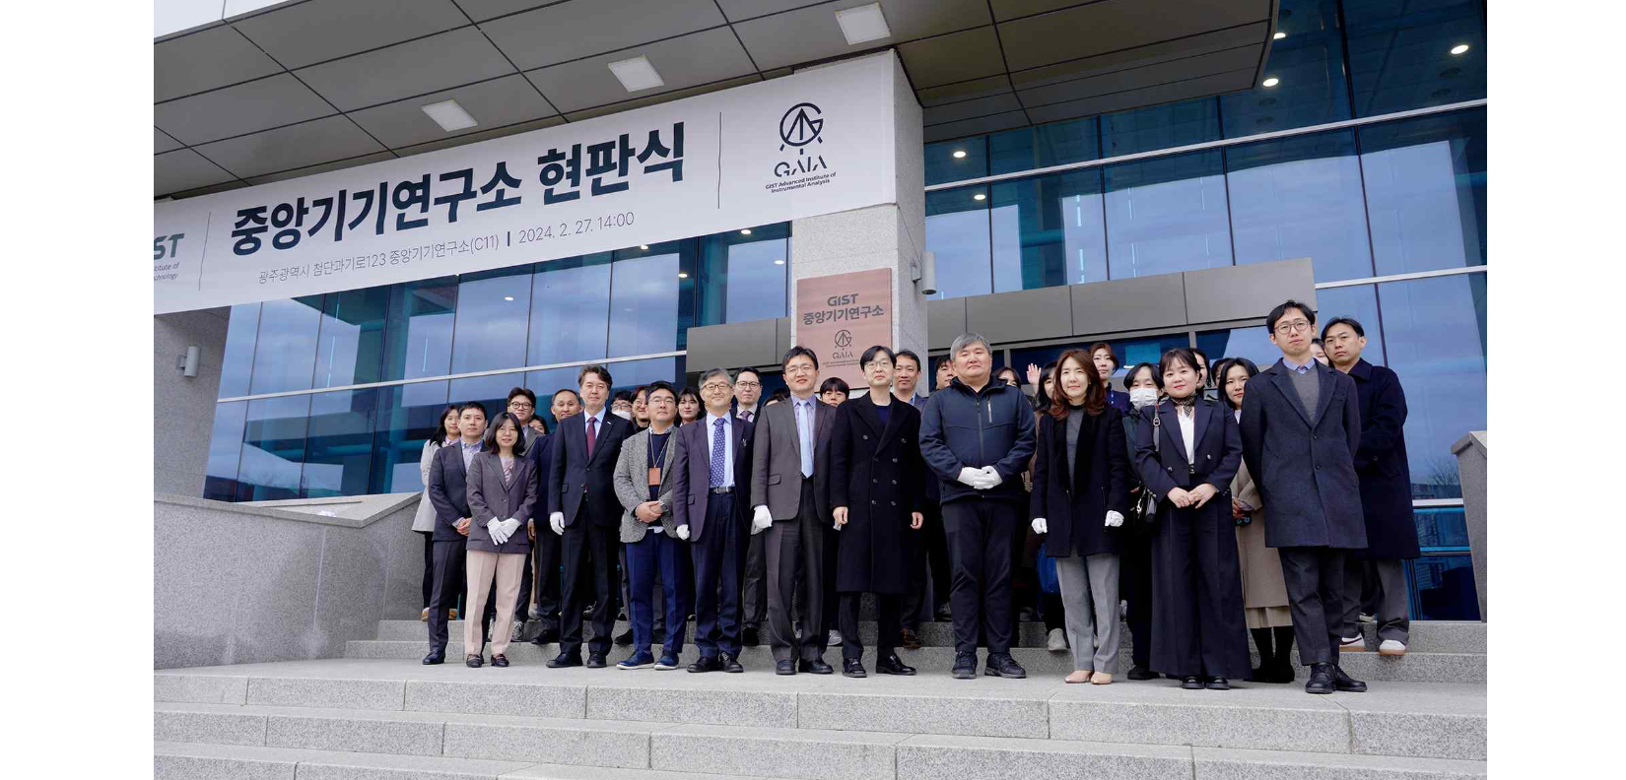▲ Attendees are taking commemorative photos at the GIST Institute for Research Facilities’s signboard hanging ceremony.



