GIST-University of Bern, Switzerland-KARI-Hanwha Systems International sign joint research MoU to realize space optical network

- Globally competitive domestic optical communication technology expands into the space field... Expecting international cooperation in the space laser communication field
- GIST Advanced Photonics Research Institute plans to continue securing key light source and electro-optical technologies for the development of high-speed optical communication technology that will lead the new space era

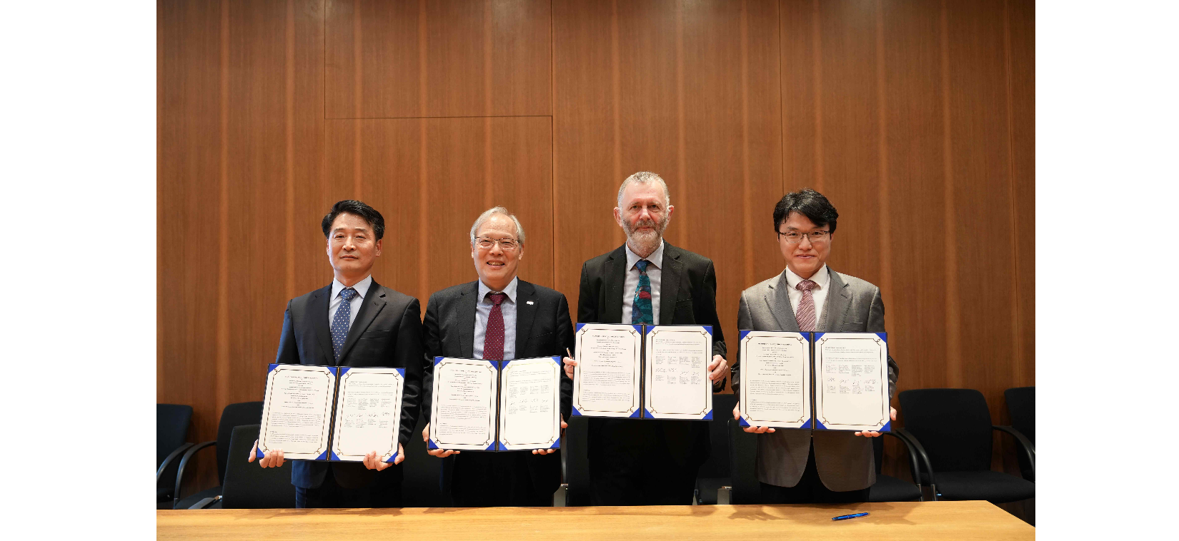▲ GIST Advanced Optical Technology Research Institute signed a ‘Joint Research Memorandum of Understanding (MoU) for the Development of Space Optical Communication Technology’ at the University of Bern, Switzerland on Monday, February 26th. (From left) KARI Future Innovation Center Director Moon-gyu Jeong, GIST Advanced Photonics Research Center Director Do-Kyeong Ko, Bern University Space Research and Planetary Science Research Department Director Professor Nicolas Thomas, and Hanwha Systems Electro-Optics Research Center Director Ki-young Park

The Gwangju Institute of Science and Technology (GIST, President Kichul Lim) announced that the Advanced Photonics Research Institute (Director Do-Kyeong Ko) signed a ‘Joint Research Memorandum of Understanding (MoU) for the Development of Space Optical Communication Technology’ at the University of Bern, Switzerland on Monday, February 26.

This four-party business agreement to develop inter-satellite communication technology using lasers in space includes ▴ GIST Advanced Photonics Research Institute ▴ Space Research & Planetary Sciences, University of Bern, Switzerland ▴ Korea Aerospace Research Institute (KARI) Future Innovation Research Center and ▴ Hanwha Systems Electro-Optics Research Center.

The agreement ceremony included ▴ GIST Advanced Photonics Research Institute Director Director Do-Kyeong Ko and Senior Researcher Woojin Shin ▴ Professor Nicolas Thomas and Chief Engineer Dr. Daniele Piazza, Director of the Department of Space Research and Planetary Science, University of Bern, Switzerland ▴ Director Mun-gyu Jeong of KARI Future Innovation Research Center ▴ Hanwha Systems Electro-Optics Ki-young Park, head of Team 1 of the research institute, attended and discussed ▴ mutual technology exchange ▴ facility support ▴ human resource exchange and joint research project promotion for research cooperation in the space laser communication field.

As the only optics and laser research institute in Korea that specializes in space and defense, the Advanced Photonics Research Institute has been conducting research collaboration in the field of lasers and optics with the Institute of Applied Physics at the University of Bern, Switzerland, since 2009.

In addition, they are actively conducting research on inter-satellite laser communication terminal technology with Hanwha Systems, and are particularly focusing on building a demonstration platform (G-SPACE) for the development of inter-satellite laser communication and laser communication technology between the ground and satellite.

Through this agreement, the Advanced Photonics Research Institute is expected to expand its research field with partner organizations beyond its existing research fields to aerospace and conduct research that expands its usability to the space and satellite fields.

Director Director Do-Kyeong Ko said, "Through this agreement, our laboratory plans to continue to secure the light source and electro-optical technologies needed to develop high-speed optical communication technology that will lead the New Space era. In addition, starting with the opening of the Aeronautics and Space Administration scheduled for May 24, we expect that Korea will be able to expand its competitive optical communication technology in the ICT field to the space field."



