GIST holds entrance ceremony for 2024 school year... 505 ‘2nd generation GIST’ protagonists standing at the starting line

- A total of 505 students enrolled, including 236 in the bachelor's program, 158 in the master's program, 60 in the combined master's and doctoral program, and 51 in the doctoral program.
- Welcoming speech by Dr. Sang-Jun Lee (scheduled to be appointed as professor in July), the first graduate of the undergraduate program... A special impression was delivered

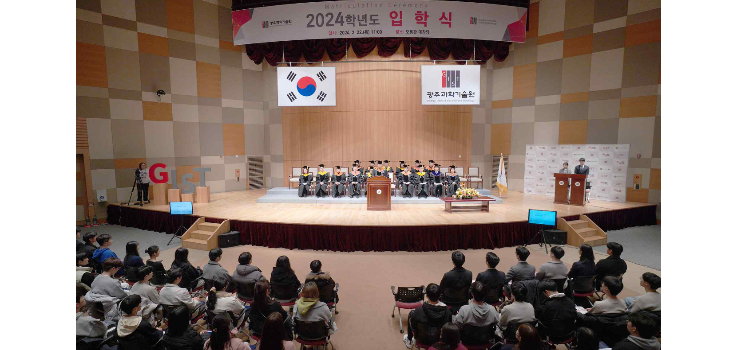▲ The 2024 school year entrance ceremony was held at 11 a.m. on the 22nd (Thursday) in the Oryong Hall main auditorium.

The Gwangju Institute of Science and Technology (GIST, President Kichul Lim) announced that it held the entrance ceremony for the 2024 school year at the Oryong Hall main auditorium at 11 a.m. on the 22nd (Thursday).

A total of 505 new students enrolled on this day, including 236 in the bachelor's program, 158 in the master's program, 60 in the combined master's and doctoral program, and 51 in the doctoral program.

The entrance ceremony began with an academic report by Academic Affairs Dean Sukwon Hong, followed by a declaration of admission by President Lim Ki-cheol and gave new student representative’s ‘Admission Oath’ and the reading of ‘GIST Spirit’ to students ▴ Young-Hoon Jeon (School of Materials Science and Engineering, PhD candidate) ▴ Taeyoon Kim (School of Earth Sciences and Environmental Engineering, Integrated Course) ▴ Suji Jo (Department of Physics and Photon Science, Master’s Candidate) ▴ Seungbin Won (Department of Semiconductor Engineering, undergraduate course). Presidential scholarship certificates were awarded to 12 students with excellent admission scores.

In particular, on this day, Dr. Sang-Jun Lee, a graduate of the first class of GIST's bachelor's program in 2010, stood up on the podium to congratulate the juniors on their admission and expressed a special emotion.

Dr. Sang-Jun Lee, who graduated from GIST's School of Life Sciences (advisor: Professor Chunghee Cho) in August 2014 and earned a master's and doctoral degree in neurobiology from the California Institute of Technology (Caltech), is scheduled to take up his position as a professor in the Department of Biomedical Science and Engineering in July.

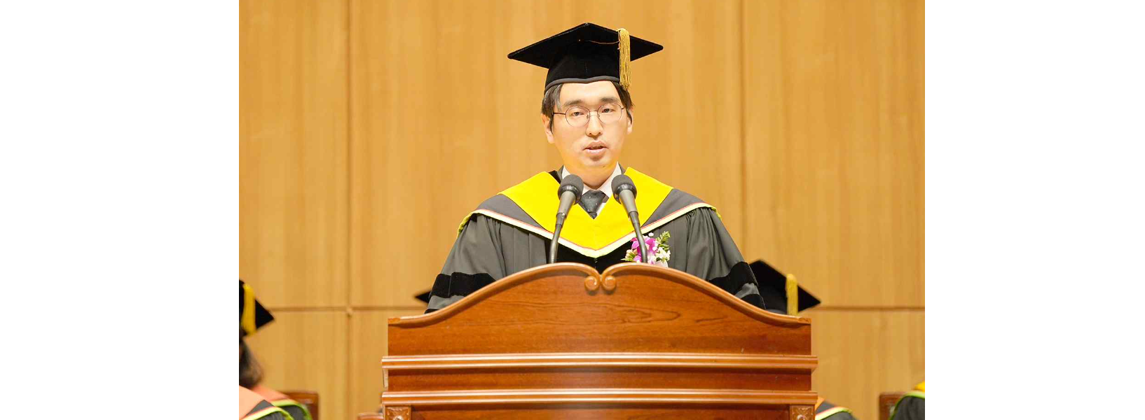▲ Dr. Sang-Jun Lee, the first graduate of the undergraduate program, is giving a welcoming speech.

In his welcoming speech that day, Dr. Sang-Jun Lee said, "I am very honored to stand here as GIST's first undergraduate graduate. As someone who has walked the path ahead of you, I have experienced first-hand how influential GIST’s education and values are. GIST has provided a foundation for many graduates, including me, to be active in various fields of society. We were able to grow with GIST as the stage. At GIST, I hope that by turning challenges into opportunities, you will each be able to focus on pioneering your own path and realizing your own dreams. Let us start this new journey together."

At the entrance ceremony, President Kichul Lim said, "Generations are usually divided into 30-year increments, but GIST, which celebrated its 30th anniversary last year, is entering its 'second generation' with the admission of today's students. The first generation of GIST was a "small but very strong university," leading education and research in the field of science and technology in Korea, and creating outstanding results in entrepreneurship and technology commercialization."

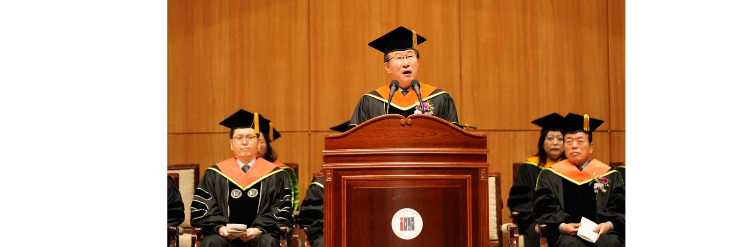▲ President Lim Ki-cheol is speaking at the entrance ceremony.

President Lim also said, "The new students entering today are the protagonists of the ‘2nd generation GIST’ and the future of Korea’s science and technology. The GIST campus, which is energized by the youth and excitement of new students, is empathetic, communicative, and considerate. I hope that we will mature into a more ‘mature society’ where bonds and trust are built through sharing."

Meanwhile, at the entrance ceremony on this day, freshmen who were finally accepted into the Samsung Electronics recruitment-linked semiconductor engineering department, which was newly established this year to cultivate semiconductor experts and attracted attention by recording a high competition rate of about 70 to 1 in regular recruitment, also attended the entrance ceremony.

GIST, which celebrated its 30th anniversary last year, introduced the liberal arts college education system for the first time in Korea in the bachelor's program, offering a variety of subjects in the fields of mathematics, science, humanities, social studies, and arts and physical education to a small number of elite students with humanities knowledge. While nurturing global science and technology leaders, 53 graduates who received doctoral degrees at the graduation ceremony held on the 16th (Friday) published an average of 5.6 papers per person in SCI (Science Citation Index) level academic journals while attending school, showing an authentic research-oriented university by publishing.



