“Graduates, please expand the surface area of good coincidences” GIST 2023 commencement ceremony held

- Among a total of 263 degree recipients (53 doctoral degrees, 113 master's degrees, 97 bachelor's degrees), 13 foreigners received master's and doctoral degrees
- Ph.D. graduates publish an average of 5.6 papers per person in SCI-level journals... Foreign siblings even graduate together
- Congratulatory remarks were given by Joo-sun Park, Chairman of the GIST Development Support Group, and Hashed CEO Seo-jun Kim... Video congratulatory remarks by Minister of Science and Technology Jong-ho Lee, and Young Lee, former Minister of SMEs and Startups

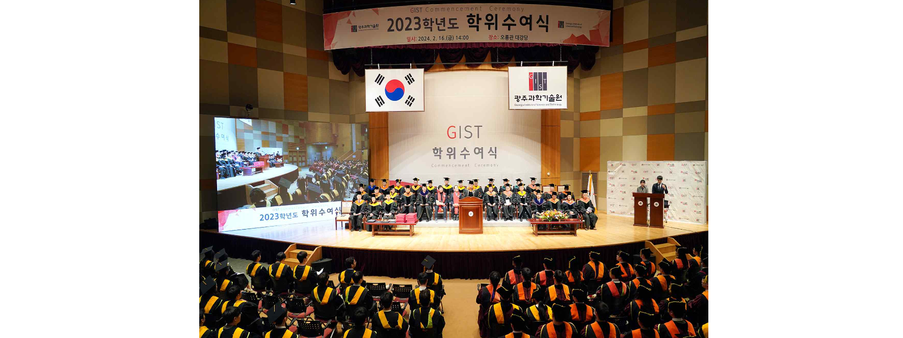▲ The 2023 graduation ceremony was held at the Oryong Hall auditorium on Friday the 16th.

The Gwangju Institute of Science and Technology (GIST, President Lim Ki-cheol) announced that it held the 2023 graduation ceremony at the Oryong Hall main auditorium at 2 p.m. on Friday the 16th.

On this day, GIST awarded degrees to 263 people, including 53 doctorates, 113 master's degrees, and 97 bachelor's degrees. At this graduation ceremony, GIST produced 13 foreign graduates from a total of 8 countries, including Pakistan (5 students), Vietnam (2 students), Mongolia, India, Kazakhstan, Honduras, Ethiopia, and Bangladesh.

As a result, since its establishment in 1993, GIST has produced a total of 8,178 high-level science and technology personnel, including 1,891 doctorates, 5,023 master's degrees, and 1,264 bachelor's degrees, over the past 30 years.

Following video congratulatory remarks by Minister of Science and ICT Jong-ho Lee and former Minister of SMEs and Startups Young Lee, GIST Development Support Chairman Joo-sun Park and Hashed CEO Seo-jun Kim came up to the podium to deliver congratulatory remarks.

Joo-sun Park, Chairman of the Korea Petroleum Association (former Vice-Chairman of the National Assembly, Chairman of the Presidential Inauguration Preparation Committee), who serves as the Chairman of the GIST Development Support Committee, said, "At the crossroads of countless choices, I had the courage to choose the path I thought was right, and once I had the courage, I was able to choose the right path without difficulty the next time."

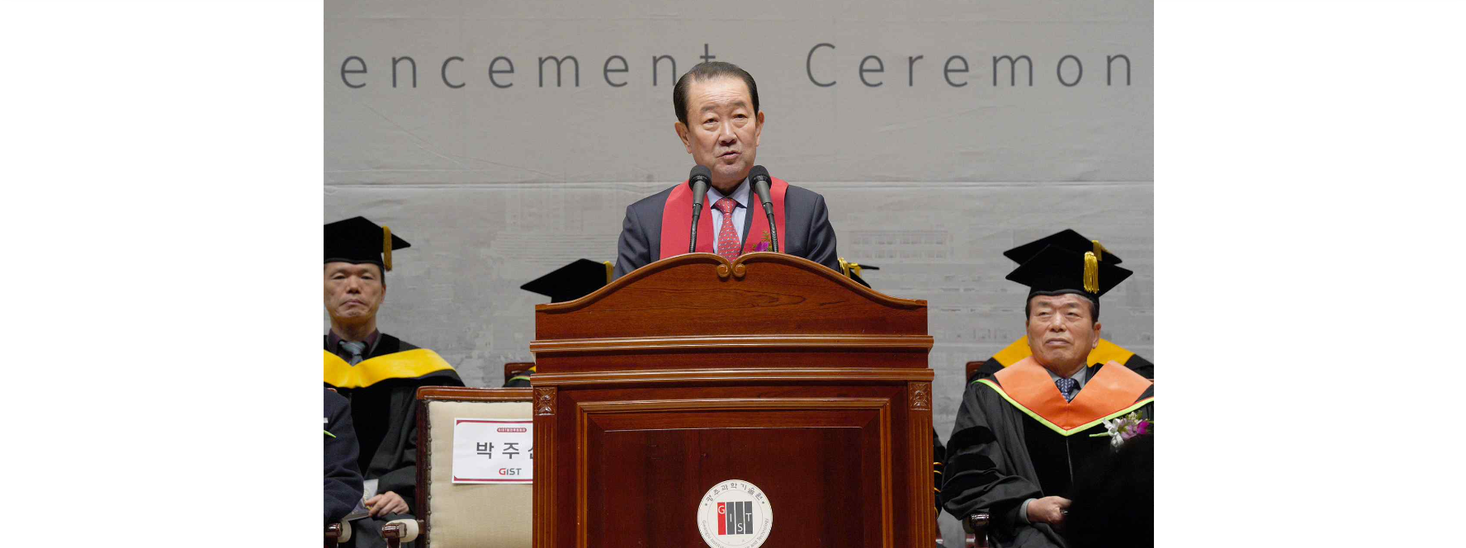▲ GIST Development Support Group Chairman Joo-sun Park (former Vice-Chairman of the National Assembly and Chairman of the Presidential Inauguration Preparation Committee) is giving a congratulatory speech.

Chairman Park also said, "When we are young like you, there are bound to come moments when we worry about a challenge, but once we take on a challenge, our lives gain new momentum, and a path to follow naturally emerges as we experience failure and success. Don’t be afraid of failure and take the ‘path of justice’ again and again."

CEO Seo-jun Kim, who graduated from Seoul Science High School and studied at POSTECH's Computer Engineering Department, sincerely told a story based on his life as a senior engineer and a "role model" of a young scientific engineer who succeeded in starting a deep tech business and achieved remarkable results.

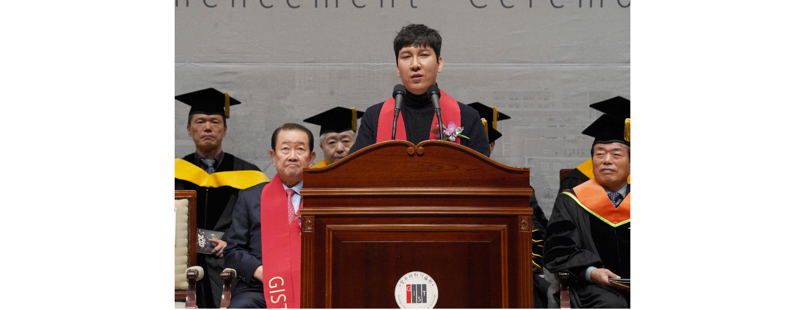▲ Seo-jun Kim, CEO of Hashed, is giving a congratulatory speech at the GIST graduation.

CEO Kim said, "I thought the congratulatory speech was too much for my achievements and status, but since I am not much different in age or experience from those of you who are graduating today, I am here with the thought that I will be able to tell you something more touching. When I was six years old, I began to fall in love with the magic of science and technology through the ‘coincidence’ of receiving a car toy that ran on an electric motor as a gift from my parents."

And then he said, "If someone asks you about the ‘purpose function’ of living a worthwhile life, the answer is ‘It is to expand the surface area of good coincidences. ▴ First, get out of your comfort zone and make uncomfortable choices. ▴ Second, establishing my own perspective that overturns existing rules. ▴ Third, I sincerely hope that the ‘surface area of good coincidences’ can be further expanded through three principles such as having an identity as a ‘citizen of a network country’ rather than as a ‘citizen of the Republic of Korea.’"

It was confirmed that the 53 doctoral students who received their degrees this time published an average of 5.6 papers per person in SCI (Science Citation Index) level academic journals during their time in school.

The Excellence in Research Award (Minister of Science and ICT Award) was received by Dr. Minh Phu Bui (Advisor Professor Jung Won Yoon) from the School of Integrated Technology as the first foreign student. Dr. Minh Phu Bui, who published 10 papers in SCI-level international academic journals while attending school, participated as first author in 5 of them. He achieved the success of applying for two domestic patents and one foreign (US) patent.

Seon-su Kim, a bachelor's degree graduate from the School of Mechanical Engineering who received the Outstanding Research Award (Future Talent Award), was a summa cum laude graduate and won the Future Talent Award as well as the Outstanding Paper Award, making him a ‘triple winner’.

It was also noteworthy that foreign siblings received their degrees at the same time. They are Dr. Zafran Khan from the School of Electrical Engineering and Computer Science (advisor Professor Moongu Jeon) and master's student Zeeshan Khan (advisor Professor Byung-Geun Lee) from the same department. Dr. Zafran Khan received the Excellent Research Award (Korea Atomic Energy Research Institute Director's Award) in recognition of his research performance in artificial intelligence and machine learning. The younger brother, who received his master's degree, plans to follow in his older brother's footsteps and enter the GIST doctoral program to continue his research in the field of deep learning.

President Kichul Lim said, "We hope that our graduates will continue to take on the challenge of facing the big world based on deep consideration of new paths rather than staying within the confines of their major knowledge. We support the beautiful youth of our graduates who will wisely overcome obstacles big and small at times and grow to an extent where the end is unknown."

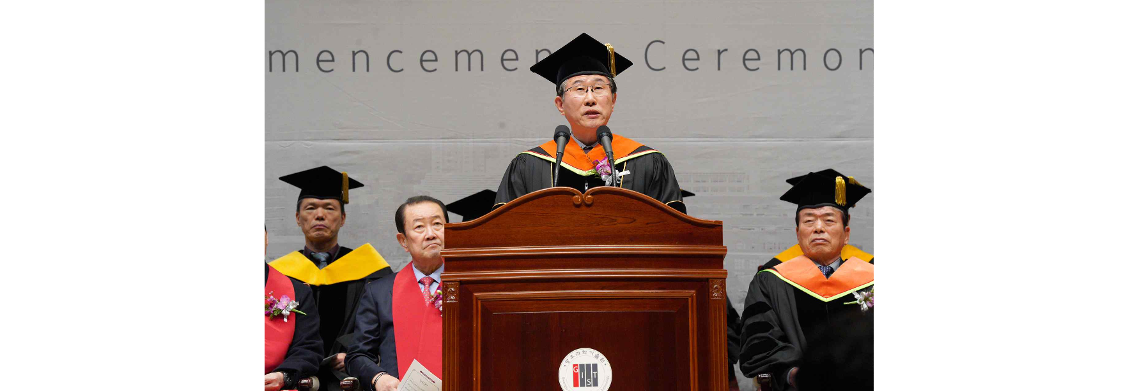▲ President Kichul Lim is giving an address at the commencement ceremony.



