GIST holds a graduation ceremony on the 16th... More than 8,000 graduates, with congratulatory remarks from former National Assembly Vice Speaker Joo-sun Park and Hashed CEO Seo-jun Kim

- A total of 263 degrees are scheduled to be awarded, including 53 doctoral graduates, who published an average of 5.6 papers per person in SCI-level international academic journals... a total of 8,178 graduates.
- In congratulatory remarks, former Vice-Chairman Joo-sun Park of the National Assembly and Hashed CEO Seo-jun Kim... Minister of Science and ICT Jong-ho Lee and former Minister of SMEs and Startups Young Lee were also scheduled to deliver video congratulatory remarks

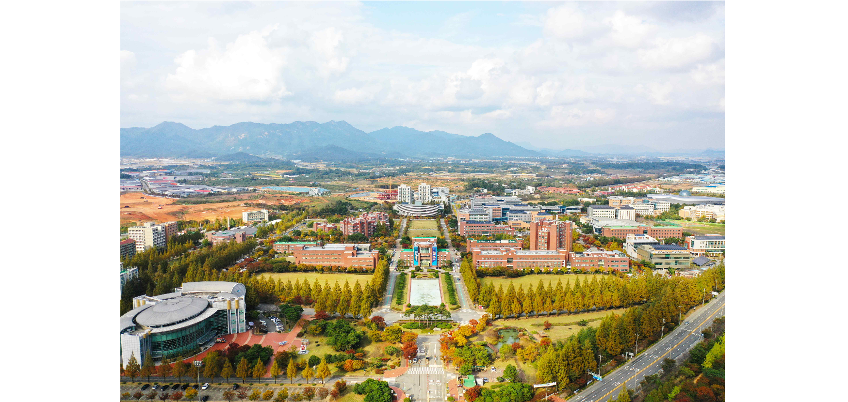▲ Panoramic view of GIST campus

The Gwangju Institute of Science and Technology (GIST, President Kichul Lim) announced that it will hold the 2023 graduation ceremony at the Oryong Hall main auditorium at 2 p.m. on Friday the 16th.

On this day, GIST plans to award degrees to 263 people, including 53 doctorates, 113 master's degrees, and 97 bachelor's degrees.

As a result, since its establishment in 1993, GIST has produced a total of 8,178 high-level science and technology personnel, including 1,891 doctorates, 5,023 master's degrees, and 1,264 bachelor's degrees, over the past 30 years.

This graduation ceremony was held with Joo-sun Park, Chairman of the Korea Petroleum Association (former Vice-Chairman of the National Assembly, Chairman of the Presidential Inauguration Preparation Committee), who serves as the Chairman of the GIST Development Support Committee. Seo-jun Kim, founder of Hashed, a blockchain investment company based in Seoul and San Francisco, drew attention by delivering a congratulatory speech.

Joo-sun Park, chairman of the GIST Development Support Committee, has a background in the legal profession. He served as the legal secretary in the Presidential Secretariat (1998-99), served as a four-term member of the National Assembly in 16.18.19.20, and served as vice-chairman of the National Assembly in the first half of the 20th National Assembly. To GIST graduates, Chairman Park will look back on the path he has walked with a sense of mission and urge them to “walk vigorously on the ‘path of justice towards emerging science and technology.’”

Meanwhile, CEO Kim (39 years old), who graduated from Seoul Science High School and POSTECH's Department of Computer Engineering, founded Hashed in 2017 with the conviction that virtual assets (cryptocurrency) are a core technology that will lead innovation in the next generation industry, and operates 86 blocks around the world. He is the person who developed it into Asia's largest venture capital (VC) that invests in chain-related startups. Attention is focused on what message CEO Kim will deliver to GIST graduates as a ‘role model’ for young scientists and engineers.

In addition, Minister of Science and ICT Jong-ho Lee and former Minister of SMEs and Startups Lee Young will also congratulate and encourage GIST graduates on obtaining their degrees through video congratulatory remarks.

President Kichul Lim said, "We asked some inspiring people to give congratulatory speeches to our graduates, who will have many questions about how to choose a direction for their lives and how to find the courage to take on challenges. We wish our graduates the best of luck in their beautiful youth, as they will face challenges, both big and small, and will grow into something that will never end."

Meanwhile, according to GIST, 53 doctoral candidates published an average of 5.6 papers per person in SCI (Science Citation Index) level international journals during their studies.



