Yun-seop Kim, Chairman of Hanyoung P&S Co., Ltd., inaugurated as President of GIST Techno Management Business Academy Alumni Association

- Following the 6th chairman, Seung-jong Na, CEO of Hyojin Co., Ltd., he took on the role of the 7th president of the alumni association... Inauguration ceremony held on the 30th

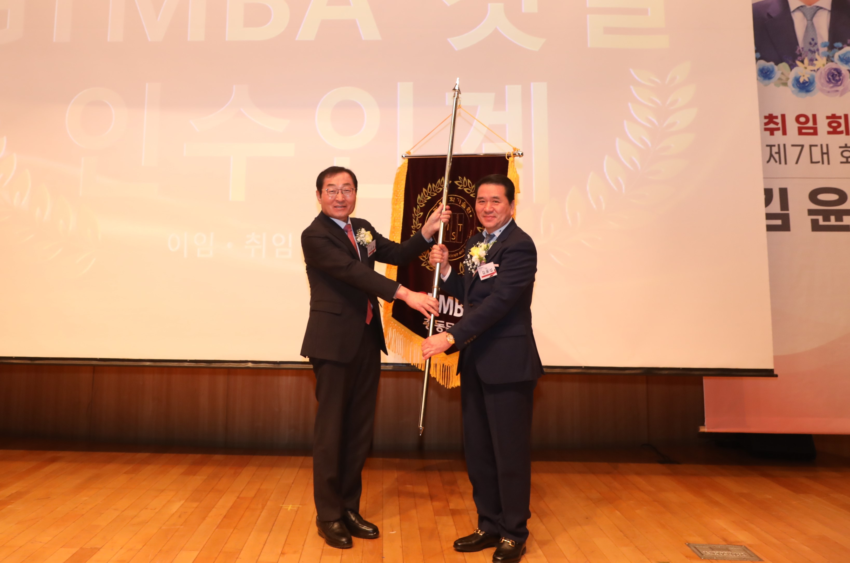▲ Yun-seop Kim, the 7th Alumni Association President (right), is receiving the GTMBA flag from the 6th Alumni Association President Seung-jong Na (left).

The Gwangju Institute of Science and Technology (GIST, President Kichul Lim) announced that the Techno Management Business Academy (GTMBA) Alumni Association held the 10th regular general meeting of GTMBA and an inauguration ceremony of the alumni association president at Oryong Hall on Tuesday, January 30.

At the event on this day, GIST Vice President for External Affairs Yonghwa Jeong and Chairman Seung-jong Na of Hyojin Co., Ltd., the 6th President of the Alumni Association, attended the event. With GIST Development Foundation Chairman Hae-myeong Kim and about 80 alumni in attendance, Hanyoung PNS Co., Ltd. Chairman Yun-seop Kim was elected as the 7th Alumni President.

At the event on this day, GIST Vice President for Public Affairs Yonghwa Jeong and Chairman Seung-jong Na of Hyojin Co., Ltd., the 6th President of the Alumni Association, attended the event. With GIST Development Foundation Chairman Hae-myeong Kim and about 80 alumni in attendance, Hanyoung PNS Co., Ltd. Chairman Yun-seop Kim was elected as the 7th Alumni President.

Hanyoung P&S Co., Ltd., of which GTMBA 8th class alumnus Yun-seop Kim serves as CEO, is a metal spring manufacturer, including steel processing and mold manufacturing, established in 2012. It is located in Hanam Industrial Complex, Gwangsan-gu, Gwangju, and produces refrigerators, washing machines, air conditioners, etc. The company mainly manufactures home appliance parts such as doors, ice crushers, and springs.

In his inauguration speech,Yun-seop Kim, the 7th President of the Alumni Association said, "I will do my best to help the GTMBA Alumni Association take a new leap forward through new projects during my term. We will further solidify and develop our achievements so far and create an alumni association that respects and encourages one another."

Seung-jong Na, the 6th President of the Alumni Association, who led the Alumni Association for the past year, said in his resignation address, "We were able to successfully lead the GTMBA Alumni Association with the generous love and support of our alumni. We would like to express our deepest gratitude to the six executives and executives of the Alumni Association, GIST officials, and GTMBA alumni for their loving interest and support."

▲ GTMBA is holding the 10th regular general meeting and inauguration ceremony for the alumni association president and taking commemorative photos.

GIST Academy operates the Techno Management Business Academy (GTMBA, opened in 2010) as a non-degree program. Starting this year, it is opening a GTMBA Eastern Region course and recruiting the first batch of new students.

GIST Academy helps managers in each field gain a deep understanding of changes in the corporate environment and global management strategies through lectures by Korea's best experts, and forms a broad human network, contributing to the revitalization of the local economy and industry-academia cooperation.



