GIST to discuss ways to foster and cooperate with the Jeju Special Self-Governing Council for the elderly-friendly industry

- Sharing of local senior-friendly industry development status and best practices
- Expect mutual cooperation and synergy effects to promote senior-friendly industries

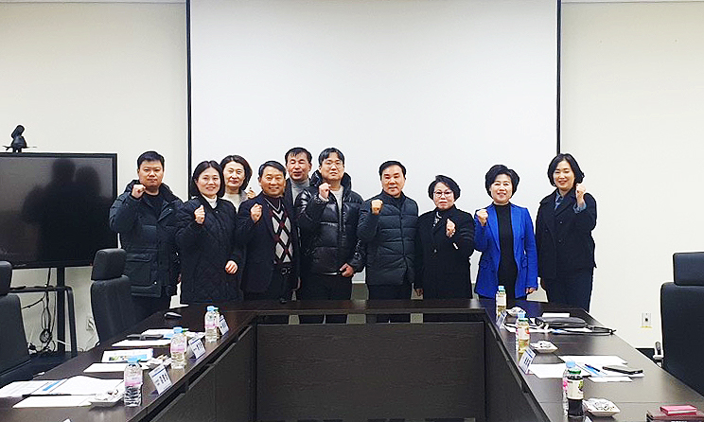▲ GIST Senior-Friendly Industry Support Center and Jeju Special Self-Governing Province Council are taking a commemorative photo after discussing ways to cooperate with senior-friendly industries.

The Gwangju Institute of Science and Technology (GIST, President Lim Ki-cheol) and the Senior-Friendly Industry Support Center (Center Director Chang-Myung Oh, hereinafter referred to as the Center) invited the Jeju Special Self-Governing Provincial Council (Chairman Gyeong-hak Kim) on the 29th (Monday) to discuss cooperation plans for local senior-friendly industry innovation.

The Jeju Special Self-Governing Provincial Council visited the Senior-Friendly Industry Support Center on this day to seek welfare policy directions to prepare for an aging society and benchmark best practices in the current status of fostering senior-friendly industries.

A total of 11 people, including Jeju Special Self-Governing Provincial Council Vice Chairman Yang Byeong-woo, lawmakers Ha-young Kang, Hwa-ja Won, Gyeong-sim Lee, Yongbeom Park, team leader of the Gwangju Robot Home Appliance Medical Industry Department, and other officials attended, and Center Director Chang-Myung Oh explained the status of fostering senior-friendly industries and operating the center and introduced major facilities.

In particular, the Jeju Special Self-Governing Province Council showed great interest in corporate support cases utilizing the CosMedicare usability evaluation environment and the practical environment verification infrastructure based on the daily life living lab, which is one of the know-how and excellent results accumulated by the GIST Senior-Friendly Industry Support Center and discussed ways to combine the capabilities of both organizations and cooperate in the future.

Center Director Chang-Myung Oh said, "This visit to the Jeju Special Self-Governing Provincial Council's center is meaningful in that it establishes a new collaboration channel to promote senior-friendly industries and create synergy. We will continue to strive to contribute to the development of the domestic senior-friendly industry by cooperating with the Jeju Special Self-Governing Province in various aspects such as verification and usability evaluation of the senior-friendly industry."

Meanwhile, the Senior-Friendly Industry Support Center has recently been designated by the Ministry of Health and Welfare as a ‘Regional Senior-Friendly Industry Innovation Center’ and has carried out projects such as the ‘Life Care Robot Demonstration Base Creation Project’ and the ‘Senior Cos Medicare Demonstration Center Construction Project’ and are leading the growth of local senior-friendly industries by creating remarkable results and establishing a foundation for related industries.



