GIST successfully holds the '2023 Culture Technology Future Forum' to predict the direction and future of culture technology

– Discussion of cooperation and future development in the advancement of cultural industries in the digital convergence era and the convergence of culture, art, and technology under the theme of ‘Cultural technology direction and future in the era of generative artificial intelligence’

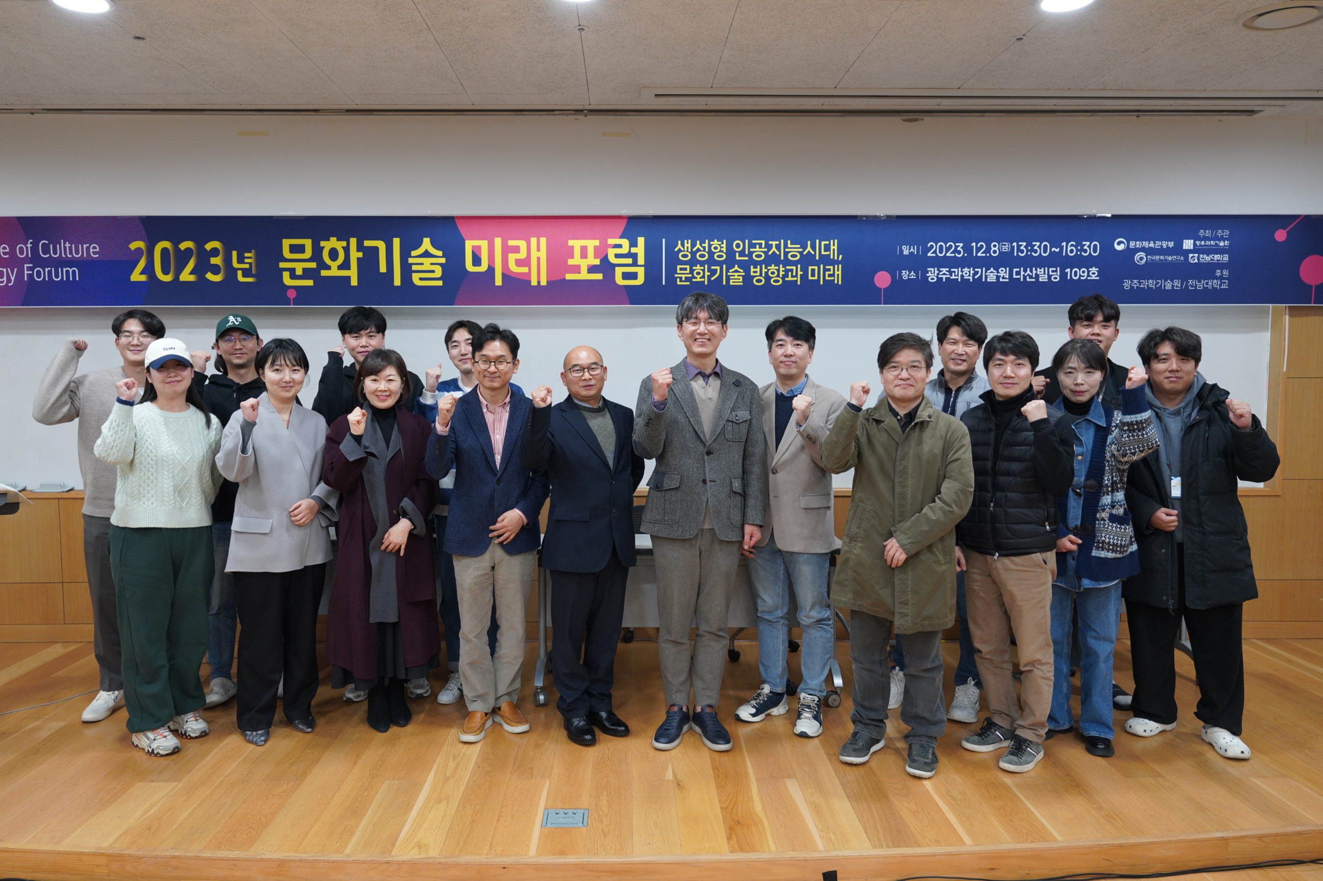▲ GIST Korea Culture Technology Research Institute successfully held the ‘2023 Culture Technology Future Forum’ at Dasan Building on Friday the 8th, and attendees are taking a group photo.

The Gwangju Institute of Science and Technology (GIST, President Kichul Lim) and the Korea Culture Technology Institute (Director Kyung-Joong Kim) announced that they successfully held the ‘2023 Culture Technology Future Forum’ to welcome the era of generative artificial intelligence.

This forum, which was held as part of the ‘CT Imagination Room Exhibition’ event that showcases the research and development achievements of the Korea Culture Technology Institute over the past year, was held under the theme of ‘the direction and future of cultural technology in the generative AI era’. It was prepared to advance the cultural industry in the digital convergence era and discuss cooperation and future development in the field of culture, art, and technology convergence.

The forum was co-hosted by GIST Korea Culture Technology Institute and Chonnam National University Graduate School of Culture and was held at GIST Dasan Building on the 8th (Friday) with Director Kyung-Joong Kim, Professor Chang Wook Ahn, GIST researchers, and researchers from participating companies in attendance.

The first session, on the theme of culture, technology, and art convergence and diffusion, was an AI-based music creation workshop with pre-recruited participants.

For about 20 selected participants, Creative Mind Co., Ltd. (CEO Jonghyun Lee) provided an experience of creating the music they wanted using artificial intelligence technology, which received a great response from the participants.

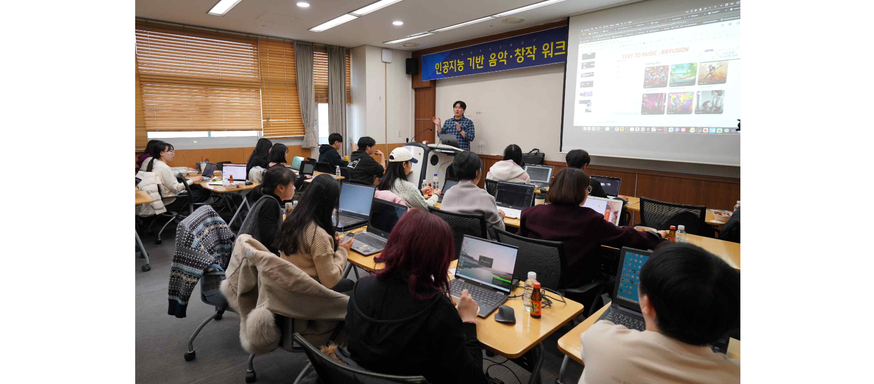▲ Creative Mind Co., Ltd. (CEO Jonghyun Lee), widely known for its AI composition, is providing an experience of creating the music you want using artificial intelligence technology.

The second session was held with keynote presentations by Professor Kwang-seok Lee of Seoul National University of Science and Technology and Professor Kyung-Joong Kim, Director of the GIST Culture Technology Institute (and professor in the Institute of Integrated Technology).

The third session was under the theme of ‘Recent cultural technology research and development trends’, chaired by Professor Chun-seong Shin of Chonnam National University while Professor Chang Wook Ahn of GIST AI Graduate School presented, ‘Is AI composition creative? ‘Focusing on EvoM’. Jeong Woo-jin Jeong, director of Giant Step Co., Ltd., gave a presentation on the topic of ‘Creation and diffusion of culture and arts through technology convergence.’

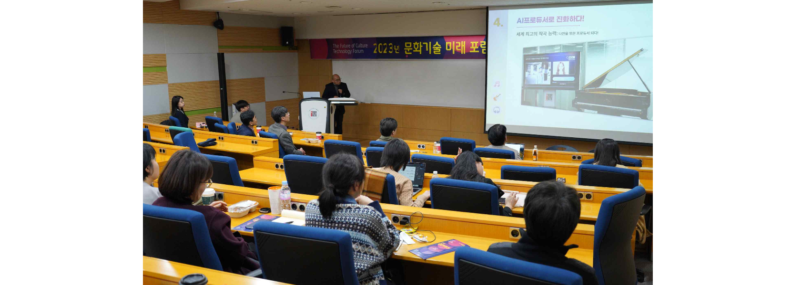▲ Professor Chang Wook Ahn of GIST AI Graduate School asked, ‘Is AI composition creative?' during a presentation on the theme of ‘Focusing on EvoM’.

The general discussion that followed included examples of creation and distribution in the cultural field in response to the generative AI era recently triggered by ChatGPT. The forum concluded with a discussion on the meaning of technological convergence and the value of creativity.

Director Kyung-Joong Kim said, "A recent hot topic in cultural technology research and development is how to apply generative AI to content production sites. I hope that this forum will be a very meaningful opportunity to discuss the future direction of cultural technology with researchers from not only the research institute but also related organizations."

Meanwhile, the ‘CT Imagination Room Exhibition’, a performance exhibition of the Korea Culture Technology Institute prepared in conjunction with the forum, was held for three days from December 6 to 8 in the research center on the first floor of the GIST Dasan Building. The results of a year of research were presented as content produced in collaboration with a media artist.

The main exhibition contents of the 'CT Imagination Room Exhibition' are sign language conversion technology for the deaf, media wall gesture recognition technology, and cultural heritage 3D data, and the technology was reinterpreted through the eyes of a media artist, providing visitors with various experience opportunities.



