[GIST Academy, November Breakfast Forum] Special lecture by Jeong-hyeon Lee, Vice Chairman of the Local Times Committee, ‘It's a good era to live anywhere in Korea’

- Vice Chairman Jeong-hyeon Lee gave a special lecture at the November 27 Breakfast Forum on the topic of ‘Vision and Strategy for the Local Era’

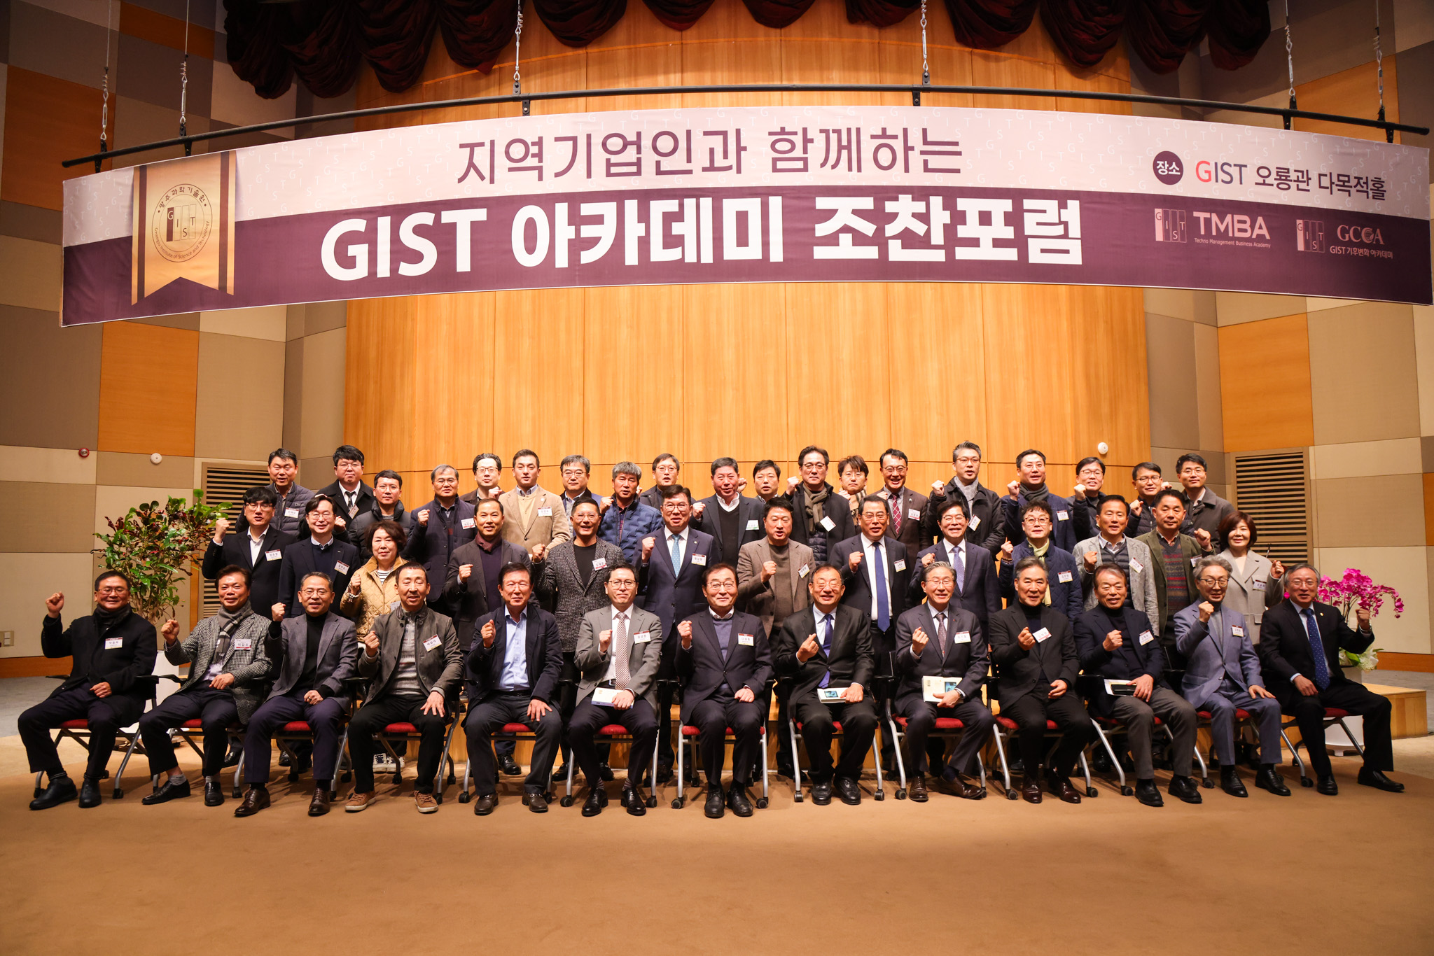▲ Commemorative photo of GIST Academy holding a breakfast forum in November at Oryong Hall

The Gwangju Institute of Science and Technology (GIST, President Kichul Lim) announced that it held the November Breakfast Forum at Oryong Hall on Monday, November 27, with about 50 representative businesspeople from the Gwangju and Jeonnam regions attending.

Vice Chairman Jeong-hyeon Lee of the Local Times Committee, who was a speaker at the forum on this day, gave a lecture on the topic of ‘Vision and Strategy for the Local Era’.

Vice Chairman Jeong-hyeon Lee, who served as a member of the 18th, 19th, and 20th National Assembly, and as Senior Secretary to the President for Political Affairs and Senior Secretary to the President for Public Relations, presented a vision of ‘an era in which people can live comfortably anywhere in Korea.’ As a goal, he emphasized local-led balanced development and responsible local decentralization, attracting a lot of attention from attendees.

In the lecture, Vice Chairman Lee presented ‘Strategy and Values for the Local Era’ and ‘Nine Policies for the Local Era’ while explaining the tasks to be pursued, expected effects, and future results.

First of all, the five strategies for local-led balanced development include ▴ ‘Bold local decentralization to increase autonomy’ ▴ ‘Bold education reform to cultivate talented people’ ▴ ‘Creative, innovative growth that creates jobs’ ▴ ‘Leading specialized development that preserves individuality’ ▴ Focused on ‘customized welfare to improve quality of life.’

The nine major policies of the local era are ▴ Designation as a special opportunity development zone ▴ Introduction of special education development zones ▴ Creation of a special urban convergence zone led by local governments ▴ Creating a cultural content ecosystem through localism ▴ Local economic growth centered on high-tech strategic industries ▴ Strengthening local new industry innovation capabilities through digital reinvention ▴ Creation of attractive farming and fishing villages ▴ Complete elimination of killer regulations ▴ Transition to a decentralized country.

He also mentioned the need to establish and implement a comprehensive plan under regional leadership and emphasized the importance of fostering new and specialized industries, expanding transportation infrastructure, and resolving regional long-awaited projects as key tasks for local governments.

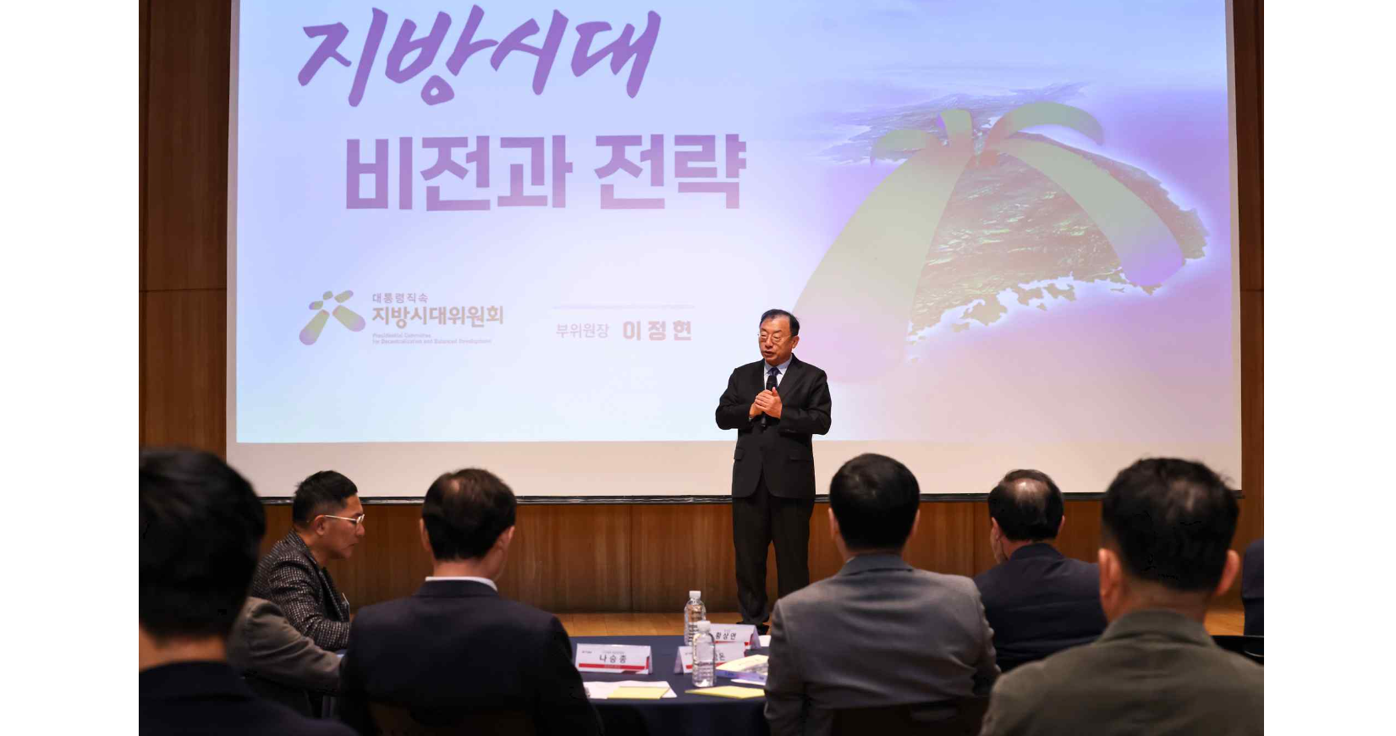▲ Vice Chairman Jeong-hyeon Lee of the Local Times Committee, is giving a lecture on the topic of ‘Vision and Strategy for the Local Era’.

Lastly, Vice Chairman Lee said, "If balanced development is achieved under local leadership, high-quality new jobs and the local youth population will increase, and local universities can become the birthplace of local innovation and talent development. We look forward to the day when true regional integration and balanced development will occur."

GIST Academy is a non-degree program at GIST that operates the Techno Management Business Academy (GTMBA, opened in 2010) and the Climate Change Academy (GCCA, opened in 2016). On the last Monday of every month, the ‘GIST Academy Breakfast Forum’ is held for academy alumni and executives of local companies, inviting experts from various fields as speakers.

GIST Academy contributes to revitalizing the local economy and industry-academia cooperation by helping managers in each field gain a deep understanding of changes in the corporate environment and global management strategies through lectures by Korea's best experts and form a broad human network.

