GIST opens 'HYPE Perception Neuroscience Research Center'... To develop treatment for incurable neurological diseases

- Selected as a convergence research and development project for the 2023 STEAM Research Project Science Challenge Challenge... Goal of uncovering the cause of hypersensitivity perception phenomenon and developing treatment for the aftereffects of nerve damage, etc.

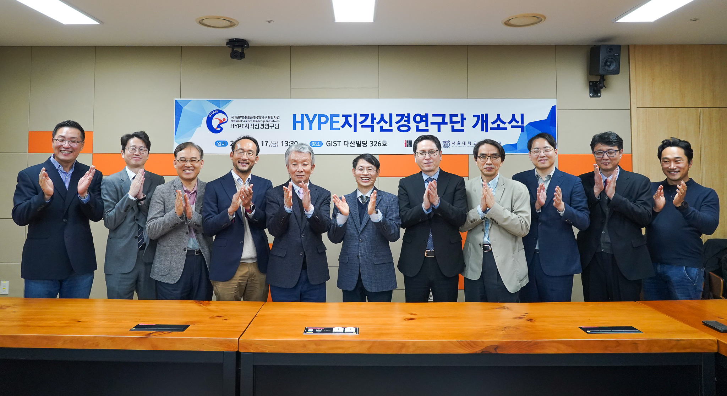▲ On Friday, November 17th, an opening ceremony was held for the ‘HYPE Perceptual Neuroscience Research Center’, a national scientific challenge convergence research and development project, at GIST Dasan Building and a commemorative photo was taken. (From left) GIST Professor Hyuk Sang Kwon, Neurogreen CEO Seon-kwang Kim, GIST Professor Chun Taek Rim, Seoul National University Professor Sang-jeong Kim, National Science Challenge Cooperation Support Group Director Seong-jin Seong, Research Director Euiheon Chung (Professor of GIST Department of Biomedical Science and Engineering), and GIST Vice President for Academic Affairs Sang-Don Kim, Seoul National University Graduate School of Dentistry Professor Seok-bae Oh, Neurogreen Co., Ltd. CEO Ji-hoon Jeong, expert member of Korea University Medical School Sun-wook Hwang, and Professor Sang-seong Kim of GIST.

If you become sensitive to physical and mental stress due to a nervous system abnormality, you may experience depression, anxiety, and suicidal impulses, and further suffer from drug dependence and addiction.

In modern society, the number of patients suffering from related diseases is not only increasing, but it is also emerging as a serious social problem, and research to solve this problem is attracting attention.

The Gwangju Institute of Science and Technology (GIST, President Kichul Lim) announced that the ‘HYPE Perception Neuroscience Research Center’, headed by Professor Euiheon Chung of the Department of Biomedical Science and Engineering, held an opening ceremony at the Jonghyun Lee Studio in GIST’s Dasan Building on the 17th (Friday).

The name of the research center, ‘HYPE’, means that it is a group passionately researching the phenomenon of ‘hyperexcitable’ nervous system and ‘hypersensitive’ perception. This research center focuses on studying the phenomenon in which the perceptual system exaggerates negative information due to abnormalities in the nervous system.

The core research of the ‘HYPE Perception Neuroscience Research Center’ illuminates abnormal phenomena that cause pain that occur during sensory signal processing. The goal is to identify the basic mechanism of the cognitive process by which the central nervous system processes abnormal information.

Patients suffering from abnormal perception feel painful even from small changes in the external environment. There is currently no effective treatment for this phenomenon, so the symptoms become chronic and patients suffer endless pain.

The research center aims to dramatically improve the quality of life of patients by deeply understanding the mechanisms of perceptual abnormalities and developing non-invasive treatments based on this understanding.

At the opening ceremony on this day, GIST Department of Biomedical Science and Engineering Professor Hyuk Sang Kwon, Neurogreen CEO Seon-kwang Kim, GIST Graduate Schoolof Energy Convergence Professor Chun Taek Rim, Seoul National University Professor Sang-jeong Kim, National Science Challenge Cooperation Support Group Director Seong-jin Seong, Research Director Euiheon Chung (Professor of GIST Department of Biomedical Science and Engineering), and GIST Vice President for Academic Affairs Sang-Don Kim, Seoul National University Graduate School of Dentistry Professor Seok-bae Oh, Neurogreen Co., Ltd. CEO Ji-hoon Jeong, expert member of Korea University Medical School Sun-wook Hwang, and Professor Sang-seong Kim of GIST attended.

Research Director Euiheon Chung said, "The HYPE Perception Neuroscience Research Center is focused on a clear understanding of the fundamental mechanism by which symptoms of perceptual abnormalities become chronic in neurological diseases. Through this research, the quality of life of patients suffering from incurable diseases caused by nervous system damage and sensory abnormalities is improved. We will present a practical alternative that can solve the side effects and dependence problems of existing narcotic drugs."

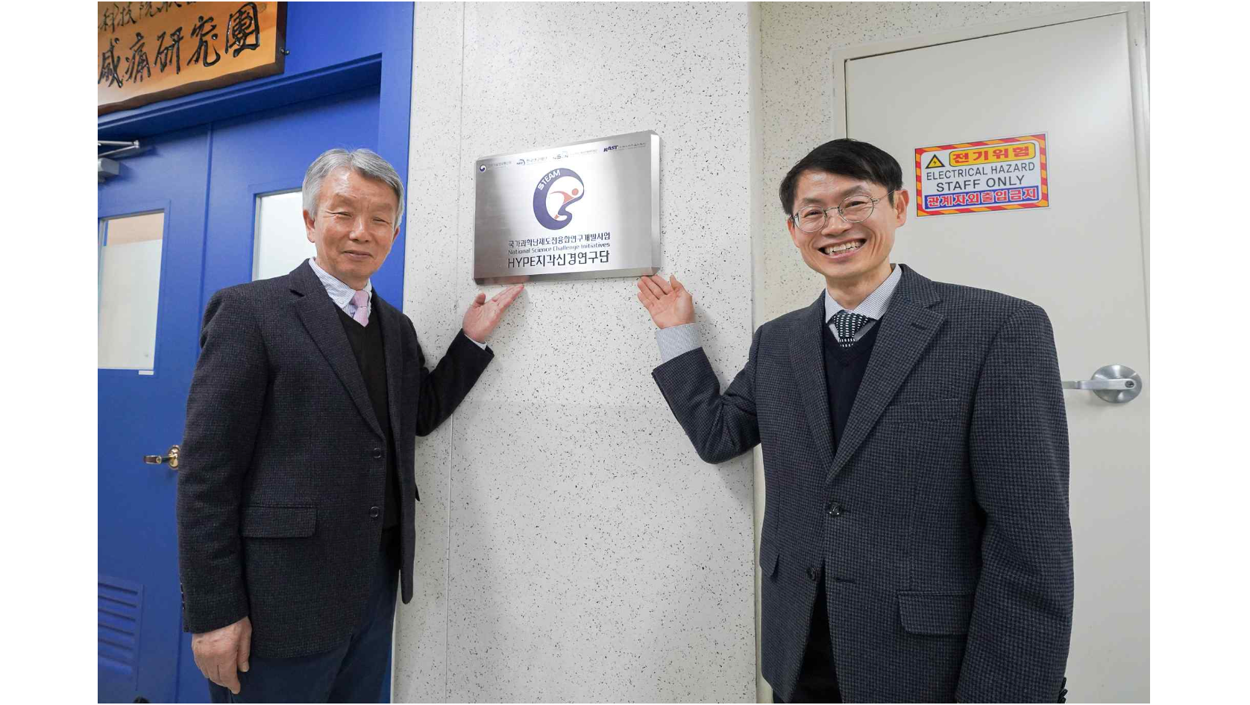▲ (From the left) Seong-jin Seong, Director of the National Science Challenge Cooperation Support Group, and Research Director Euiheon Chung (Professor, GIST Department of Biomedical Science and Engineering)

Meanwhile, the Korea Academy of Science and Technology's scientific challenge convergence research and development project, for which the 'HYPE Perceptual Neuroscience Research Group' was selected, creates innovative research results and contributes to the common good of humanity by challenging social and human issues through convergence between basic science and engineering.

The ‘HYPE Perceptual Neurons Research Center’ plans to receive a total of 4.6 billion won in research funding through step-by-step evaluation over a total research period of 5 years and 5 months from August 2023 to December 2028.



