GIST celebrates its 30th anniversary by inviting embassies in Korea and holding a cultural night for foreigners

- Invitation to 8 embassies and institutions, including the Embassy of Laos in Korea, and held an international culture night event
- Expectation of practical cooperation and bonding, including nurturing global specialists and expanding exchanges

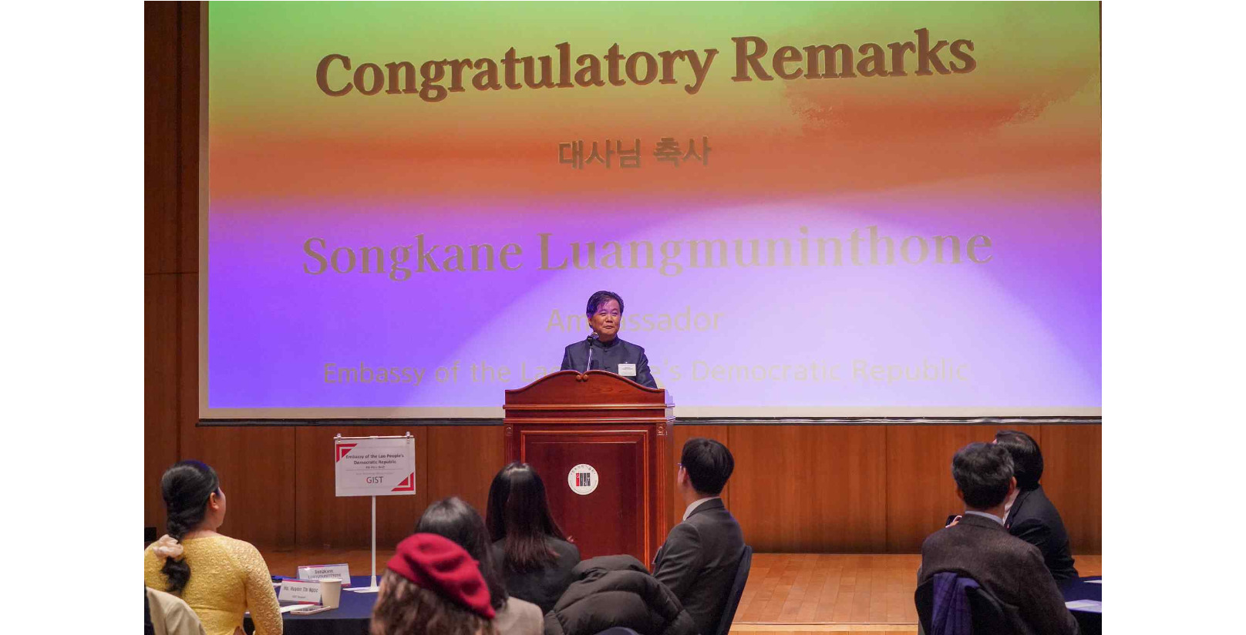▲ Ambassador of Laos to Korea Songkane Luangmuninthone is giving a congratulatory speech at ‘GIST International Day’, an event for ambassadors and consuls in Korea held at Oryong Hall to commemorate its 30th anniversary

In celebration of its 30th anniversary, the Gwangju Institute of Science and Technology (GIST, President Kichul Lim) held ‘GIST International Day’ and ‘GIST Culture Night’, an event inviting ambassadors and consuls to Korea, at Oryong Hall.

The ceremony was attended by dignitaries from eight embassies, including Ambassador Songkane Luangmuninthone of Laos, Deputy Ambassador Lucas Pavez of Chile, and Acting Ambassador Kipkosgei Toroitich of Kenya, to celebrate GIST's 30th anniversary.

The 'GIST Culture Night' event, which is held annually by foreign students to experience the culture and food of other countries, was also held on the same day in conjunction with the invitation of foreign embassies in Korea.

At the Culture Night event, 240 foreign students and local residents from 38 countries attended, and a program to experience traditional food, costumes, and games from each country was held.

A GIST official said that this event, which allows people to enjoy various cultures, is expected to promote respect for other cultures and form bonds among members and local residents.

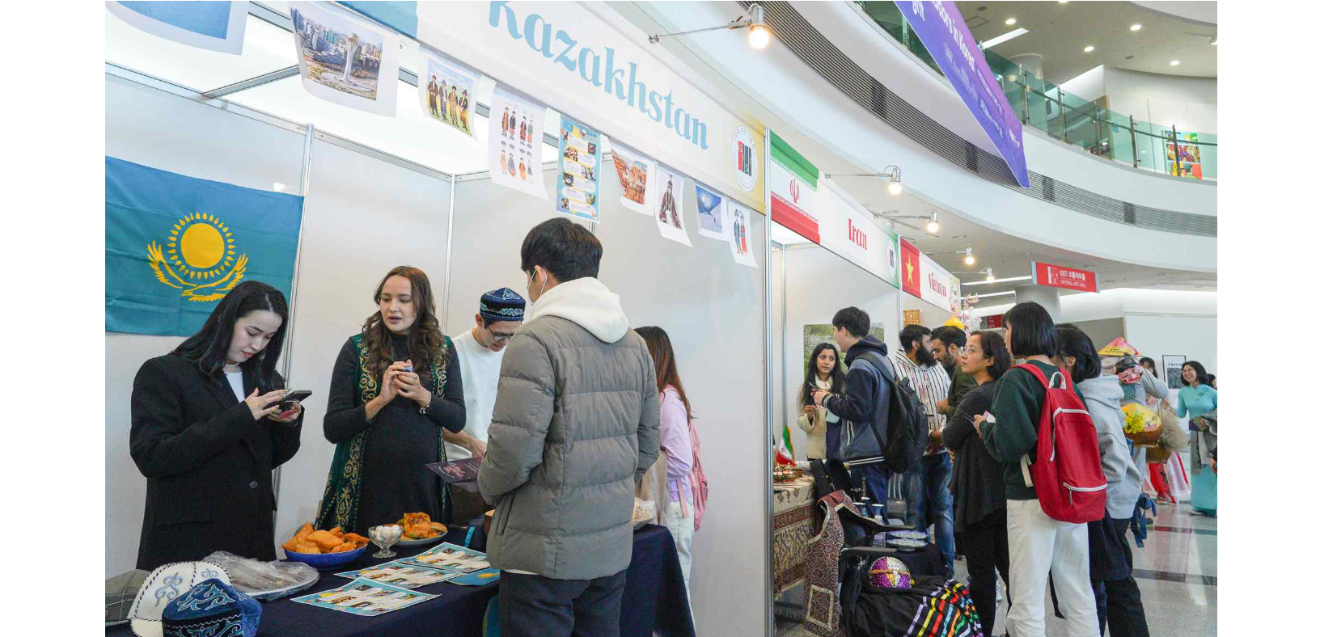▲ The ‘GIST Foreign Culture Night’ event, which is held every year, is a venue for foreign student to exchange and experience the culture, costumes, games, and food of each country was held with 240 foreign students and local residents from 38 countries.

President Kichul Lim said in the welcoming speech, "I would like to take this opportunity to express my sincere gratitude to the ambassadors, ministries, and officials in the Republic of Korea for their support in enabling outstanding foreign talents to expand and realize their scientific and technological capabilities and dreams at GIST. As global research cooperation has become more important, we will do our best to create an environment where excellent foreign students can pursue stable education and research."

The Laos Ambassador to Korea Songkane Luangmuninthone said in a congratulatory address, "I am grateful to GIST officials for organizing this event, and expect that our global talent exchange and efforts to cultivate excellent students will actively contribute to the development of each country and the world."

GIST International Student Association President Siddhant said, "I will strive to become a global talent who will lead the development of future science and technology by embracing different cultures, languages, and education systems and focusing on my studies and research as a student."

GIST has signed agreements (MoUs) for mutual cooperation with over 250 universities, research institutes, and industries around the world and is expanding its global network. Currently, about 170 foreign students, exchange students, interns, and researchers from 38 countries live on the GIST campus.



