GIST holds 30th anniversary ceremony and vision declaration ceremony

- Celebrating the 30th anniversary of establishment, the vision of ‘GIST 2053’ was declared for a ‘central science and technology research institute that creates better future value for humanity’
- Congratulatory remarks from the first class of alumni, added meaning to the 30th anniversary of the founding of the school as a speech given by newly appointed professors

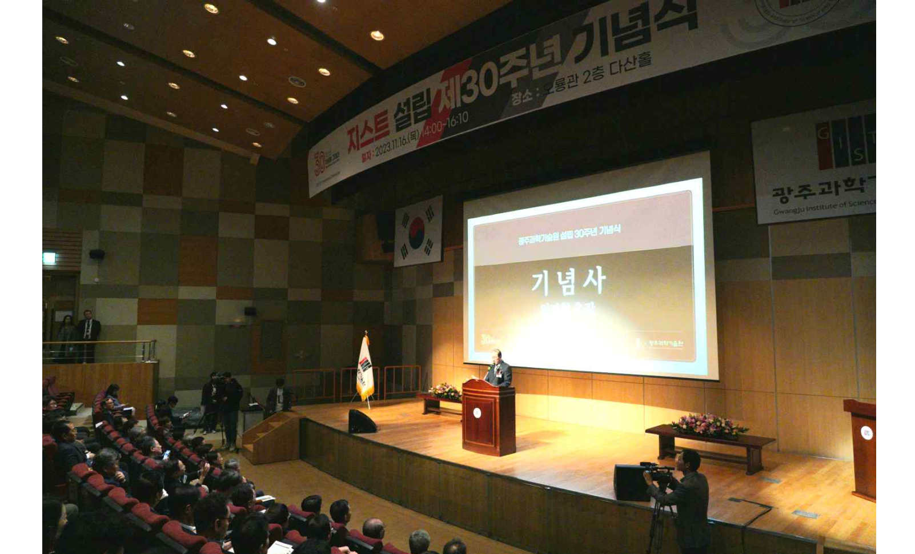▲ President Kichul Lim is giving a speech at the ceremony commemorating the 30th anniversary of the establishment of GIST held at Oryong Hall on the 16th (Thursday).

The Gwangju Institute of Science and Technology (GIST, President Kichul Lim) held the 30th anniversary ceremony and vision declaration ceremony at Dasan Hall on the second floor of GIST Oryong Hall at 2 p.m. on Thursday, November 16.

In accordance with the Gwangju Institute of Science and Technology Act, GIST trains high-level scientific and technological experts who will lead the innovation of cutting-edge science and technology and conducts collaborative research with industry. It was established in 1993 to contribute to the development of national science and technology by promoting education and research exchanges with foreign countries, transferring and commercializing technology, and supporting start-ups.

A total of 500 people, including Gwangju Metropolitan City Mayor Ki-jeong Kang and other distinguished guests, as well as GIST students and faculty, attended the ceremony. Starting with a congratulatory performance by musical actor Jeong-won Choi, President Kichul Lim's commemorative speech, congratulatory remarks from foreign guests, vision declaration ceremony, viewing a 30th anniversary promotional video, a congratulatory performance by the student dance club ('Reckless'), and commendations from the president to internal members.

In particular, alumnus Seok-joong Oh (graduated from the School of Materials Science and Engineering, Chairman of Eco World Farm Co., Ltd.), a member of GIST's first class, gave a congratulatory address, and Professor Emeritus Yong Tak Lee (School of Electrical Engineering and Computer Science), who took office in the early days of GIST's opening (1994) and retired at retirement age (2016) gave a retrospective speech to add meaning to commemorating the 30th anniversary of its establishment.

President Kichul Lim said in a commemorative speech: "GIST has grown into a research center with world-class research capabilities in the 30 years since its establishment, thanks to the support of the Gwangju and Jeonnam local communities. I would like to express our gratitude and repayment to everyone who has been with us through this opportunity, and we will work harder to become GIST, which leads the future of the innovative economy together with the region, resolutely resolving to ‘transform 30 years of our strength into the 30 years of the future."

At the vision declaration ceremony, GIST looked back on the achievements of the past 30 years and announced its vision of becoming a 'central science and technology research institution that creates better future value for humanity' in 2053, 30 years from now, in order to enter the top 50 in the world university rankings and announced plans to take a leap forward in the areas of education, research, and dissemination of results.

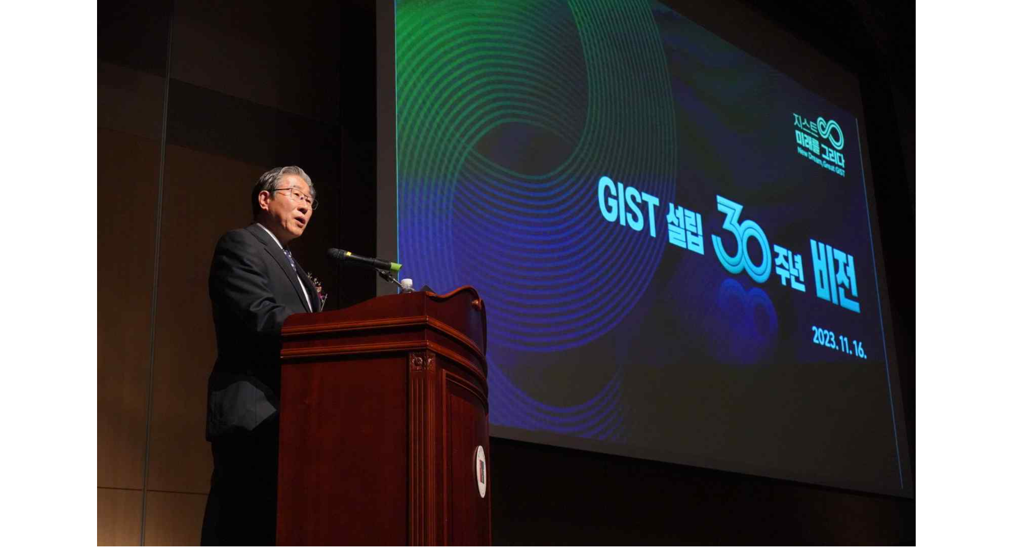▲ President Kichul Lim is announcing ‘GIST Vision 2053’ at the vision declaration ceremony for the 30th anniversary of GIST’s establishment held at Oryong Hall on the 16th (Thursday).

In addition, specific goals of ‘GIST Vision 2053’ include ▴ (Building a roadmap for nurturing advanced science and technology talent throughout the cycle) Training 30,000 global science and technology experts ▴ (Performing mission-oriented R&D and improving research quality) Produced 30 global scholars who provide solutions to humankind’s challenges ▴ (High value-added performance diffusion and value creation) The production of 30 unicorn-level companies.

Minister of Science and ICT Jong-ho Lee said in a video congratulatory speech, "I congratulate GIST on its 30th anniversary, having created various research results and fostered excellent researchers in science and technology since taking root in Gwangju Metropolitan City in 1993 with the wishes of the people and local residents. In the future, it will grow into a world-class research institution and play a large role as a central institution for regional innovation."

Since its first graduates in 1997, GIST has produced a total of 7,915 (1,838 doctoral, 4,910 master's, 1,167 bachelor's) outstanding specialists in science and engineering*, and is a joint partner in the field of artificial intelligence (AI) with the Massachusetts Institute of Technology (MIT). GIST has a global R&D network and is actively engaging in international research cooperation. In addition, GIST is taking the lead in disseminating research results, recording a cumulative technology transfer contract amount of KRW 61.6 billion and being selected as an ‘Outstanding Startup University’ by the Korea Business Incubation Association.

* Based on degree grantees in the second half of 2023 (August), an average of approximately 5 papers will be published in SCI-level academic journals per doctoral degree grantee. 10% of doctoral graduates are appointed as professors at leading domestic and international universities.



