GIST exhibits achievements in ‘camera mimicking crab eyes’ and ‘AI for identifying unknown data’

- Exhibition and demonstration of two excellent research results at the 2023 National Science and Technology Exhibition
- ‘Amphibious camera mimicking crab eyes’ and ‘AI technology to distinguish unknown data’ introduced

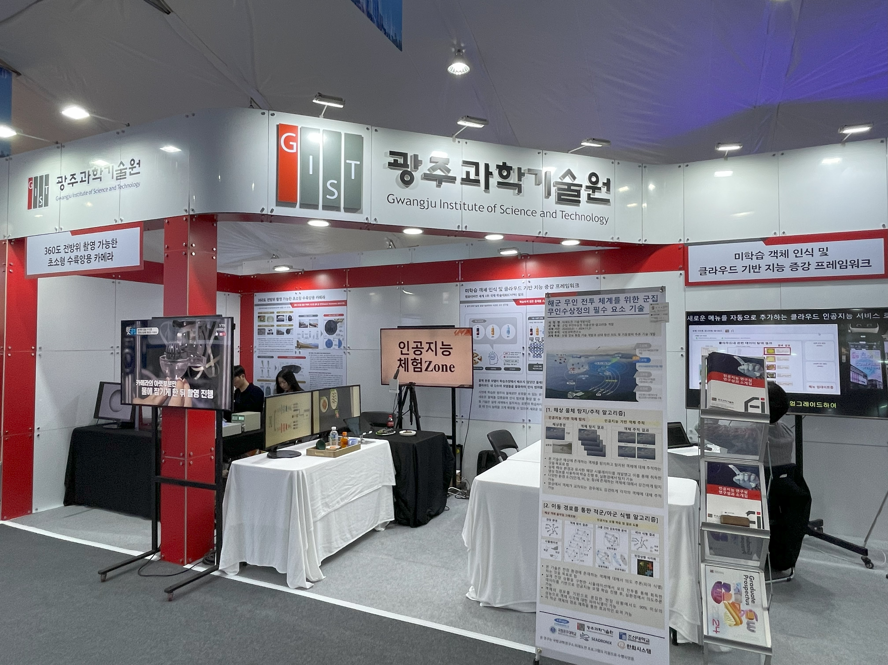▲ GIST is exhibiting excellent research achievements by participating in the ‘2023 Korea Science and Technology Exhibition’ held at the Gwacheon National Science Museum from November 9th to 12th.

The Gwangju Institute of Science and Technology (GIST, President Kichul Lim) participated in the ‘2023 National Science and Technology Exhibition’ held at the Gwacheon National Science Museum from November 9 to 12 and presented excellent research results.

GIST set up a booth in Area B of the Institutional Performance Hall to introduce the research achievements of 'Miniature Amphibious Camera Capable of 360-degree Omnidirectional Shooting (Prof. Young Min Song, School of Electrical Engineering and Computer Science)' and 'Object Recognition Intelligence Enhancement Framework (Prof. Kyoobin Lee, Institute of Integrated Technology)' to visitors and display them for hands-on experience.

Professor Young Min Song’s lab’s ‘ultra-small amphibious camera capable of 360-degree omnidirectional shooting’ was designed to imitate the protruding compound eye structure of a sea crab and capture images in all directions at once.

This camera is capable of 360-degree omnidirectional shooting and simultaneous shooting in environments both in and out of water. In addition, it alleviates the distortion of existing wide-angle cameras and enables omnidirectional/all-weather image processing, so it is expected to be used for object recognition in autonomous driving and VR/AR.

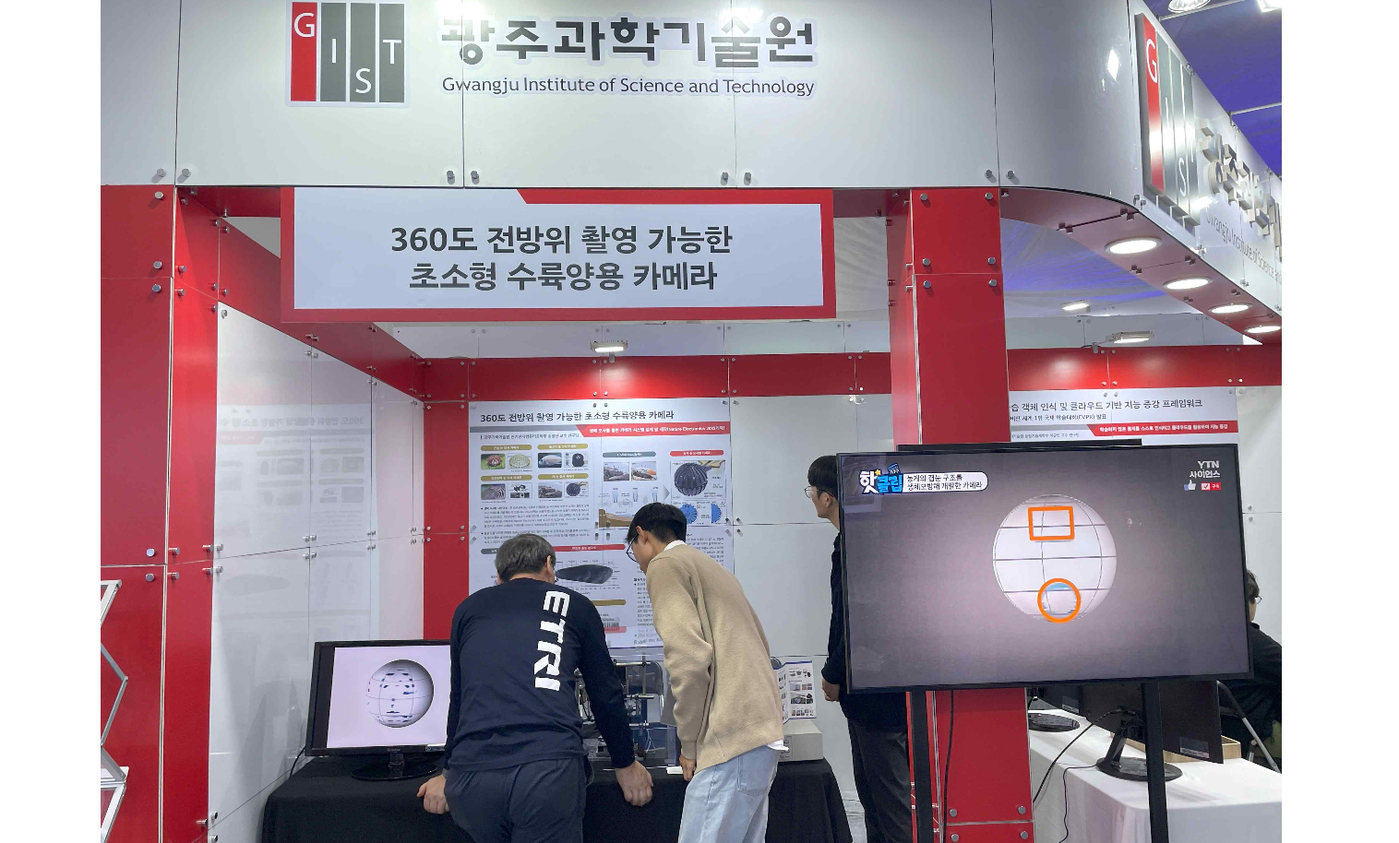▲ Ultra-small amphibious camera booth capable of 360-degree omnidirectional shooting (Professor Young Min Song’s research results)

Professor Kyoobin Lee’s lab’s ‘Object Recognition Intelligence Augmented Framework’ is an artificial intelligence (AI) technology that distinguishes between unknown data that has not yet been learned.

Unlike humans who say they don't know what they don't know, an AI trained to find the correct answer will recognize a similar value as the correct answer even if it doesn't know the answer. AI can recognize new objects that were not in the training data and connect with existing AI to augment its intelligence.

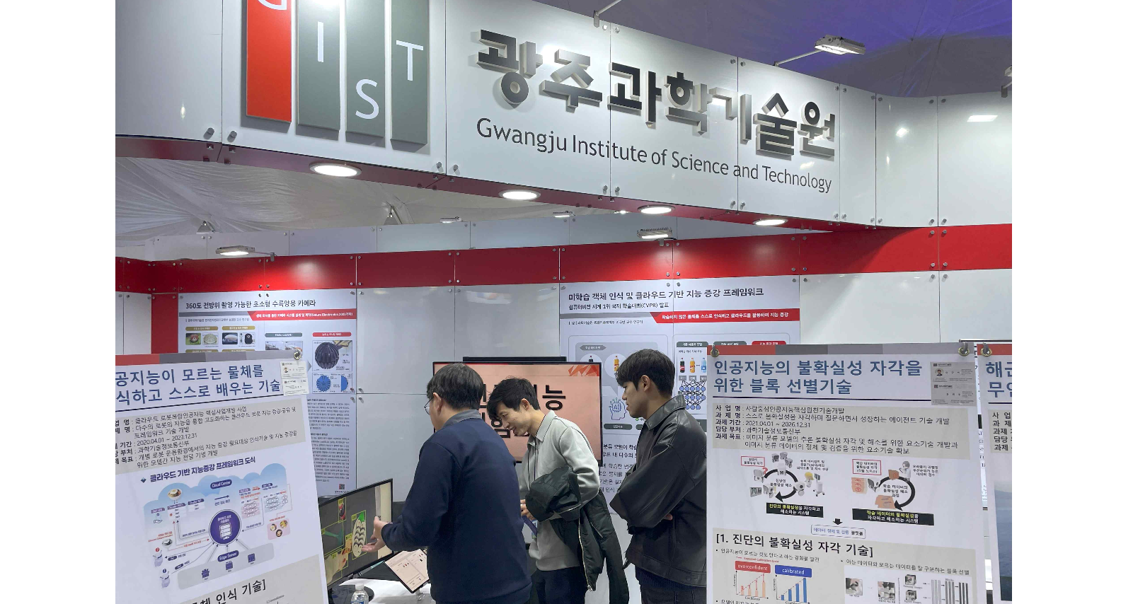▲ Object recognition intelligence augmented framework booth (Professor Kyoobin Lee’s research results)

President Kichul Lim said, "We are very pleased to be able to inform citizens of GIST's excellent research results through the National Science and Technology Exhibition. GIST, which celebrates its 30th anniversary this year, will contribute to the development of Korea's science and technology through innovative scientific and technological research and nurturing future scientific specialists to improve the quality of life of the people."

Meanwhile, the '2023 National Science and Technology Exhibition' is hosted by the Ministry of Science and ICT and organized by the National Research Foundation of Korea at the Gwacheon Science Museum from November 9th (Thursday) to 12th (Sunday) under the theme of 'Korean science and technology that will change the world'.

This year, in celebration of the 60th anniversary of national R&D investment, a comprehensive display of R&D achievements in each field of science and technology will be exhibited, and 50 organizations, including government-funded research institutes, universities, and companies, will participate to exhibit excellent research results, forums, seminars, public science lectures, and consists of a variety of programs, including a science camp zone.

