GIST Signs MoU With Army Training Center to Promote Development of AI Science and Technology Forces Based on Defense Innovation 4.0

- Establishment of a cluster in the Gwangju and Jeonnam regions and cooperation in the fields of robots, mobility and AI
- Expectations for practical cooperation, such as joint research and human resource exchange in the field of defense science and technology

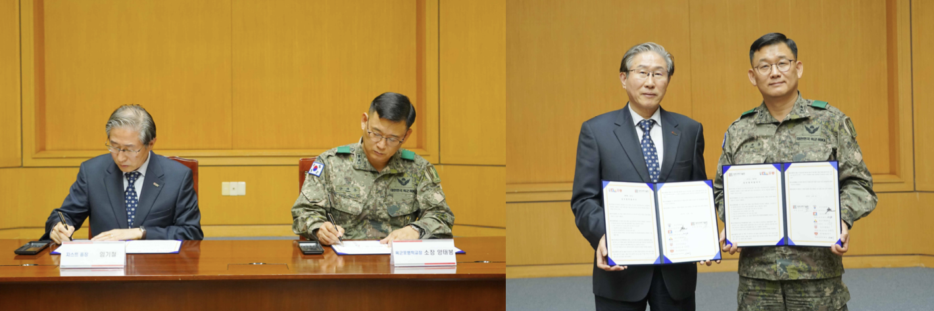▲ GIST and the five military schools of the Army Training Center signed a business agreement and are taking commemorative photos. (From the left) GIST President Kichul Lim and Sangmudae Army Artillery School Director Tae-bong Yang.

The Gwangju Institute of Science and Technology (GIST, President Kichul Lim) announced that it signed a business agreement (MoU) with the Army's largest military education facility, Sangmudae*, to foster Gwangju and Jeonnam AI science and technology forces based on Defense Innovation 4.0.

For the Korean military to become a combat-type force that can fight and win in the future battlefield environment, the 'Defense Innovation 4.0' promoted by the current government is to further strengthen the cohesion of the three armed forces of land, sea, and air and the mental strength of soldiers. The key is to foster AI science and technology powerhouses by securing cutting-edge power based on the 4th Industrial Revolution science and technology in a timely manner through system innovation.

* Sangmudae's five military schools: Army Infantry School (Director, Major General Won-ho Park), Army Artillery School (Principal, Major Tae-bong Yang), Army Mechanization School (Principal, Brigadier General Soo Park), Army Engineer School (Principal, Brigadier General Soong-jae Lee), Army Chemical, Biological and Radiological School (Principal, Brigadier General) Dae-hui Lee)

This agreement ceremony was held on November 7 (Tuesday) in the conference room on the second floor of the GIST administration building with key officials attending, including GIST President Kichul Lim, School of Mechanical Engineering Dean Jaewook Lee, Professor Kyunghwan Choi, International and Public Affairs Dean Jae Gwan Kim, Sangmuda University Army Artillery School Director Major General Tae-bong Yang, and Ministry of National Defense Defense Innovation Planning Office Colonel Kyung-il Kang.

With this agreement, the two organizations decided to pursue cooperation and will ▴ conduct joint technology planning and research cooperation in the fields of robots, mobility, and AI ▴ carry out personel training in the field of defense science and technology ▴ cooperate in academic and combat development seminars and publish research materials ▴ exchange of technology and professional researchers, etc.

In particular, the fields of robotics, mobility, and artificial intelligence (AI) are essential research areas for securing "advanced core power based on AI" based on Defense Innovation 4.0, and the development of technologies to build a combined manned and unmanned combat system composed of AI, robots, and drones is key.

GIST and the Army Training Center plan to promote all-round cooperation in planning and research and development of core technologies to secure AI-based cutting-edge core forces, including establishing clusters in the Gwangju and Jeonnam regions, operating pilot projects, nurturing research personnel, and conducting joint research, as well as human resource exchanges.

President Kichul Kim said, "Through this agreement, we expect that GIST's cooperation in research and technology related to robots, mobility, and artificial intelligence (AI) will be of great help in nurturing excellent specialists in defense science and technology. We will actively cooperate to develop efficient and practical research capabilities of both institutions."

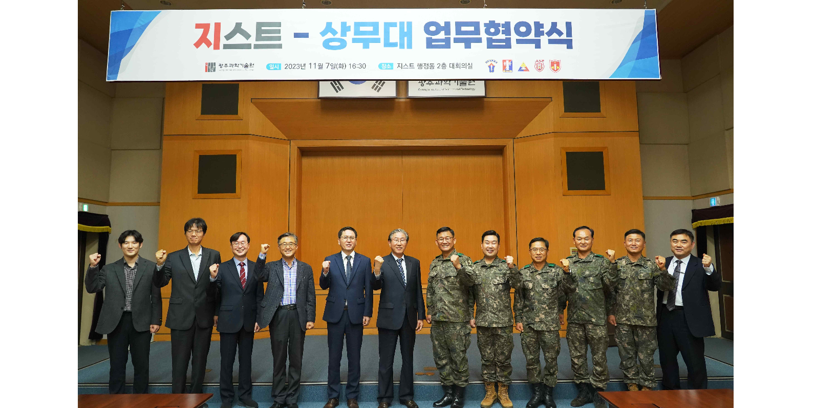▲ GIST and the five military schools of the Army Training Center signed a business agreement, and attendees are taking commemorative photos.
(From left) GIST School of Mechanical Engineering Professor Kyunghwan Choi, Professor Jaewook Lee (Dean of the School of Mechanical Engineering), International and Public Affairs Dean Jae Gwan Kim, Vice President for R&D Kwanghee Lee, Vice President for Academic Affairs Sang-Don Kim, President Lim Ki-cheol, Major General Tae Bong Yang, Chief of Army Artillery School, Brigadier General Dae Dae Lee, Chief of Army Chemical Warfare School, Brigadier General Park Soo Park, Chief of Army Mechanization School, Brigadier General Seong Jae Lee, Chief of Army Engineering School, and Colonel Taek Hwan Kim

In December 2018, GIST signed its first MoU with the Army Infantry School, under which GIST will provide R&D advisory services and personnel from the school will be admitted to GIST to complete their studies.

This time, GIST announced that it will further strengthen its mutual cooperation with the defense sector, including civil-military cooperation in defense science and technology, future army power education and training, and exchange of research personnel and technical information, by expanding the target of cooperation to the five military schools of the Army Training Center.



