Artist Jo-heum Lee's invitation exhibition at Oryong Art Hall commemorates the 30th anniversary of GIST's establishment

- Held at Oryong Hall from November 2nd (Thursday) to December 27th (Wednesday)
- Jo-heum Lee’s invitational exhibition <Universe> focuses on the social and personal existence behind the network of relationships

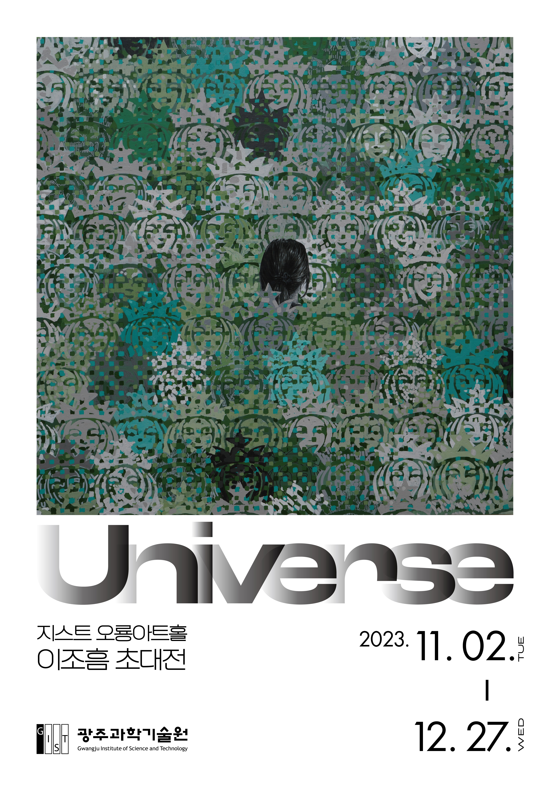
▲ Poster for <Universe>, an invitational exhibition by Jo-heum Lee at Oryong Art Hall, celebrating the 30th anniversary of the establishment of GIST

The Gwangju Institute of Science and Technology (GIST, President Kichul Lim) announced that it will hold <Universe>, an exhibition featuring Western painter Jo-heum Lee, in celebration of its 30th anniversary.

This invitational exhibition presents to the public a total of 29 paintings by artist Jo-heum Lee that are full of pop art elements.

The artist expresses works that question the lives and identities of modern people with motifs of characters and patterns familiar to the public. His works contain themes that everyone has experienced at one time or another while growing up, such as the clash between social and personal self, isolation and loneliness in a large society, and social and personal existence behind a network of relationships.

The works on display in the Oryong Art Hall's invitational exhibition, "Universe," also use cartoon characters as symbols of childhood to represent nostalgia, social networks, and the anxieties of modern people immersed in the system.

Artist Jo-heum Lee graduated from Chosun University's College of Fine Arts and is a local young artist of note who has held numerous solo exhibitions at Lotte Gallery, 10 Years Later Ground, and Space 9.

In addition, he participated in numerous group exhibitions held at the National Asia Cultural Center, Gwangju Museum of Art, Shinsegae Gallery, and Seongnam Art Setter, and also worked at the Gwangju Museum of Art, Gwangju Cultural Foundation Media Art, and Beijing BSC Residence.

Artist Jo-heum Lee said, "When people experience irony in their daily lives or are tired, they first think about their ego and identity. I hope that people who see my work will put themselves somewhere in my paintings and dream of their own universe and world, and I hope that they will capture images of a world that is confusing but beautiful at the same time."

Artist Jo-heum Lee's invitation exhibition at Oryong Art Hall <Universe> will be held for about two months from Thursday, November 2 to Wednesday, December 27, and can be viewed by anyone interested from 9 a.m. to 6 p.m. on weekdays. (Inquiries about opening on weekends/T.062-715-2628)

Meanwhile, Oryong Art Hall is an exhibition space created on the inner walls of the first and second floors of Oryong Hall, a multi-purpose building for events, meetings, lectures, seminars, etc., to provide a venue for strengthening exchanges and cooperation with the local community by GIST, which has grown due to the interest of local residents. From the end of last year to this <Universe> exhibition, a total of 6 invitational exhibitions were held, providing an open space for cultural enjoyment for both internal and external visitors.

