GIST signs cooperation agreement with University of Computer Studies, Yangon (UCSY), Myanmar... Join hands in computer and AI fields

- Expected to conduct joint research and hold academic exchange workshops through MoUs in the future
- Contribute to substantial growth of developing countries and revitalization of bilateral exchanges through international cooperation in science and technology

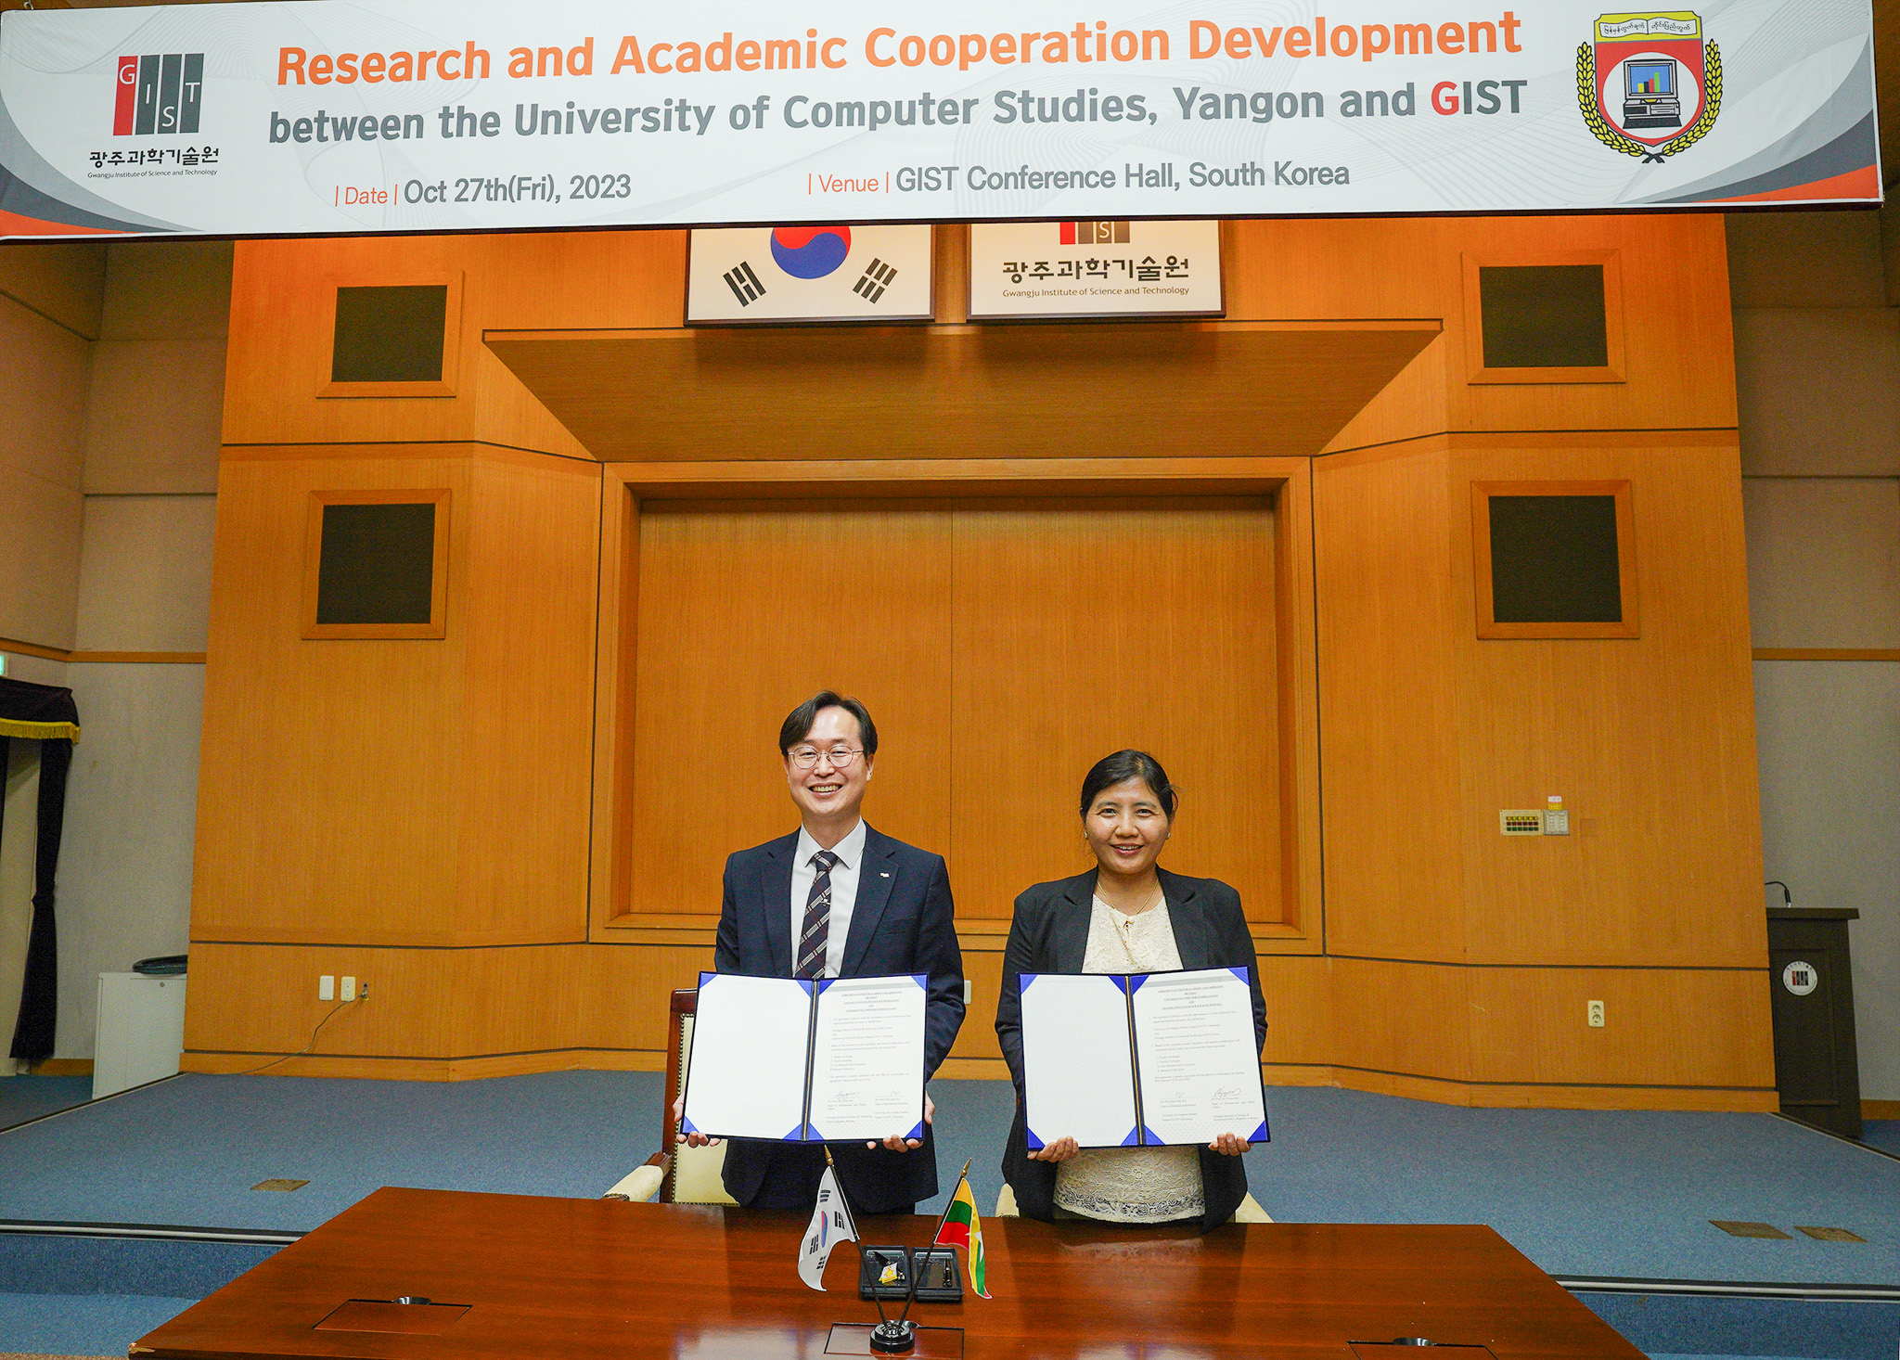▲ University of Computer Studies, Yangon, Myanmar Cooperation Agreement Signed: A delegation from University of Computer Studies, Yangon , Myanmar, visited GIST on the afternoon of the 27th to discuss the MoU and take a commemorative photo after signing the cooperation agreement. (From left) GIST International and Public Affairs Dean Jae Gwan Kim, and Khin Mar Soh, Director of International Exchange at Yangon Computer University, Myanmar.

The Gwangju Institute of Science and Technology (GIST, President Kichul Lim) and the University of Computer Studies, Yangon, Myanmar held a human exchange and joint research workshop on Friday, October 27. A cooperation agreement was signed for various international cooperation, including discussions on initiatives for educational cooperation.

The signing ceremony held in the GIST Administrative Building conference room at 2 p.m. on that day and was attended by GIST International and Public Affairs Dean Jae Gwan Kim, AI Graduate School Dean JongWon Kim, University of Computer Studies, Yangon, Myanmar President Mie Mie Khin, and International Exchange Director Khin Mar So.

Myanmar Yangon Computer University is currently conducting joint research with several Korean industries and research institutes, such as Korea's Samsung Electronics Myanmar branch and the Electronics and Telecommunications Research Institute (ETRI), and is conducting international cooperation in various fields, such as building a training system for Android development and exchanging teachers and students.

In particular, the visiting delegation from Myanmar's University of Computer Studies, Yangon, on this day showed great interest in ways to promote mutual cooperation in GIST's strengths, such as computer engineering and artificial intelligence (AI), and expressed expectations for a developing cooperative relationship between the two institutions.

University of Computer Studies, Yangon, Myanmar President Mie Mie Khin said, "We are very pleased to be able to establish a cooperative relationship with GIST, Korea's leading research university in science and technology. We hope that various exchanges, including human exchanges and research cooperation, can take place in the future."

GIST International and Public Affairs Dean Jae Gwan Kim said, "We hope that the signing of this cooperation agreement with University of Computer Studies, Yangon, Myanmar will serve as an opportunity for the two universities to cooperate in the computer and artificial intelligence fields and for more Myanmar students to study at GIST in the future."

AI Graduate School Dean JongWon Kim said, "As both universities are interested in the field of artificial intelligence computing, it is hoped that mutual cooperation will be initiated through the TOP500* supercomputer operated by GIST, the only one of its kind in Korea."

* TOP500: A project that ranks the top 500 supercomputers in the world by performance. In the latest ranking, which was announced at the ISC High Performance 2023 supercomputing conference in Hamburg, Germany in May this year, GIST's Dream-AI was ranked 207th.

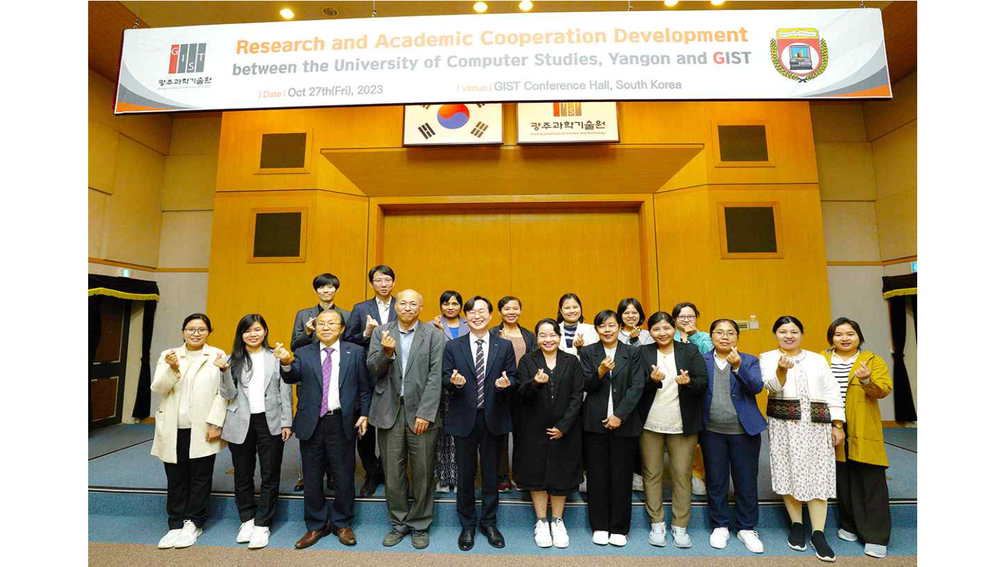▲ Group photo of the signing of the MoU: A delegation from University of Computer Studies, Yangon, Myanmar visited GIST on the afternoon of the 27th and took a commemorative photo after discussing the MoU and signing the cooperation agreement.

Meanwhile, GIST plans to provide a total of 112 'Hope Water Purifiers' using GIST International Environmental Research Institute's water treatment technology to Myanmar, which is suffering from political turmoil and civil war, so that it can be used continuously for at least 10 years without separate electricity supply or special maintenance.

Dean Jae Gwan Kim said, "GIST will continue to use science and technology to solve local community problems and respond to global issues. Furthermore, we hope that through international cooperation in science and technology, we can contribute to the actual growth of developing countries and the revitalization of exchanges between the two countries."

