GIST Climate Change Academy graduation ceremony held... All 6th class alumni donate to the development fund

– 25th (Wed), GCCA 6th class of 31 students completion ceremony held... 6th class alumni donate to the development fund

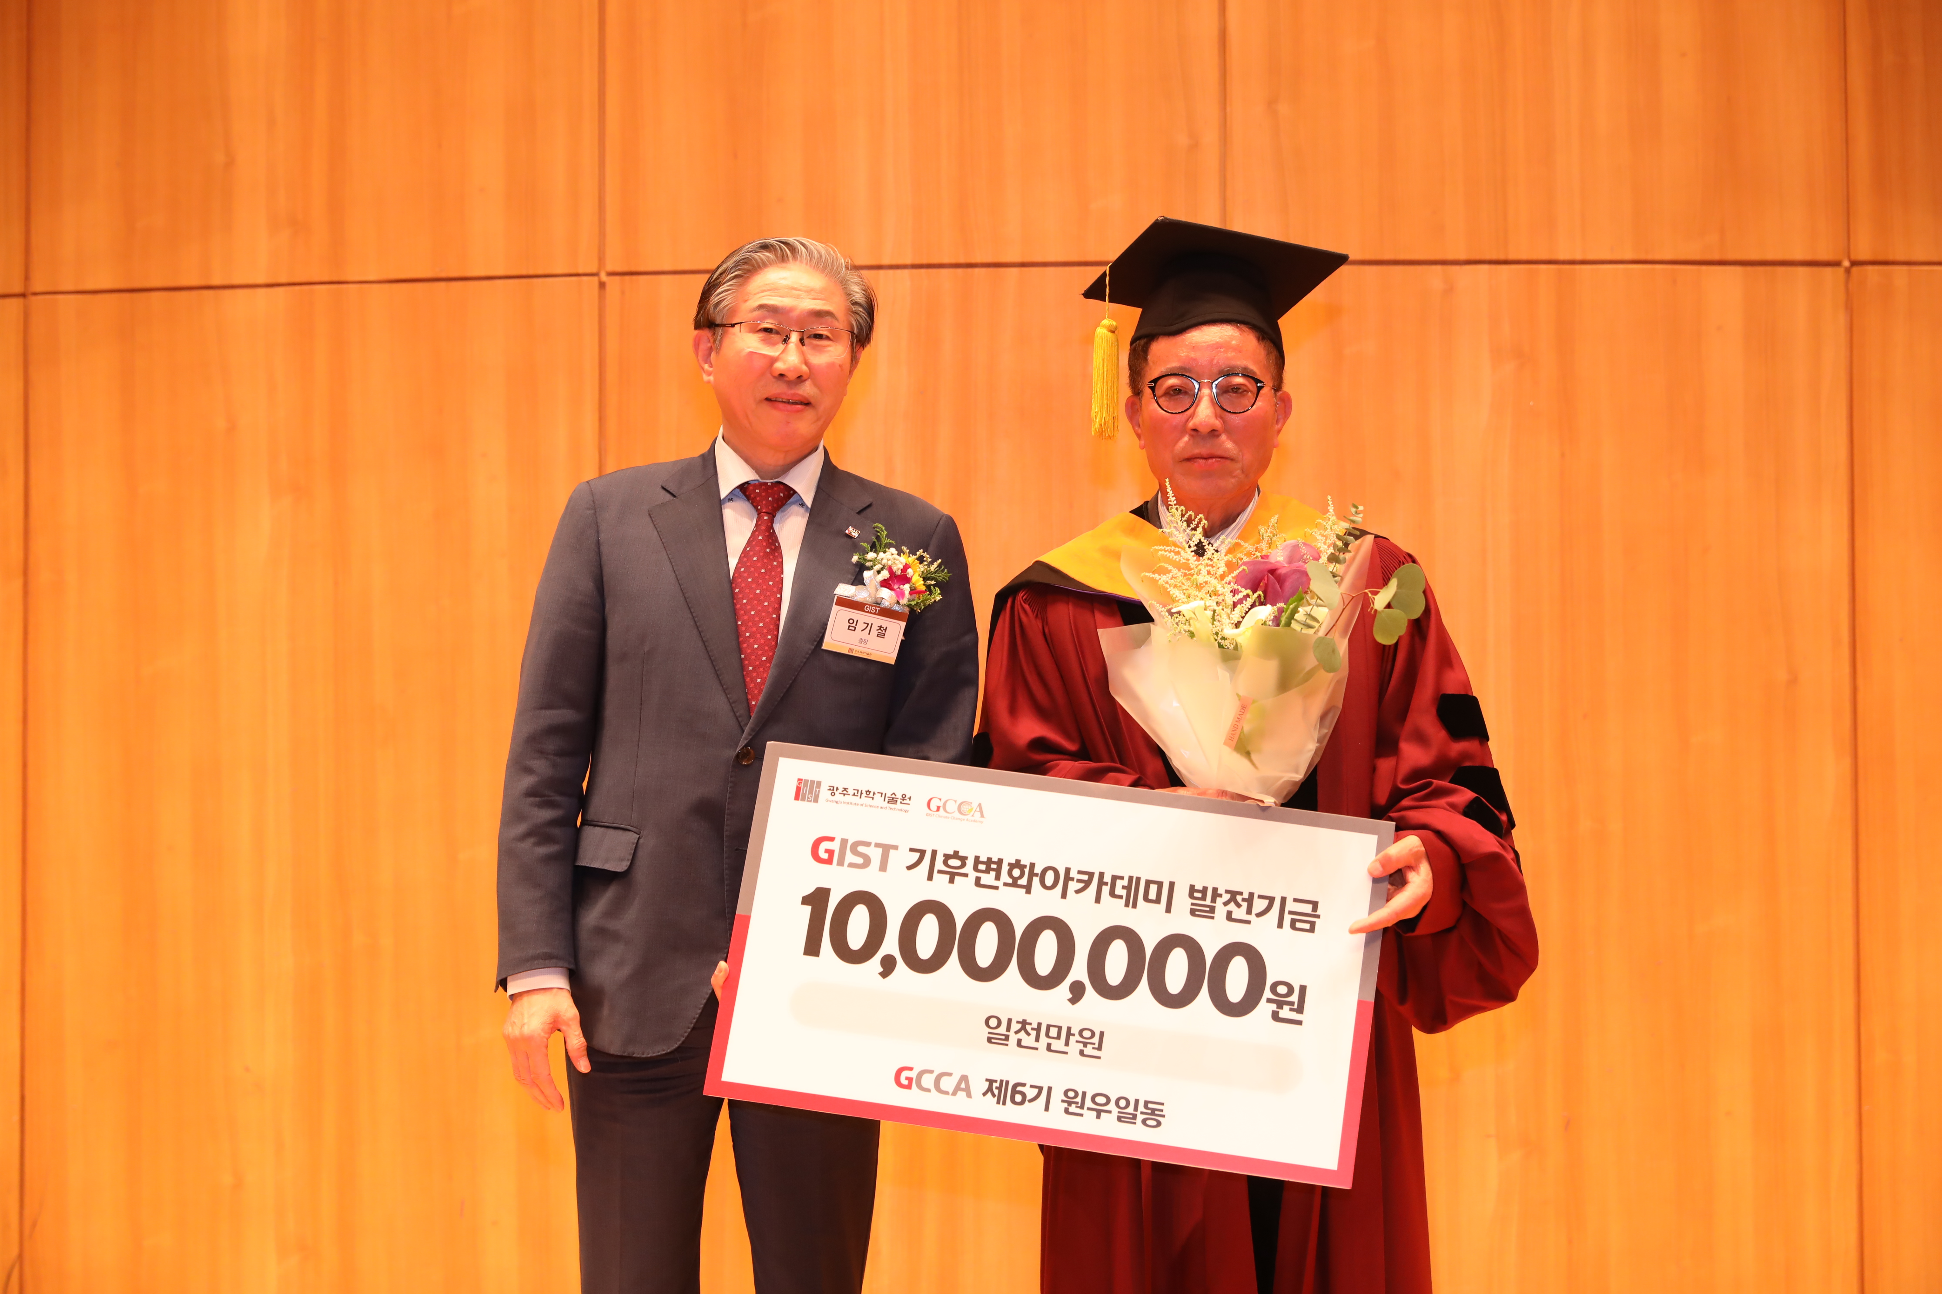▲ GIST Climate Change Academy held its 6th graduation ceremony on October 25 (Wed) at the Oryongwan Multipurpose Hall. The 6th alumni association held a donation ceremony for the 10 million won development fund collected by the alumni association. (From left) GIST President Kichul Lim, Jeong-cheol Kim, Chairman of Gongilgong Power Telecom Co., Ltd.

The Gwangju Institute of Science and Technology (GIST, President Lim Ki-cheol) announced that the Climate Change Academy (President Myeong-joong Kim, GCCA) held its 6th graduation ceremony on Wednesday, October 25.

The event was held at the Oryong Hall Multipurpose Hall with the attendance of about 50 people, including GIST President Lim Ki-cheol, 6th class graduates, and GIST officials.

A total of 31 students who completed the academy's curriculum, including the latest science and technology and global climate change response and trends, over a total of 22 weeks, were awarded certificates in the name of the president. The GIST President's Award was awarded to Jeong-cheol Kim, Chairman of Gongilgong Power Telecom Co. and the 6th Wonwoo Chairman.

Gongilgong Power Telecom Co., Ltd. is an officially certified distributor of SK Telecom that provides wired and wireless communication products such as mobile phones, wireless data, telephones, and high-speed Internet, as well as ADT Caps' security services.

Upon establishment in November 2003, the company achieved rapid growth and achieved the feat of attracting 100,000 registered customers in the shortest period of time for SK Telecom's national dealerships. Since its establishment, the company has developed dramatically, operating 20 directly managed stores in Seoul and the metropolitan area and is growing by cooperating with approximately 150 partners and companies.

On this day, a donation ceremony was held for the 10 million won development fund for which the 6th class alumni came together with one mind, and the fund will be used for the development of the GIST Climate Change Academy.

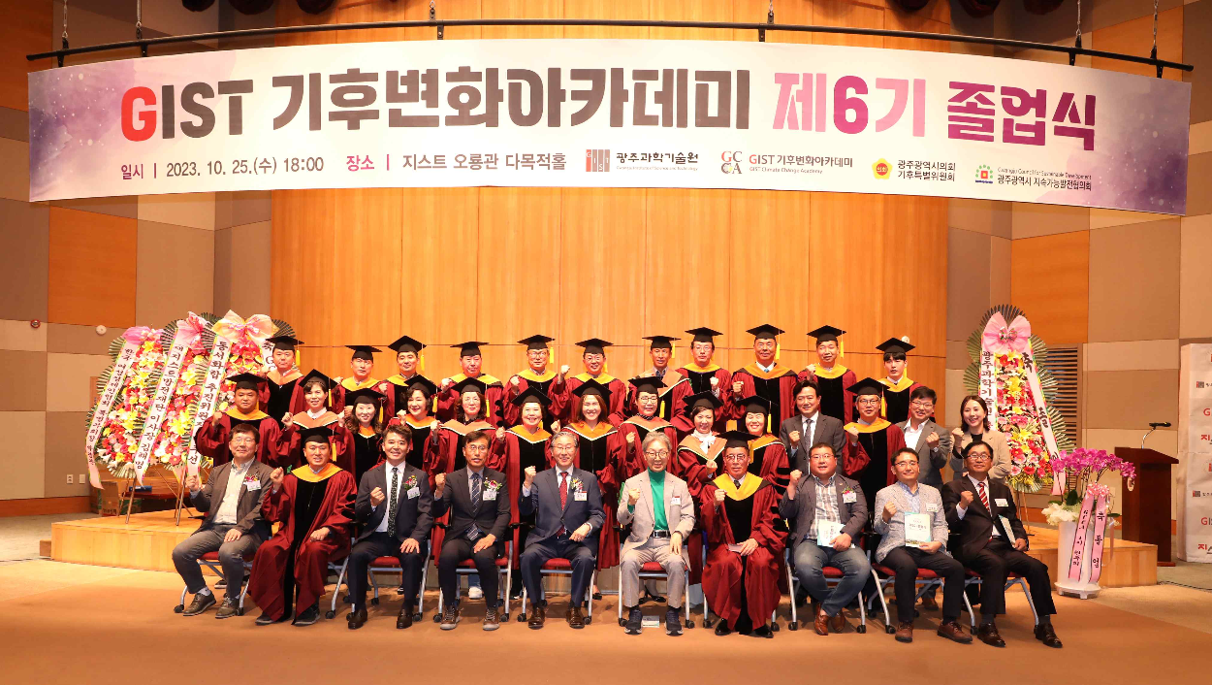▲ GIST Climate Change Academy held its 6th graduation ceremony at the Oryong Hall Multipurpose Hall on Wednesday, October 25, and a group photo of attendees was taken.

Jeong-cheol Kim, the 6th Alumni Chairman, took the lead in fund raising and said, "With the hope that GIST will stand tall as a world-class science and engineering education and research institute based in the region, we agreed to donate a development fund together with our alumni. We would like to thank the GIST Climate Change Academy and its staff for providing a high-quality educational program, and we will strive to contribute to the development of GIST and revitalization of the local economy together with our alumni in the future."

President Kichul Lim said, "We ask you to always hold in your heart the pride and pride of being a member of the GIST Climate Change Academy alumni, and take the lead in responding to the climate crisis and improving the competitiveness of local industries based on the insight and the human network you have gained through this process. In the future, we ask that GIST and local industries work together to ensure continued communication and environmental protection."

The GIST Climate Change Academy was established in 2016 to foster chief executives who can creatively respond to the global climate crisis, and since then, about 218 alumni have become top global leaders in various fields of society.



