GIST promotes establishment of a convergence research-oriented graduate school of science, technology and medicine

Stable operation of the Department of Biomedical Science and Engineering for 15 years provides capabilities and foundation for training physician scientists

- Among the 67 doctoral graduates of the Department of Biomedical Science and Engineering, 20 are medical scientists (MD-PhD) and continue research at university hospitals, etc.
- Optimal response to the need to train physician-scientists that has emerged since COVID-19 with a convergence education system such as AI

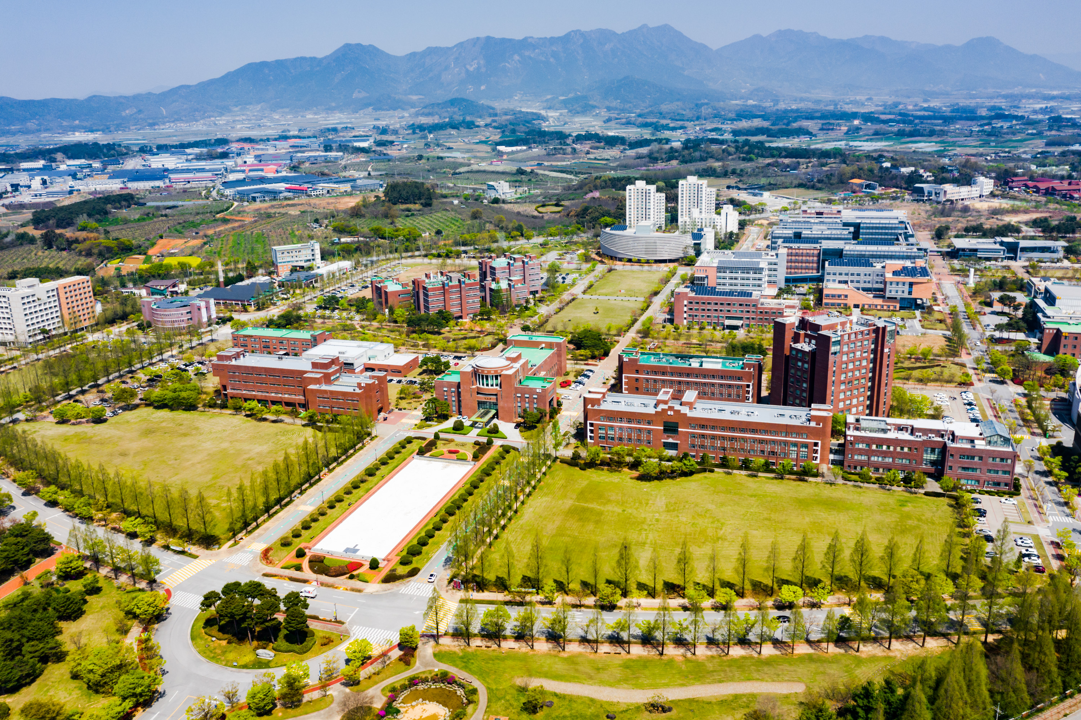▲ Panoramic view of GIST campus

Gwangju Institute of Science and Technology (GIST, President Kichul Lim) announced on the 19th (Thursday) that it is necessary to establish a graduate school of science and technology and medicine.

When a science and medical center is established, bachelor's degree holders are selected and receive convergence education through a mandatory master's course to obtain medical doctor qualifications (MD, Medical Doctor). If convergence medicine research is conducted during the doctoral course, a doctorate in engineering is awarded. It is expected to be designed as a curriculum for medical scientists (MD-PhD) who receive a doctoral degree (PhD).

The plan to foster physician-scientists from the four major science centers was already conceived on June 21, 2021, in the form of the "Policy Research Report on the Plan to Foster Physician-Scientists Based on the Science Center Education System" by the Joint Secretariat of the Korea Advanced Institute of Science and Technology.

In the case of GIST, the Department of Biomedical Science and Engineering (Dean Euiheon Chung), established in 2008 to foster globally competitive convergence leaders in the biomedical industry, which is emerging as a next-generation national growth engine, has been successfully operating for 15 years.

Currently, GIST's Department of Biomedical Science and Engineering has 10 full-time professors and 87 students (10 in the master's program, 44 in the doctoral program, and 33 in the combined master's and doctoral program).

In particular, half of the full-time professors are medical scientists (MD-PhD), and this ratio is the same at the Korea Advanced Institute of Science and Technology (KAIST) Graduate School of Medical Science, which aims to foster human resources for convergence in medical science and biomedical engineering. This is higher than the Pohang University of Science and Technology (POSTECH) Graduate School of Convergence (Medical Science Major) and the Ulsan National Institute of Science and Technology (UNIST) Department of Biomedical Engineering.

Faculty start-ups in this field are also active. ‘Genome & Company’, founded in 2015 by Professor Hansoo Park of the Department of Biomedical Science and Engineering, is a company that develops microbiome medicines and new drug target-based immunotherapy drugs and will be listed on KOSDAQ in 2020 and received great attention when it was listed.

'TEDI MEDI', a company that develops digital healthcare products related to sleep and dementia based on brain science, was founded in 2021 by Professor Jae Gwan Kim and Professor Tae Kim of the same department and was selected for various investment attraction and market entry programs (Ministry of SMEs and Startups TIPS). This also demonstrates the capabilities of the ‘pseudo-scientist faculty.’

In addition, among the 67 doctoral program graduates produced so far, 20 are medical scientists (MD-PhD) with medical qualifications, or 30% of the total. 95% of these physician-scientist graduates work at university hospitals and continue to research.

The trend of physician-scientist training systems in major developed countries, such as the United States and the United Kingdom, focusing on strengthening convergence research capabilities that combine with all fields of engineering, including artificial intelligence (AI), which also raises expectations about the role of GIST.

With the goal of nurturing convergence specialists, GIST opened the Institute of Integrated Technology in 2015 and the AI Graduate School in 2019 and is actively conducting convergence research centered on research groups meeting each other beyond fields and disciplines. Starting in 2021, GIST is conducting AI-based joint research with the Massachusetts Institute of Technology (MIT) in the United States, with a research budget of 20 billion won.

Department of Biomedical Science and Engineering Dean Euiheon Chung said, "Based on GIST's medical science convergence education and research capabilities, it is expected that the establishment of a science and technology center will ultimately foster new types of specialists and promote research to create economic and social added value."

President Kichul Kim said, "GIST, which celebrates its 30th anniversary this year, has accepted leading-edge convergence research as an important identity of the institution since its establishment in 1993. The international community's cooperation in preventing the recurrence of the pandemic, along with the aging population, a global megatrend, eventually requires the training of physician scientists at the national level. GIST, which has all the capabilities and foundation required to train medical scientists, will respond to the demands of the times."

Meanwhile, at a meeting held at the conference room of the National Science and Technology Advisory Council in Jongno-gu, Seoul on the 18th (Wednesday), President Lim proposed a plan to establish a joint science and technology center among the four science and technology institutes at the meeting of the presidents of the four major science and technology institutes and the United Graduate School of Science and Technology (UST). A GIST official said that the proposal was made.



