Enjoy reading with your library robot friend! GIST develops AI-based robot to support children’s reading activities

- GIST Korea Culture Technology Institute developed a service to support children’s reading activities as the lead research institute for the ‘Policy Designation Project for Supporting Cultural Technology Research Organizations’
- Robot service pilot operation at the National Library for Children and Youth until October 22nd (Sunday)

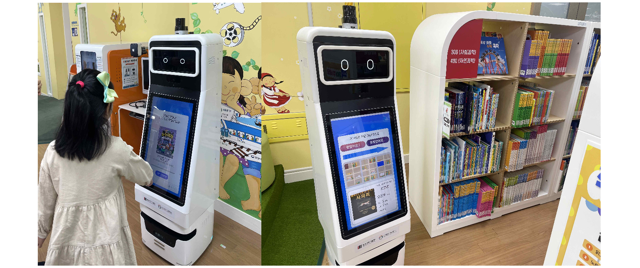▲ National Children and Youth Library book location guide robot prototype pilot service: It is a robot service that recommends books to children to read, and when the children decide on the books they want to read, the guide robot guides the location of the books and goes with the children to find the books. The service combines technology and a personal approach to provide young readers with a unique and enriching library experience.

The Gwangju Institute of Science and Technology (GIST, President Kichul Lim) announced that it will pilot an artificial intelligence (AI)-based robot service to support children's reading activities at the National Children and Youth Library this month.

Recently, in public libraries, there has been a significant increase in demand for new technology reading activity support services that provide children with an expanded experience from forced reading to enjoyable reading.

GIST Korea Culture Technology Institute (Director Kyung-Joong Kim), the lead research institute, is carrying out the development of ‘artificial intelligence (AI)-based children’s reading activity support robots and service contents in order to spread reading activity support services to public children and youth libraries across the country. (School of Electrical Engineering and Computer Science Professor Hong Kook Kim, lead researcher) (Period: 2022.04.~2024.12.)

As a research achievement, the institute developed 'UI/UX (user environment/experience) and sustainable services' that support reading activities by reflecting children's psychological characteristics as well as 'interactive robot software (SW)' and 'reading activity support robot' to provide services that stimulate children's reading interest.

GIST will introduce the mobile robot response technology for the reading activity support service to children from 7 to 10 years old at the children's resource center of the National Library for Children and Young People until Sunday, October 22. Improvements will be made with the usability evaluation.

For the book location guide robot, the institute has developed ▴ path search technology linked to book database ▴ guide robot technology including pedestrian and obstacle avoidance ▴ UI/UX-based indoor autonomous driving service technology for guiding robot operation ▴ UI/UX technology to support children’s reading activities ▴ robot response technology to support reading activities, and a server-based children's voice emotion recognition/video emotion recognition technology will be introduced.

Director Kyung-Joong Kim said, "Through successful pilot operations, we hope that the use of robot services to support children's reading activities will spread to many public libraries in the future. We hope that children will not just go to the library to read books, but will be able to enjoy a variety of reading activities by choosing and finding books with the robot, just like playing with friends."

In April 2022, the Korea Culture Technology Institute was selected as the lead research institute for the 'Policy Designation Project for Supporting Cultural Technology Research Organizations' hosted by the Ministry of Culture, Sports and Tourism, and has been working with joint research institutes at Ulsan National Institute of Science and Technology (UNIST) and Sogang University for the past year. They have been collaborating with the School Industry-Academia Cooperation Foundation and Interflow Co., Ltd., and with the National Library for Children and Youth to develop artificial intelligence-based robots and service content to support children's reading activities.

The research institute is carrying out a number of projects, including cultural technology research and development policy-designated tasks by the Ministry of Culture, Sports and Tourism, realistic content utilizing cultural heritage, AI-based art convergence creation, and media facade mapping technology. They are focusing on research and development of core cultural technologies to drive the development of the national cultural industry.



