In commemoration of the 30th anniversary of the establishment of GIST, ‘Whale Swimming in Space’ by Sang-yeon Kim is exhibited

- Sponsored by the GIST Development Foundation, a public art project to recognize global environmental problems and derive solutions through science and technology
- Scheduled to be on display at the main entrance plaza of Oryong Hall until the end of November

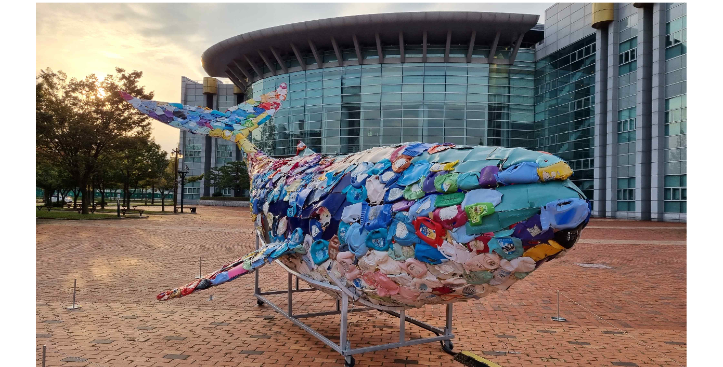▲ Artist Sang-yeon Kim’s installation work ‘Whale Swimming in Space’ displayed at the main entrance plaza of Oryong Hall under the theme of ‘GIST 30th Anniversary and Future 30 Years – Together with Environmental Art’

Gwangju Institute of Science and Technology (GIST, President Lim Ki-cheol) announced that it will exhibit artist Sang-yeon Kim’s installation work ‘Whale Swimming in Space’ at the main gate plaza of Oryong Hall under the theme of ‘GIST 30th Anniversary and Future 30 Years - With Environmental Art’.

This exhibition is a public art project promoted by Hae-myeong Kim, chairman of the GIST Foundation, which has consistently supported local artists, to celebrate the 30th anniversary of GIST's establishment, with the hope that GIST members and local residents will recognize global environmental issues and work together to solve them.

‘Whale Swimming in Space’ was produced in 2021 with the full production cost sponsored by Chairman Hae-myeong Kim, and received attention when it was presented at the Gwangju Design Biennale in the same year.

‘Whale Swimming in Space’ is an installation work made of marine waste such as plastic and rebar, covering a structure shaped like a whale.

This work, which imagines ‘a whale swimming in the sea and detecting and collecting marine debris with a unique frequency,’ uses a motion sensor to display images of the polluted sea on a screen installed on the outside of the whale. Artificial intelligence (AI) technology that responds with groaning sounds and red lighting is added to warn of the dangers of marine pollution.

GIST Foundation Chairman Hae-myeong Kim said, "In celebration of the 30th anniversary of the establishment of GIST, I hope that not only members but also many local residents will visit GIST to become aware of the seriousness of environmental pollution and feel the need for environmental protection using science and technology."

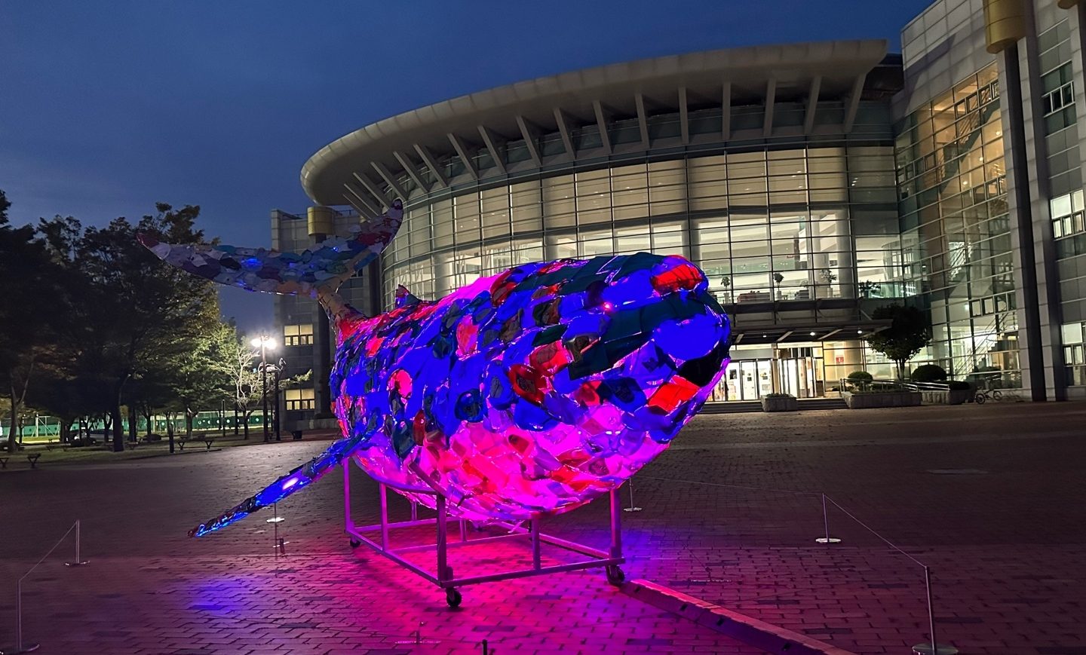▲ Artist Sang-yeon Kim’s installation work ‘Whale Swimming in Space’ (night) displayed at the main entrance plaza of Oryong Hall under the theme of ‘GIST 30th Anniversary and Future 30 Years - Together with Environmental Art’

Artist Sang-yeon Kim graduated from the Department of Fine Arts (Majoring in Western Painting) at Chonnam National University and received a master's degree from the Department of Printmaking at the National University of Chinese Art. He received the Ha Jeong-woong Young Artist Award and the Ji-ho Oh Art Award for Young Artists.

‘Whale Swimming in Space’ will be on display at the main gate plaza of GIST Oryong Hall until the end of November, and anyone can view it.



