GIST G-SURF research presentation held

- 65 undergraduate students conducted research in graduate school laboratories during summer vacation
- Develop your dream of becoming a science and technology researcher through graduate school professor mentoring and laboratory experience

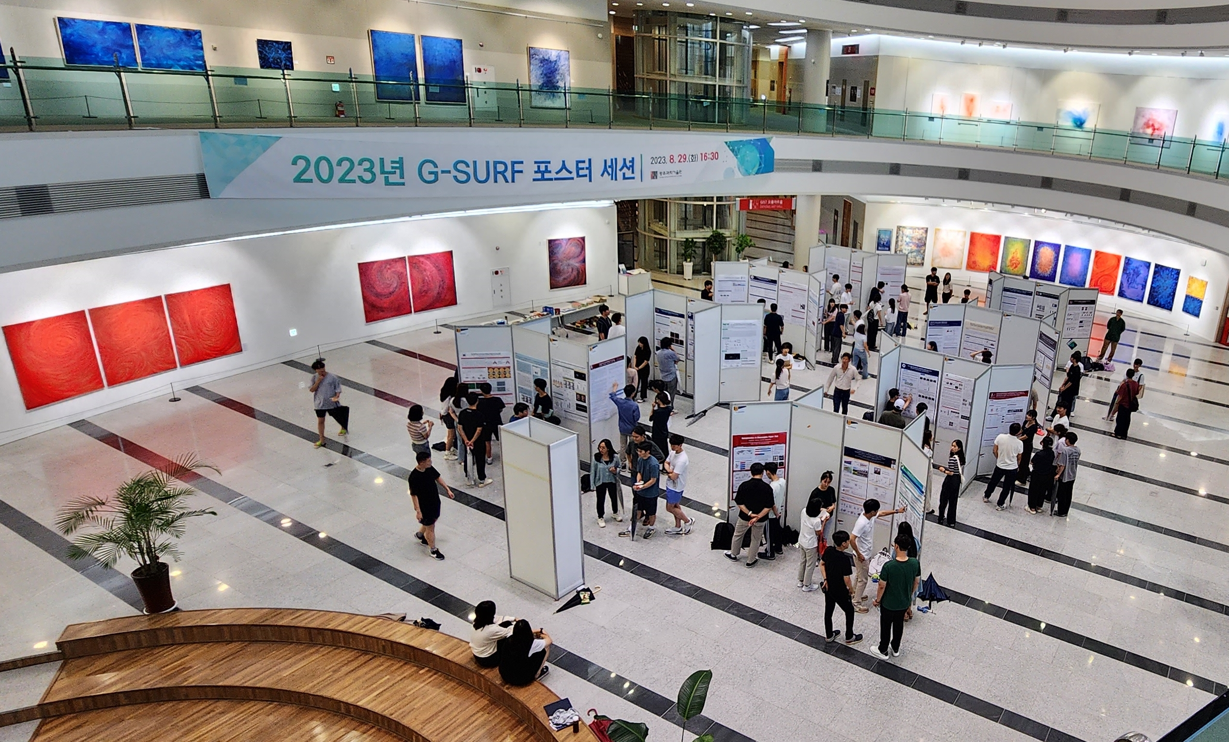▲ Panoramic view of the 2023 G-SURF poster presentation venue (GIST Oryong Hall lobby)

The Gwangju Institute of Science and Technology (GIST, President Kichul Lim) announced that it held the ‘2023 G-SURF* Poster Session’, a representative research participation program for undergraduate students.

* G-SURF: A university summer program that benchmarks SURF (Summer Undergraduate Research Fellowship), a summer undergraduate research participation program at Caltech in the United States.

G-SURF has been held every summer vacation since 2011, hosted by a student team, and it has received a lot of interest and response from students. The poster presentation was held again this year for the first time in three years due to the government's recent easing of quarantine measures.

Undergraduate students who participate in G-SURF can apply basic science principles and knowledge to actual research in graduate school laboratories during summer vacation, receive mentoring from graduate school advisors, and acquire the necessary qualities for researchers.

This year, a total of 65 undergraduate students performed research projects with 47 professors, and the results were presented in the GIST Oryong Hall lobby on Tuesday, August 29.

Seonghwan Bae (3rd year majoring in mechanical engineering), who performed G-SURF in the ‘Dynamics and Biomechatronics Lab’ of Professor Pilwon Hur in the School of Mechanical Engineering, said, "Getting good grades is important, but through a simple research experience, I realized the importance of learning about hardware and software, which are difficult to learn in theory classes, and what kind of knowledge has been actually used recently."

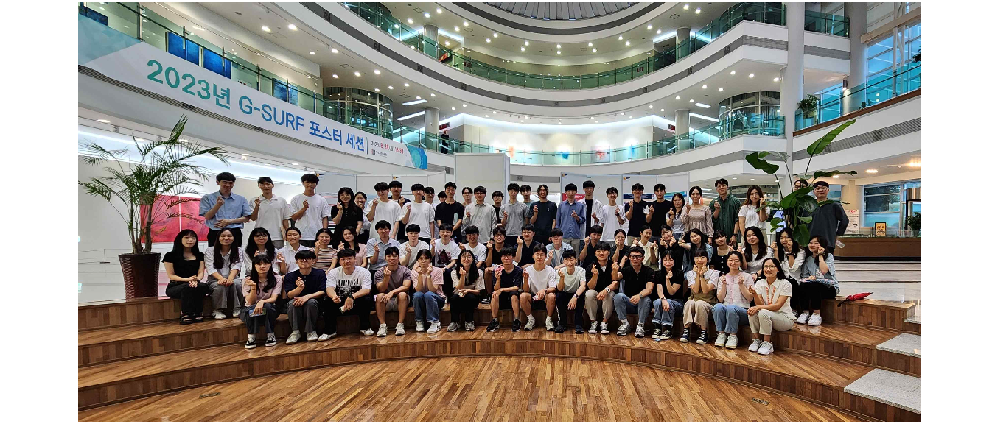▲ Group photo commemorating the conclusion of the 2023 G-SURF poster presentation

Heeju Park (3rd year majoring in Materials Engineering), who performed G-SURF in Professor Hobeom Kim’s ‘Semiconductor Photonics and Electronics Lab’ in the School of Materials Science and Engineering, said, "Through the discussion process, I was able to feel the importance of collaboration, such as knowledge sharing. I realized that applying basic scientific principles and knowledge to actual research is a completely different area from acquiring existing knowledge, and I felt the need to develop scientific thinking methods."

