Simulation for successful start-ups... GIST holds intensive start-up camp in the second half of 2023

- Simulation training for start-up and management through ‘Virtual company management game Capsim’
- 33 GIST students participated... Expected to spread start-up culture and discover future start-up leaders

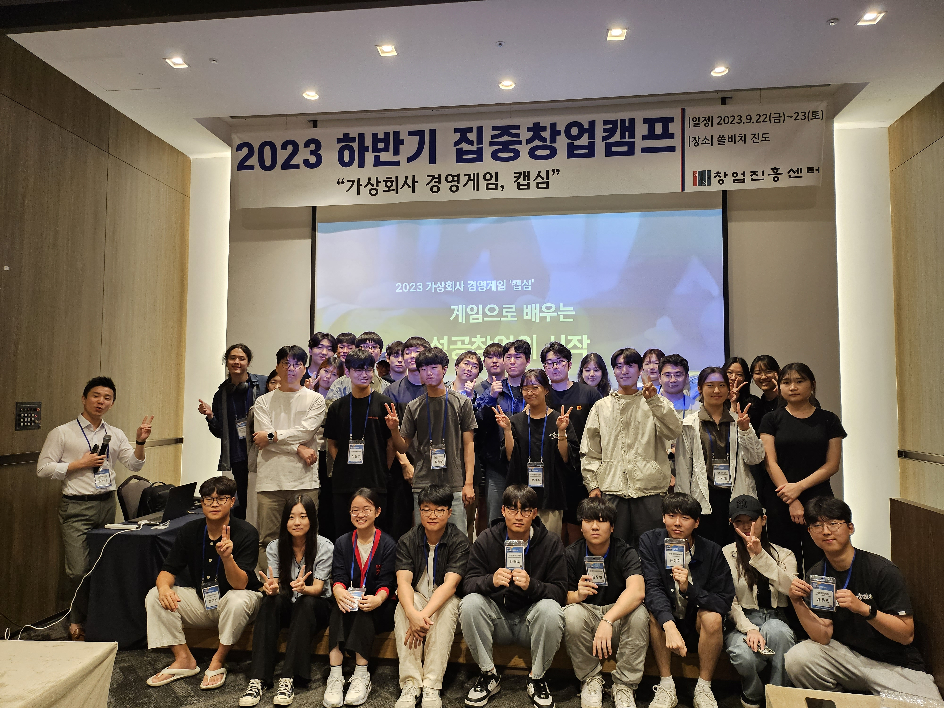▲ 33 GIST college and graduate students who are interested in future start-ups are participating in an intensive start-up camp in the second half of the year to strengthen their capabilities to become start-up leaders.

Gwangju Institute of Science and Technology (GIST, President Kichul Lim) announced on the 26th (Tuesday) that it held the ‘2023 Intensive start-up Camp in the second half of 2023’ to increase interest in entrepreneurship among current students and help them create successful start-ups.

Under the theme of 'Capsim*, a virtual company management game for successful start-ups,' the GIST start-up Acceleration Center (Director Sung-hoon Lim) conducted this camp with a company specializing in entrepreneurship education that runs Google Certified Educator courses and student career-related programs.

* Capsim: A business simulation game for management education that has been proven effective by being used for over 30 years in the regular MBA courses of over 1,500 innovative universities in over 50 countries around the world and in the education and training of executives and potential leaders of global companies.

‘Capsim’ is a management simulation program that can provide practical help to students interested in starting a business. They can acquire knowledge about overall management while experiencing R&D, marketing, production, finance, human resources management, and quality management.

In the second half of the year, the intensive start-up camp helps start-ups learn the management decision-making process necessary for stable business management. The purpose is to cultivate the ability to adapt early to the actual start-up market by finding solutions through management simulation when various problem situations arise.

In addition, the interaction with other companies is reflected as in the real world, and the strategic decisions of the CEO play a major role in the success or failure of the company, which helps prospective entrepreneurs understand how to make more rational choices about how to run a business.

This intensive entrepreneurship camp consists of a program that includes storytelling over a total of 5 stages*: establishment of a company, start of competition, expansion of business group, rational investment, differentiation strategy, and final decision, , as well as teamwork, role distribution, and education for students. A total of 33 students were organized into 6 groups and held at a resort in Jindo-gun for 2 days and 1 night.

* 5-step program
Step 1 (Establishment of a company): Establishment of company, election of executives, establishment of goals, assignment of roles
Step 2 (Start of competition): Consumer needs, market and competitor analysis, and strategy establishment through test markets
Step 3 (Business expansion): Establishment of business diversification and expansion strategies based on market understanding
Step 4 (Rational investment): Strategic decisions
Step 5 (differentiation strategy and final decision): Establish differentiation strategy for sustainable growth, market expansion
Benchmarking and inventory management system investment in progress

In the field, through the decision-making process for each round, information was collected and analyzed using reports such as production, sales volume, market share, profit and loss, inventory, stock price, and emergency loans. Creative ideas and opinions were actively shared.

When problems occurred in various situations, participants resolved them by discussing improvement plans and decision-making directions through mentoring by business consultants.

For example, in situations where the company was in difficulties due to poor decision-making, the business strategy was re-established. In cases where there were no problems with product development but the company was in difficulties due to poor marketing or production strategies, the situation was improved with the help of a business consultant.

In particular, it was an opportunity to indirectly experience situations that can only occur during an economic downturn, such as collusion and negotiation with competitors.

Center Director Sung-hoon Lim said, "The GIST Intensive start-up Camp has become an opportunity to consider and discuss innovative start-up ideas through an excellent student start-up program recognized by experts. In the future, we will make great efforts to discover excellent student entrepreneurship programs."



