GIST, Harmony-up! Professional baseball name day commemorating the 30th anniversary of establishment

- On the 22nd (Friday), approximately 2,000 people, including students, faculty, staff, officials, sponsors, and local residents, attended the professional baseball event
- President Kichul Lim's first pitch... Let's cheer as one and have time for communication and harmony

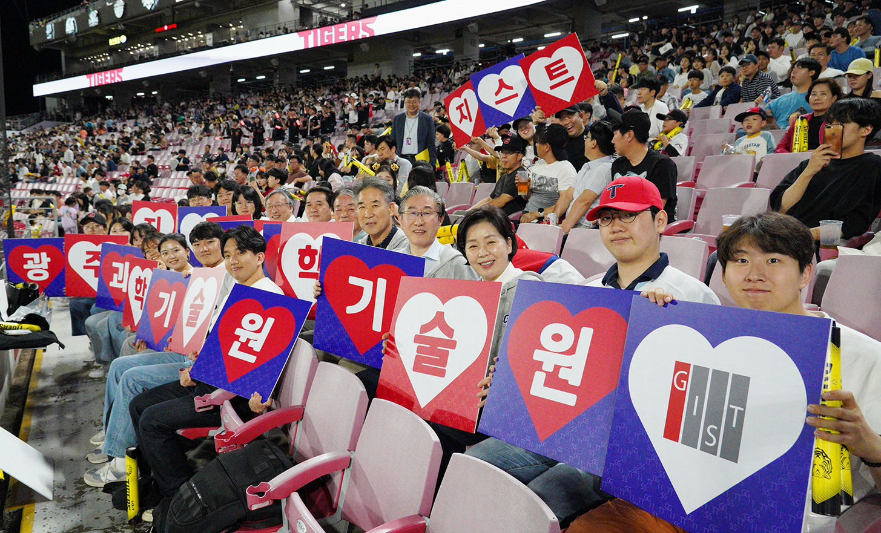▲ Hope for Korea representative Hyang-ja Yang and GIST officials who attended the Name Day event commemorating the 30th anniversary of the establishment of GIST are watching the game and cheering together at Gwangju-Kia Champions Field.

In celebration of its 30th anniversary, the Gwangju Institute of Science and Technology (GIST, President Kichul Lim) held a name day event called ‘GIST Day’ on the 22nd (Friday) at the Gwangju-Kia Champions Field where a group from GIST watched a professional baseball game.

About 2,000 people attended the event, including GIST students, faculty and staff, development foundation officials, sponsors invited by GIST, employees of related organizations, and local residents to watch the KIA Tigers vs. KT Wiz match.

Hyang-ja Yang, a member of Hope for Korea, also visited the stadium and watched the game with GIST officials and encouraged the attendees.

In particular, this Name Day event attracted attention as GIST members directly organized a competition event to provide an opportunity to build pride and unity as GIST members.

President Kichul Lim, who threw out the first pitch, went up to the mound, took off his hat, and responded to the cheering spectators. President Lim started the game by throwing the first ball at the Student Council Vice President Tae-gyu Yang (graduate student, Department of Materials Science and Engineering), who was the batter.

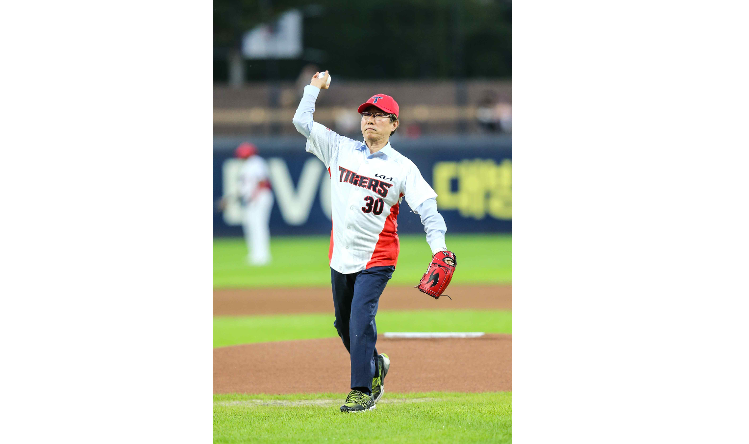▲ President Kichul Lim is throwing out the first pitch at the Name Day event commemorating the 30th anniversary of the establishment of GIST held at Gwangju-Kia Champions Field on Friday the 22nd. (Photo provided by Kia Tigers)

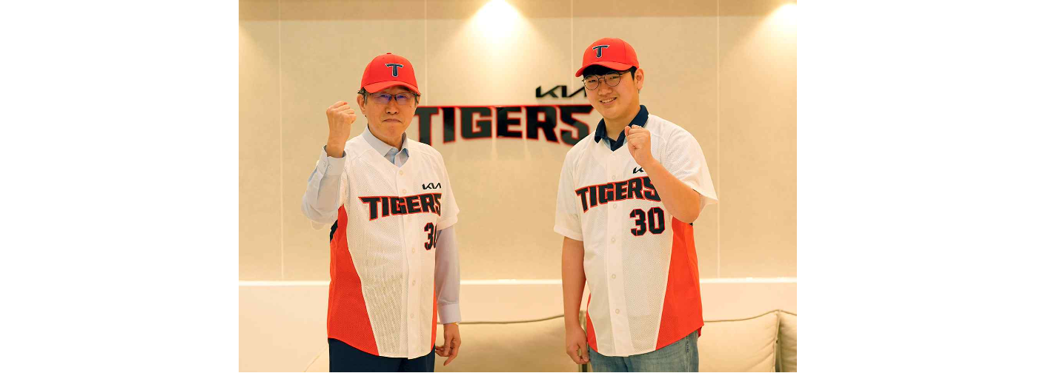▲ President Kichul Lim and Student Council Vice President Tae-gyu Yang, who took the lead, are strengthening their resolve for victory before the game starts.

Before the first pitch, International and Public Affairs Dean Jae Gwan Kim (Department of Biomedical Science and Engineering professor) and four students sang the national anthem without any accompaniment, leaving a moving impression with voices full of reverence.

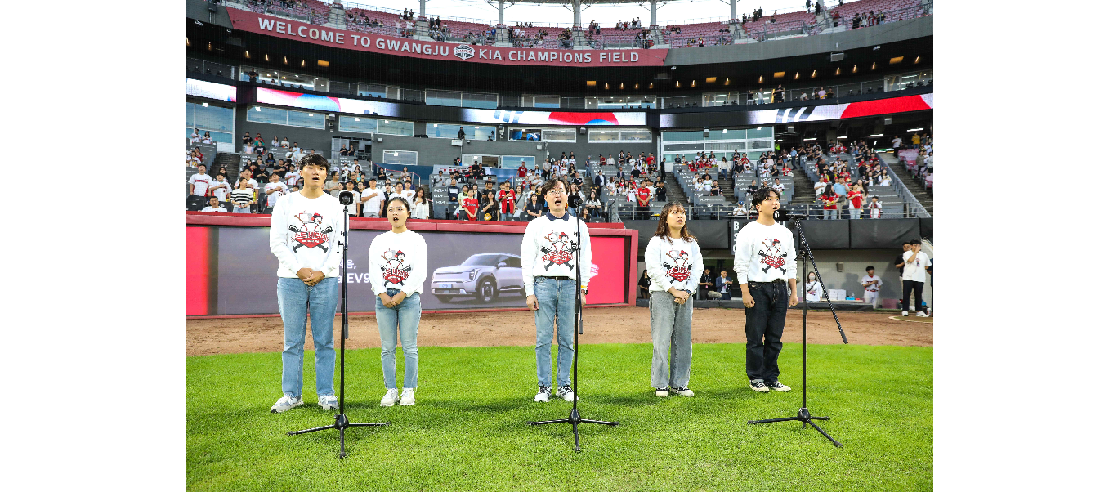▲ At the name day event commemorating the 30th anniversary of the establishment of GIST held at Gwangju-Kia Champions Field on the 22nd (Friday), International and Public Affairs Dean Jae Gwan Kim and four students are singing the national anthem without accompaniment. (Photo provided by Kia Tigers)

Additionally, during the cleaning time after the end of the 5th episode, the GIST dance club ‘Reckless’ students presented a powerful and disciplined performance, receiving a standing ovation and warm cheers from the audience.

Meanwhile, a video introducing GIST was shown on a large electronic display board, and it was a meaningful time to share and look back on the 30-year history of GIST, which was established and developed with the interest and support of local residents.

Student Min-ji Kang, a freshman in the Division of Liberal Arts and Sciences who visited the stadium with her friends that day, said, "After a long time, I left the classroom and cheered on my favorite baseball team with my professors and friends, feeling like we were becoming one. I hope that more events to promote GIST will be held in the future."

President Kichul Lim said, "I hope that the Name Day event commemorating the 30th anniversary of the establishment will be a festival in which all school members and local residents can unite and enjoy together. Please continue to watch over GIST with affection so that it can become a source of greater pride for the region and further become a game changer for science and technology in Korea."

In celebration of its 30th anniversary, GIST plans to hold a variety of events that local residents can enjoy, including the aforementioned professional baseball name day, classical concerts, Oryong Art Hall’s special exhibition ‘Scientist at the Museum’, and ‘Global Lecture Series’.



