GIST strengthens research cooperation with the German Aerospace Center (DLR)... Joint research on hydrogen energy to achieve carbon neutrality

- In celebration of the 140th anniversary of the establishment of diplomatic relations between Korea and Germany, it is attracting attention as an example of long-term international cooperation in research and development.
- Professor Jaeyoung Lee of the School of Earth Sciences and Environmental Engineering and Professor Andreas Friedrich of the Engineering Thermodynamics Research Institute under DLR have been conducting joint research for 20 years

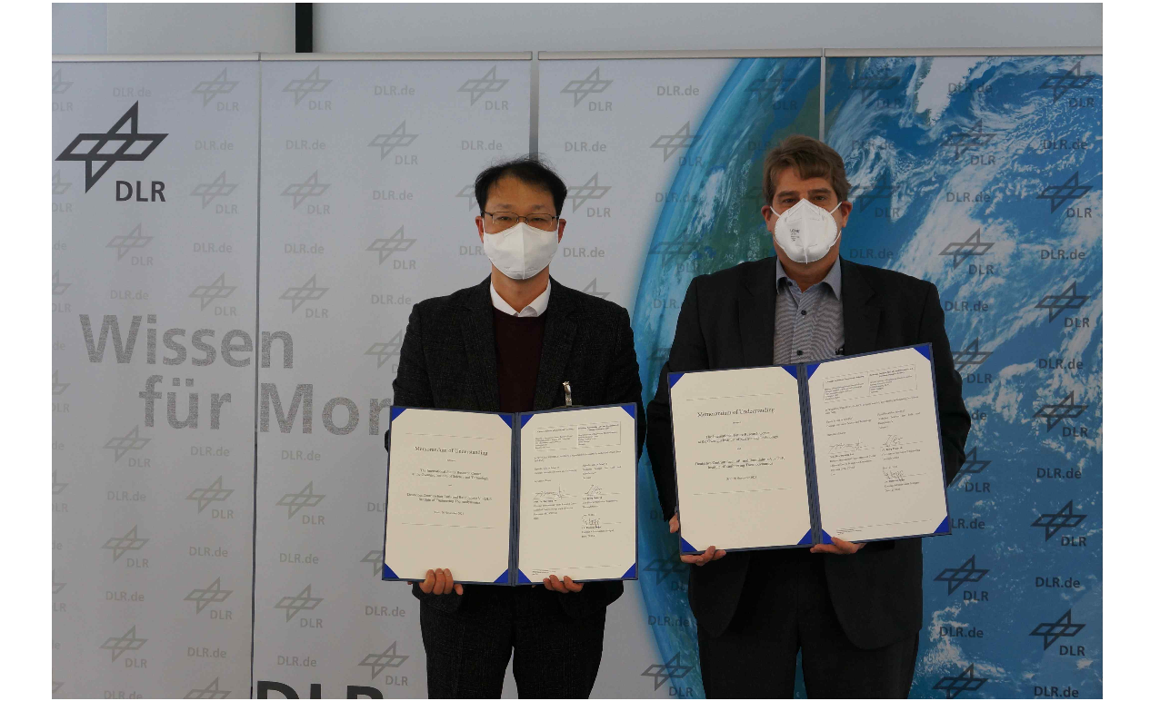▲ 2021 Korea (GIST)-Germany (DLR) MoU signing ceremony (Stuttgart, Germany)
(From the left) School of Earth Sciences and Environmental Engineering Professor Jaeyoung Lee (Director of the Future Research Center for Chemical Energy Storage and Conversion Processes) and Professor K. Andreas Friedrich of the of the Engineering Thermodynamics Research Institute under DLR

As the government's science and technology policy places great emphasis on international cooperation research and development (R&D), the long-standing joint research between Korea and Germany, which mark their 140th anniversary of diplomatic relations, is attracting attention.

Since the establishment of diplomatic relations between Korea and Germany in 1883, the two countries have developed exchanges and cooperative relationships in various fields, and international joint research between Korean and German science and technology researchers is also actively underway.

The Gwangju Institute of Science and Technology (GIST, President Kichul Lim) announced that it had recently renewed the Non-Disclosure Agreement (NDA) first signed in 2013 with the German Aerospace Center (DLR).

By re-signing the NDA this time (August 2023), the joint research partnership was further solidified. The cooperative relationship between GIST and DLR was established over the past 10 years by GIST School of Earth Sciences and Environmental Engineering Professor Jaeyoung Lee (Director of the Future Research Center for Chemical Energy Storage and Conversion Processes) and Professor K. Andreas Friedrich of the of the Engineering Thermodynamics Research Institute under DLR and is based on joint research that has been consistently conducted.

Professor Jaeyoung Lee said, "Six Korean and German patent applications are jointly in progress through the NDA, and the fact that Korean and German researchers were able to share key analysis and scale-up technologies through continuous mutual visits can be said to be a major achievement of GIST-DLR cooperation."

DLR, which is showing outstanding achievements in the fields of aviation and space, energy, and national defense, is considered one of Germany's three major specialized research institutes, along with the Max Planck Institute (basic research) and the Fraunhofer Institute (applied research).

In particular, the DLR Engineering Thermodynamics Research Institute located in Stuttgart, Germany, combines thermal process technology and electrochemical energy technology to develop fuel cells and is playing a pivotal role in the development of technologies related to merging water electrolysis and lithium battery-based energy systems.

Since the opening ceremony of the 'Nobel Ertl Center for Carbon Empty Research (Ertl Center)' in GIST in 2009, the Korean-German international joint research team has been going back and forth between Korea and Germany every two years since 2010 to co-host the 'Ertl International Symposium (International Electrochemical Society) as sponsors.

In particular, GIST successfully carried out the IMPACT international cooperation research project, an EU FP project (Improved Lifetime of Automotive Application Fuel Cell with ultra-low Pt-loading), with a total of 10 industry-academia research institutes in 5 EU countries (Germany, Netherlands, UK, Italy, and France) from August 2014 to October 2016.

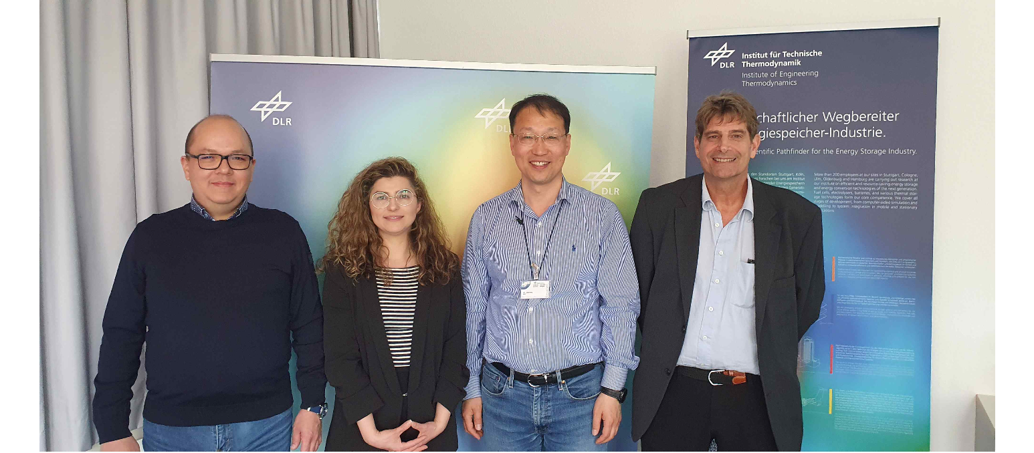▲ 2023 Korea (GIST)-Germany (DLR) International Joint Research Workshop (Stuttgart, Germany)

Professor Jaeyoung Lee, who is playing a central role in the National Research Foundation of Korea's overseas excellent research institute cooperation hub construction project (G-HUB, selected in 2021), said, "We plan to build an international joint research hub with a large industrial and academic impact through a continuous and clear win-win strategy in equal research cooperation relationships. Activation of international joint research is becoming more important in line with the core principles of the current government's science and technology policy, such as becoming a global hub, so we will expand and strengthen science and technology cooperation with Germany based on the Korean-German Alumni Network (ADeKo, Vice President)."

